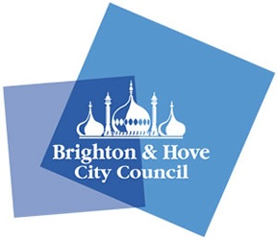


BHCC Liveable/Low Traffic Neighbourhood Pilot Scheme Hanover – An Accessibility Audit by The Get Involved Group (GIG), Possability People

Date of Audit – Various dates December 2021

Introduction

1.1 Background and scope of audit
The Get Involved Group were approached by Oliver Spratley, principal transport planner for BHCC, who is leading on this pilot scheme to carry out an accessibility review of a site comprising of a section of Western Road from the Clock Tower to Waitrose, to look at areas that could be improved in terms of accessibility for disabled people, in the run-up to the proposed plans for improvement under the scheme.
In advance of the Audit, Oliver Spratley and Graeme Trelford-Davies (Engagement and Inclusion Lead for Possability People) along with representatives from the organisation contracted to carry out the work, and Councillor Steph Powell (Green Party Councillor Hanover & Elm Grove) carried out a pre-inspection of the area to determine the exact area to be audited. We were asked to look at the area in order to raise issues that would aid future design and planning.
The main aim of this project is reduce the amount of through traffic, as certain roads within the area are well known to be used as shortcuts. However, this is largely a residential area with narrow streets and mostly comprising of terraced fisherman style cottages and additional traffic can cause a variety of issues for residents. It is also important that maintenance, refuse and emergency vehicles are able to access the area without obstruction and the project aims to take this into account. Some of the proposed plans include the blocking of one end of streets, one way system, access only signage and enforcement cameras. The plans also intend to implement some public spaces and to generally make the area more aesthetically pleasing, greener and more sustainable. There is ample unused space in the area to make this a possibility.
The area for the project is notoriously steep and hilly, and due to this, accessibility will always be a difficult task, and we will be looking to make recommendations to take away obstacles or advise on improvements, where this is possible.
Typically, when carrying out such audits, we have found that the best purpose of the report is to find and report on the following:
- Issues which present an immediate hazard to disabled people, with risk of serious injury or death, and which need to be reported and rectified promptly.
- Areas which are problematic for disabled people that may require some temporary mitigation measures, given that the completion date for the proposed work may continue several months or more into the future.
- Areas where we agree with the any current design proposals and corroborate BHCC’s case for implementation.
- Further recommendations, that have not been previously mentioned in any design proposals.

1.2 Audit Team and Method.
The Audit team comprised of Graeme Trelford-Davies, Kate Annetts, a bank member of staff for Possability People who has Cerebral Palsy and uses a mobility scooter and a volunteer auditor, Graham Oulton and guide dog Teddy, who is visually impaired and a regular contributor to the Brighton Disabled Car User Advisory Group (DCUAG), which is co-chaired by Possability People. The initial findings of this report were also discussed with the DCUAG Panel and our valued partners in the BADGE community group (who are mainly concerned with parking and driving issues for Blue Badge Holders in the Brighton & Hove area) and some of their thoughts and comments have been included at the end of the Findings section.
Typically, these kind of audits are carried out as a group, but on this occasion, due to scheduling conflicts and availability, two separate sessions were required with our auditors
. 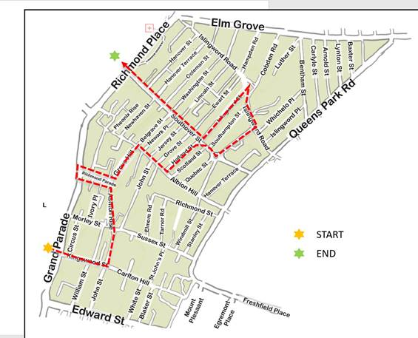
Figure 1 – Map of Audit Area
The route for this audit can be seen in Fig. 1 (above) and was chosen by Oliver and his team, based on our pre-audit site visit, and intelligence/surveys gathered in the area to identify problematic hotspots. It was not possible to audit the entire area, as it comprises of over a square mile of steep streets, and not a reasonable expectation of our disabled volunteer auditors. The route chosen however, is a good cross section of the area, and includes the majority of thoroughfares where a reduction in traffic is necessary.
Detailed notes were taken of all findings, and discussed in detail, which can be foundin the following section. Please note that for ease of reading in one place, section 3 contains a summary of all recommendations.

2.0 Findings

General
As previously stated in the introduction, the topography of this particularly area, with its steep hills, inclines and narrow streets is always going to be difficult in terms of accessibility for disabled people, but there is plenty of scope for reasonable mitigation measures or features which will at least partially alleviate some of these issues. In our extensive experience of carrying out these types of audits, we find that the majority of issues raised centre around road and pavement surfacing, crossing, walkway width and clearance capacity, a suitable and consistent amount of dropped kerbs and tactile paving, and consistency of lighting. As the audit sessions were carried out in daylight, it was not possible to assess the lighting levels and consistency, though attention was paid to lighting types and distances, and there were no identified causes for concern. This audit was consistent with our typical findings, and hence, the majority of recommendations we will make in this report will be consistent with the aforementioned topics. However, we did identify at least one area within the site that could only be described as a ‘no-go’ area for disabled people, and we will make recommendations as to how this area can be greatly improved.

Kingswood St to John Street
Our audit started outside Brewdog on the corner of Grand Parade and Kingswood Street. Although this is a moderately steep incline, the quality of the walkways and crossings are of a very high standard, as this area has been subject to very recent development and building work and the infrastructure is brand new. The surfaces are textured for extra grip and are very level, and the width of the walkways is more than sufficient for two persons to walk side by side, with ample room for wheelchairs, scooters and other mobility aids. No recommendations required.
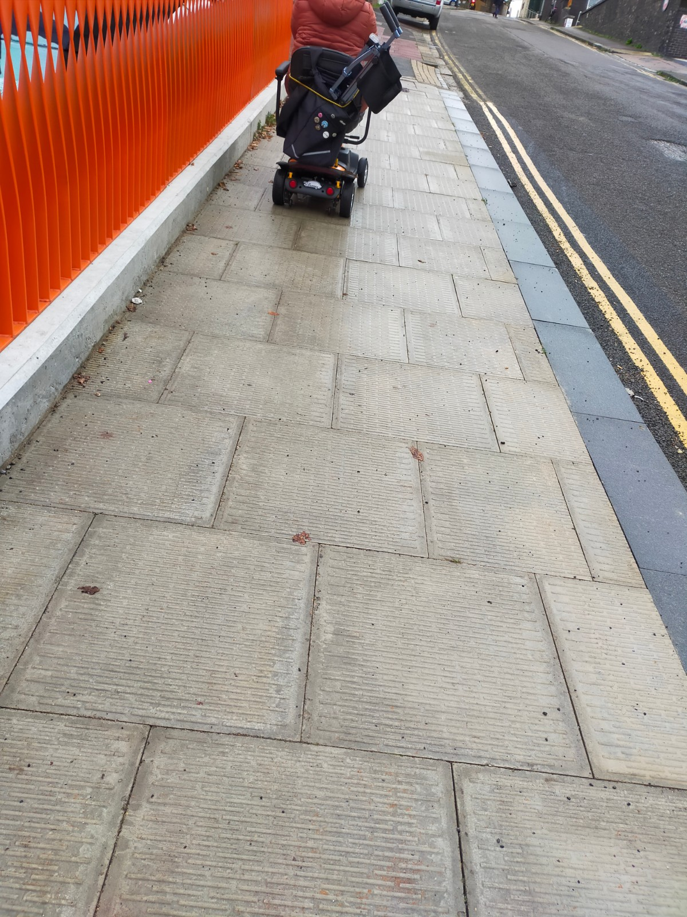
Figure 2 Example of newly laid textured paving and suitable walkway width on Kingswood St

John Street to Ashton Rise
This stretch of walkway is adequate with no major hazards or obstructions, and the surface is level. We did identify that there may be capacity to widen the pavement for ease of access and comfort, as there are fairly wide grass verges, and we would recommend considering this.

Ashton Rise/Richmond Parade/Grove Hill
Ashton Rise and Grove Hill present no major problems and no issues were identified.
The crossing over Richmond parade (Ashton to Grove Hill) has no proper dropped kerbs or tactile paving, and we recommend installation of these as soon as is possible.
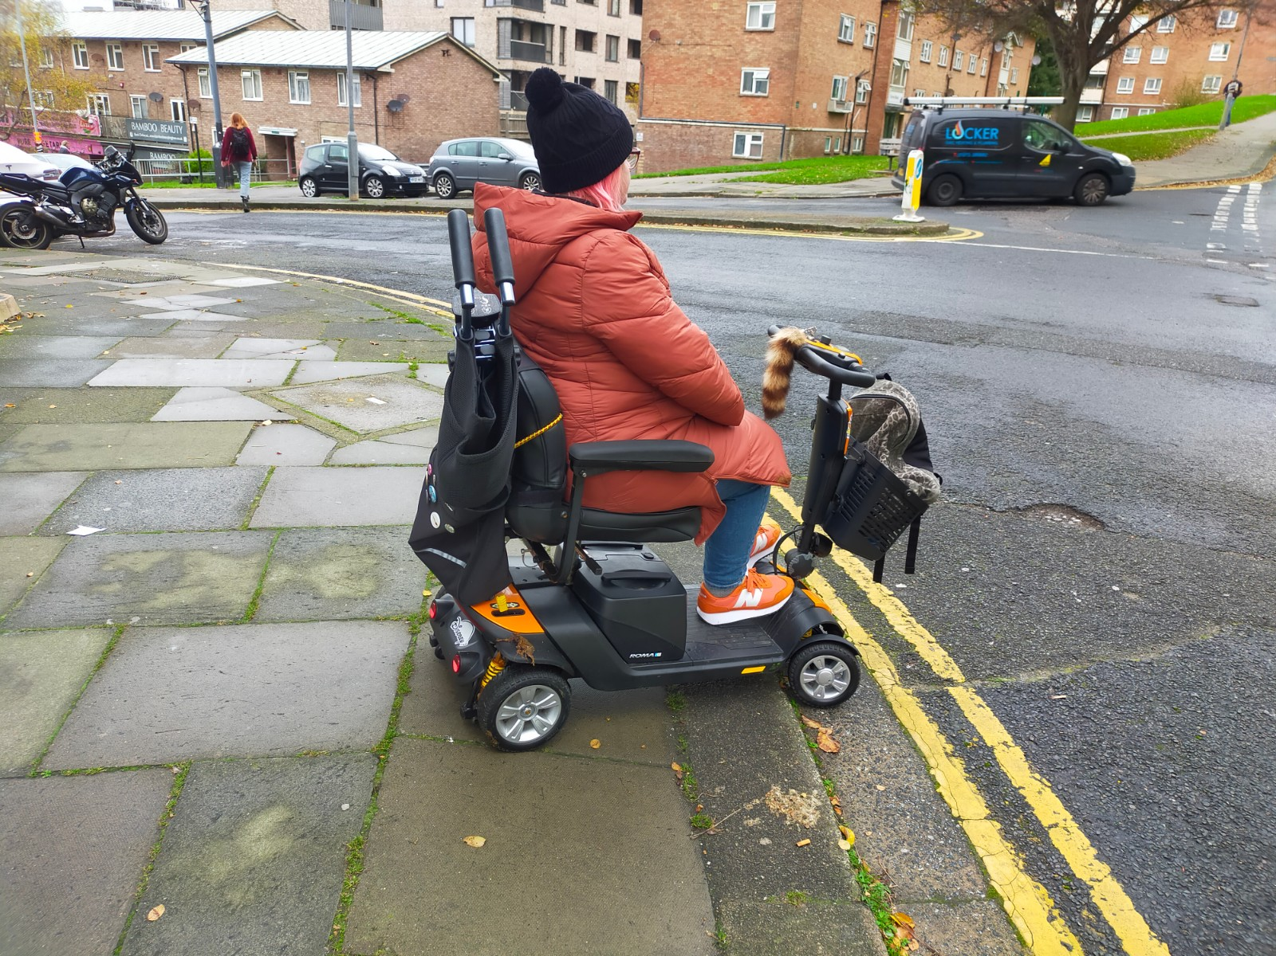
Figure 3Richmond parade crossing requiring Drop-Kerb improvement and tactile paving installation

Albion Hill
Only a small stretch of Albion Hill was included in the route, from the bottom of Grove Hill as far as Holland Street. However, Auditor Kate was unable to access Holland street in her mobility scooter as the gradient was just too steep, despite textured paving. Her only option was to be pushed up the middle of the road by Graeme and we accessed Holland street from the other end, via Southover street, which is much less steep. It may be worth looking into some signage which states that this hill is not suitable for powered mobility devices, if such a thing exists or is with precedent.
On the southernly side of Albion Hill, there is a BT inspection cover which has subsided and is now an immediate trip hazard. We would recommend contacting BT to remedy this immediately. See Fig. 4
On the corner of Albion Hill and John St, there is a bench in very poor repair, which we recommend replacing ASAP. There is also ample space for some additional seating here, which we would also recommend, given that this is one of the steepest inclines in the city, and a point at which many disabled people may require a rest break before continuing up the hill. See Fig. 5
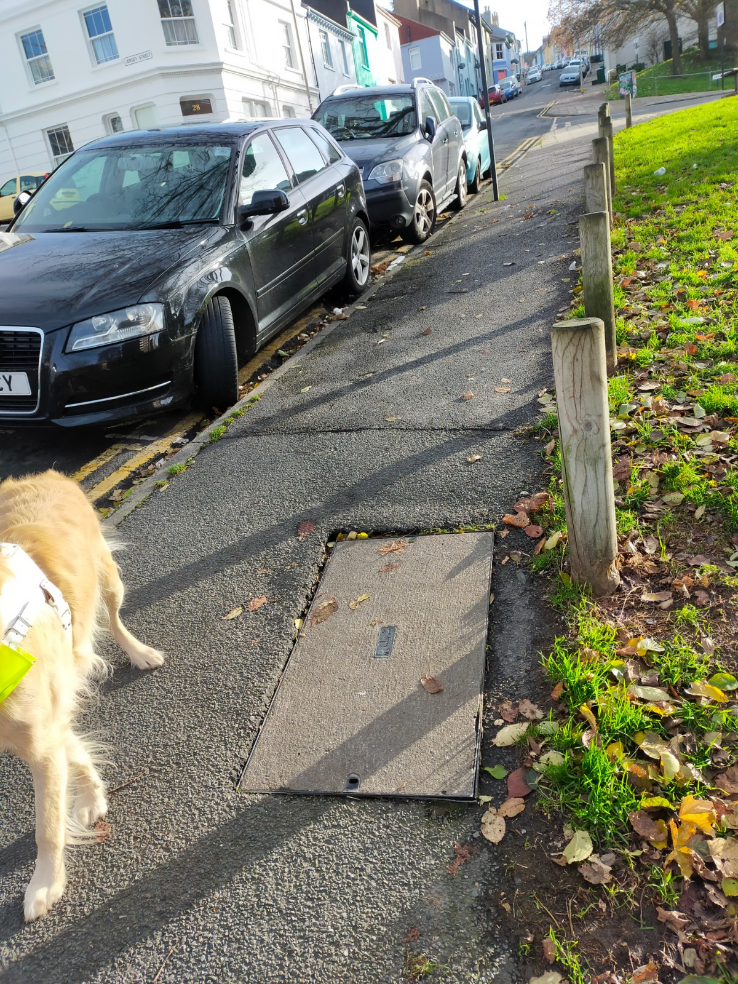
Figure 4
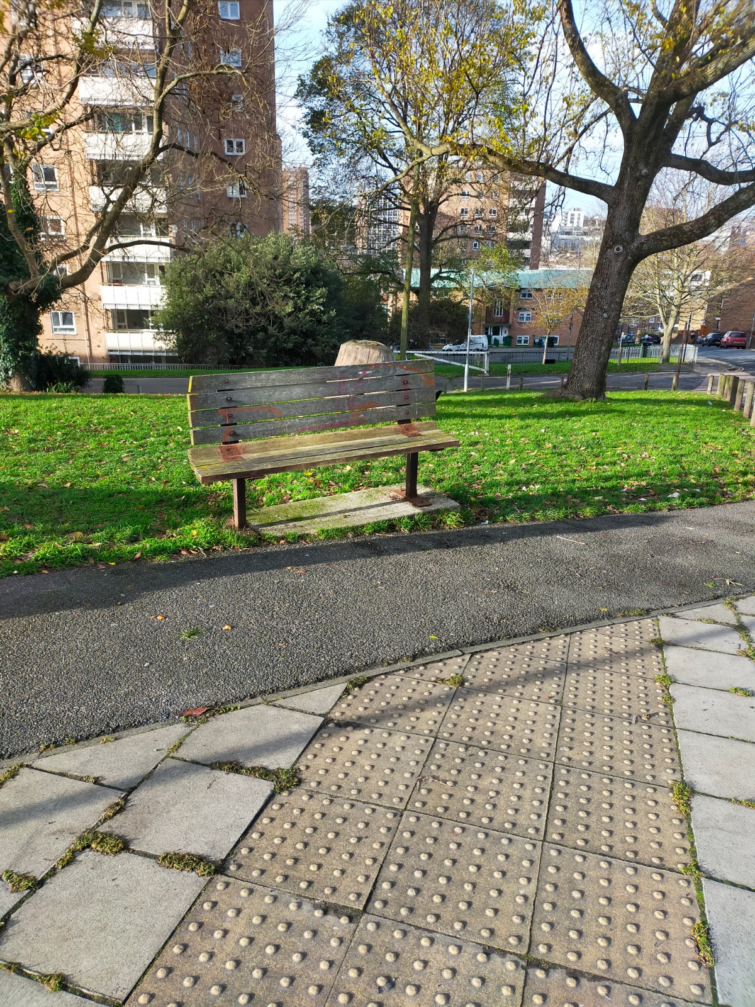
Figure 5

Grove Street/Holland Street
Grove street was not originally part of this route, but given that we needed to pass it to access Holland street, we did make some observations. In general, it is OK, and the clearance is fine, though the common problem of bins out on the street was a slight issue. This being a windy day, many of them had blown into the middle of the pavement and had to be removed before we could continue.
We also observed an unused signpost which we recommend removal of, as this is causing an unnecessary obstruction.
At the corner of Grove st and Southover St there is a BT public call box which didn’t appear to have a working phone inside. As these are more or less obsolete in current times, we recommend that BT are contacted to remove this ASAP to improve pavement width, clearance and accessibility.
Holland St was particularly difficult in terms of access, with lots of blockages caused by bins, refuse, outdoor plants, bicycles etc. This was not easy to traverse in mobility scooter at all. There was also some major deterioration of curbs and pathways, with lots of cracks, trip hazards and subsidence of paving stones. We recommend repair of these.
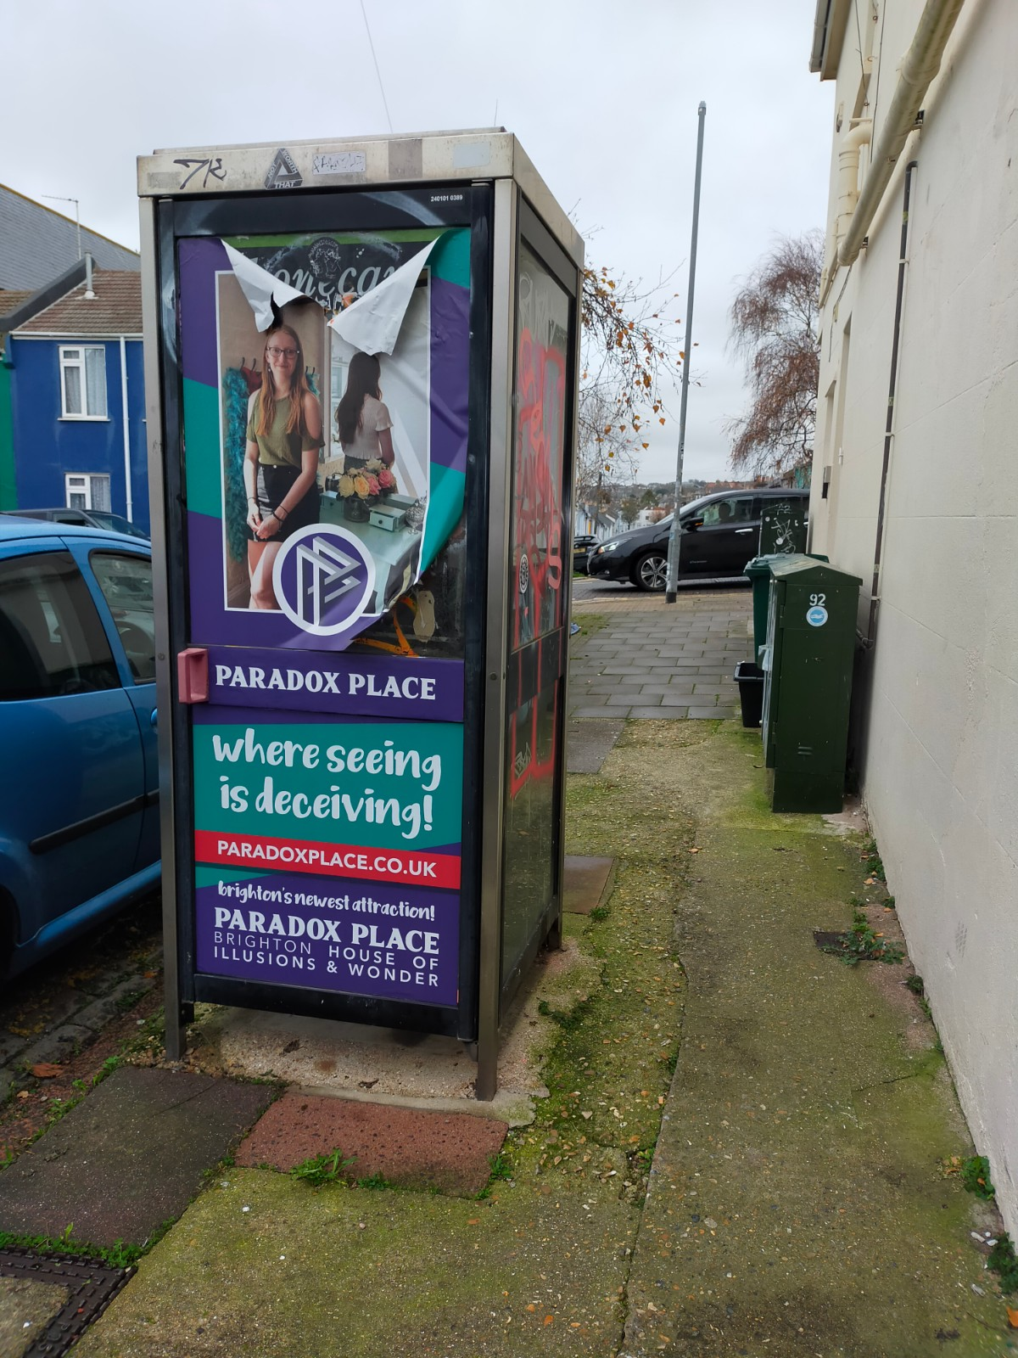
Figure 6 Phone Box on Holland Road in need of removal
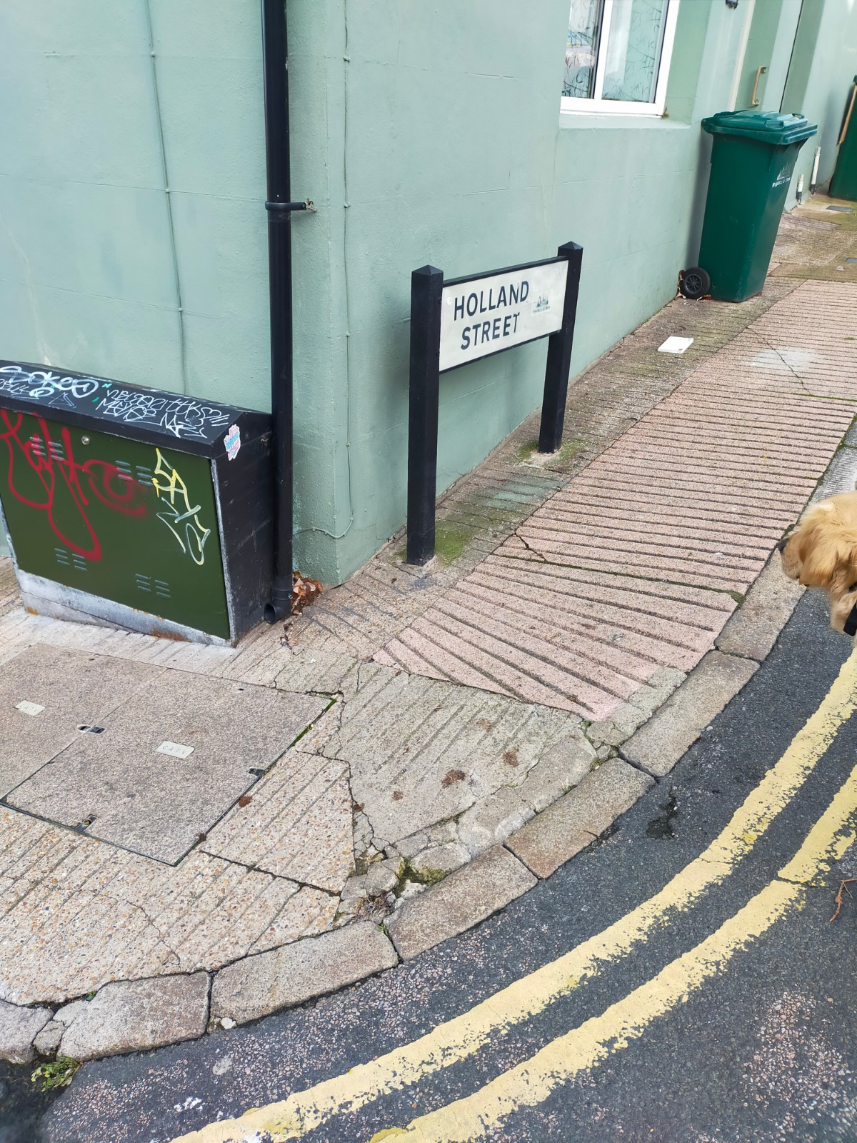
Figure 7 Example of pavement deterioration

Finsbury Road
On this street, there were a number of easily rectifiable issues identified. There is a bike rack which is bent out of shape and is not in a good position for wheelchair/scooter clearance.
There is also the remains of a bench which needs to be replaced. Furthermore, this seating area is mere feet away from a dog waste bin, which is perhaps not the best placement for it. We recommend repositioning this.
There is an arced driveway/layby to access the flats, but this does not have any kind of drop kerb and is quite inaccessible via wheelchair or scooter. We recommend installation of drop kerbs here.
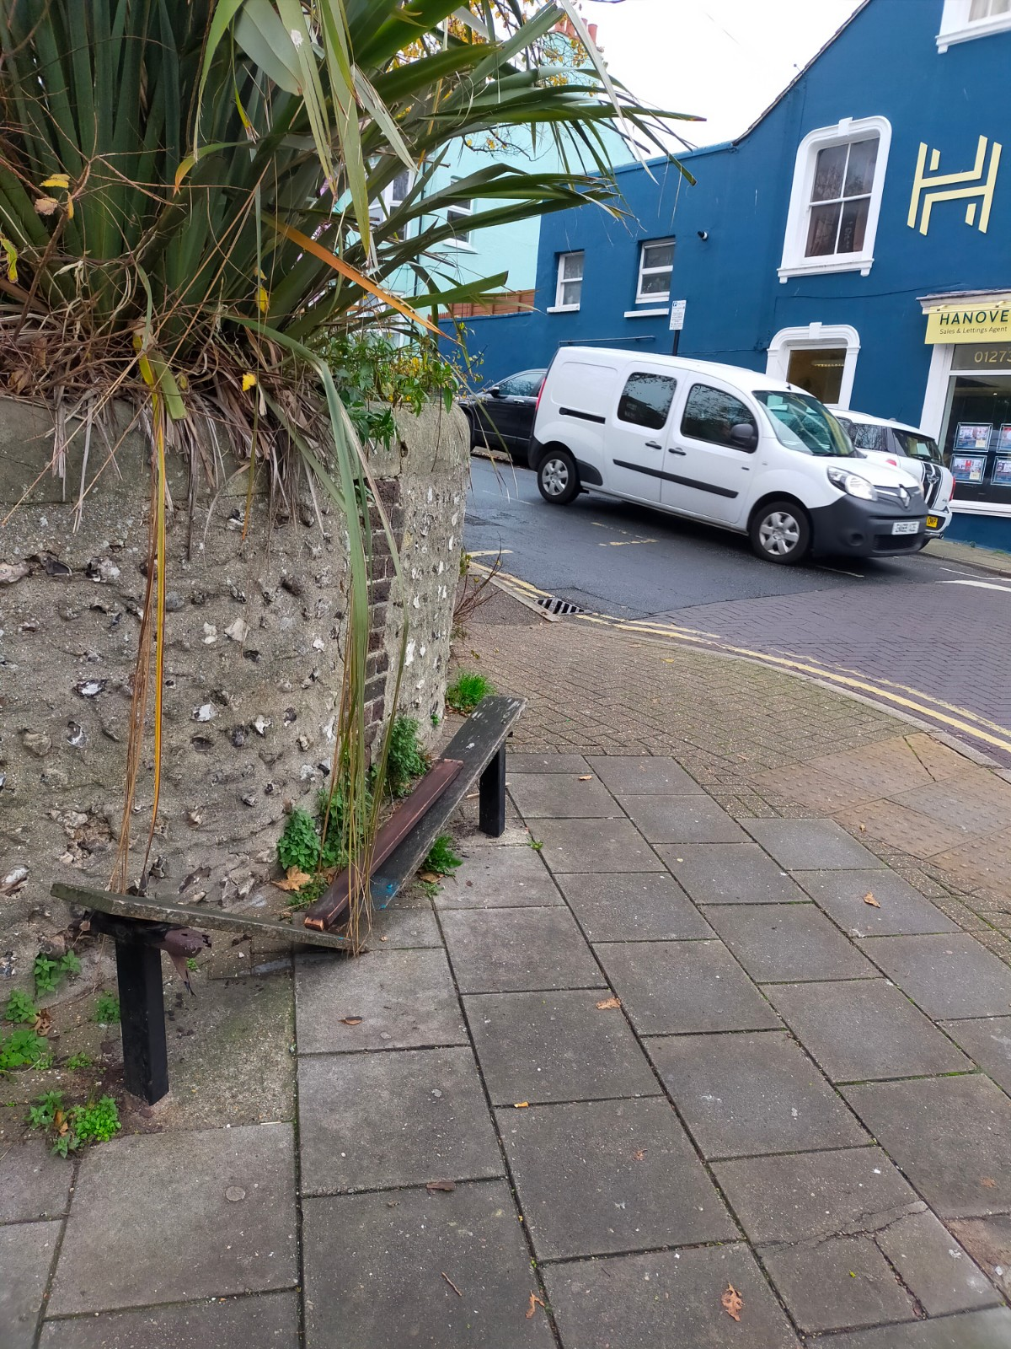
Figure 8 Remains of public bench in need of replacement

Islingword Road
This road was unequivocally the most hazardous area that we encountered during this audit, mainly due to very high kerbs with no dropped kerbs at all. Auditor Kate’s scooter got stuck trying to alight the pavement outside The Nest Nursery. She had to leave the scooter, whilst Graeme and a kind passer-by had to lift it off the kerb and on to the road. Kate was then faced with her only option being to travel down the road, which is not always an issue, but in this instance, it was the case. This section of road is quite narrow, with no room for two vehicles to pass in different directions, and Kate became ensnared in a situation where she was very close to being hit by two cars, which was very unsettling. To alleviate this issue, it may be worth looking at putting in a sign stating priority to one direction.
We recommend consistent placement of drop kerbs in this area.
There is also an opportunity to provide improved seating on this street. There is currently a platform for 2 benches which has only one in-situ, which is in a state of disrepair.
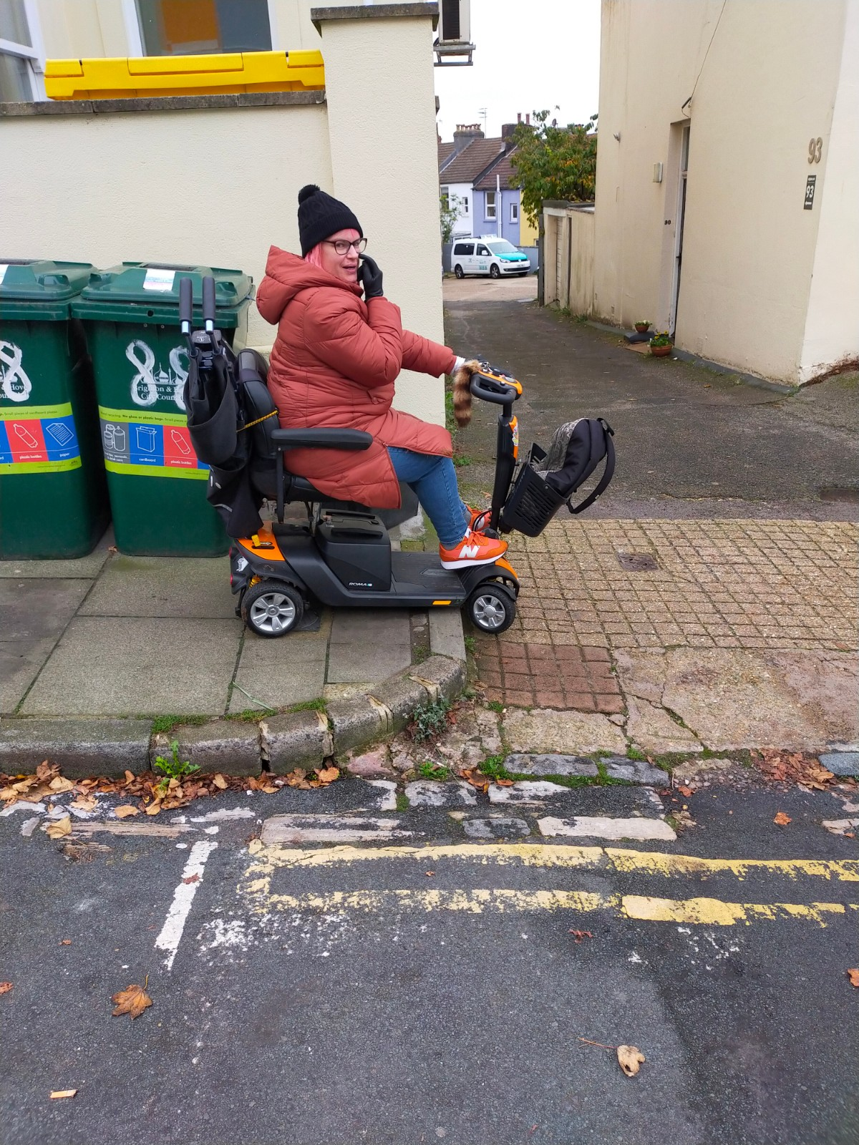
Figure 9 Auditor Kate unable to dismount kerb
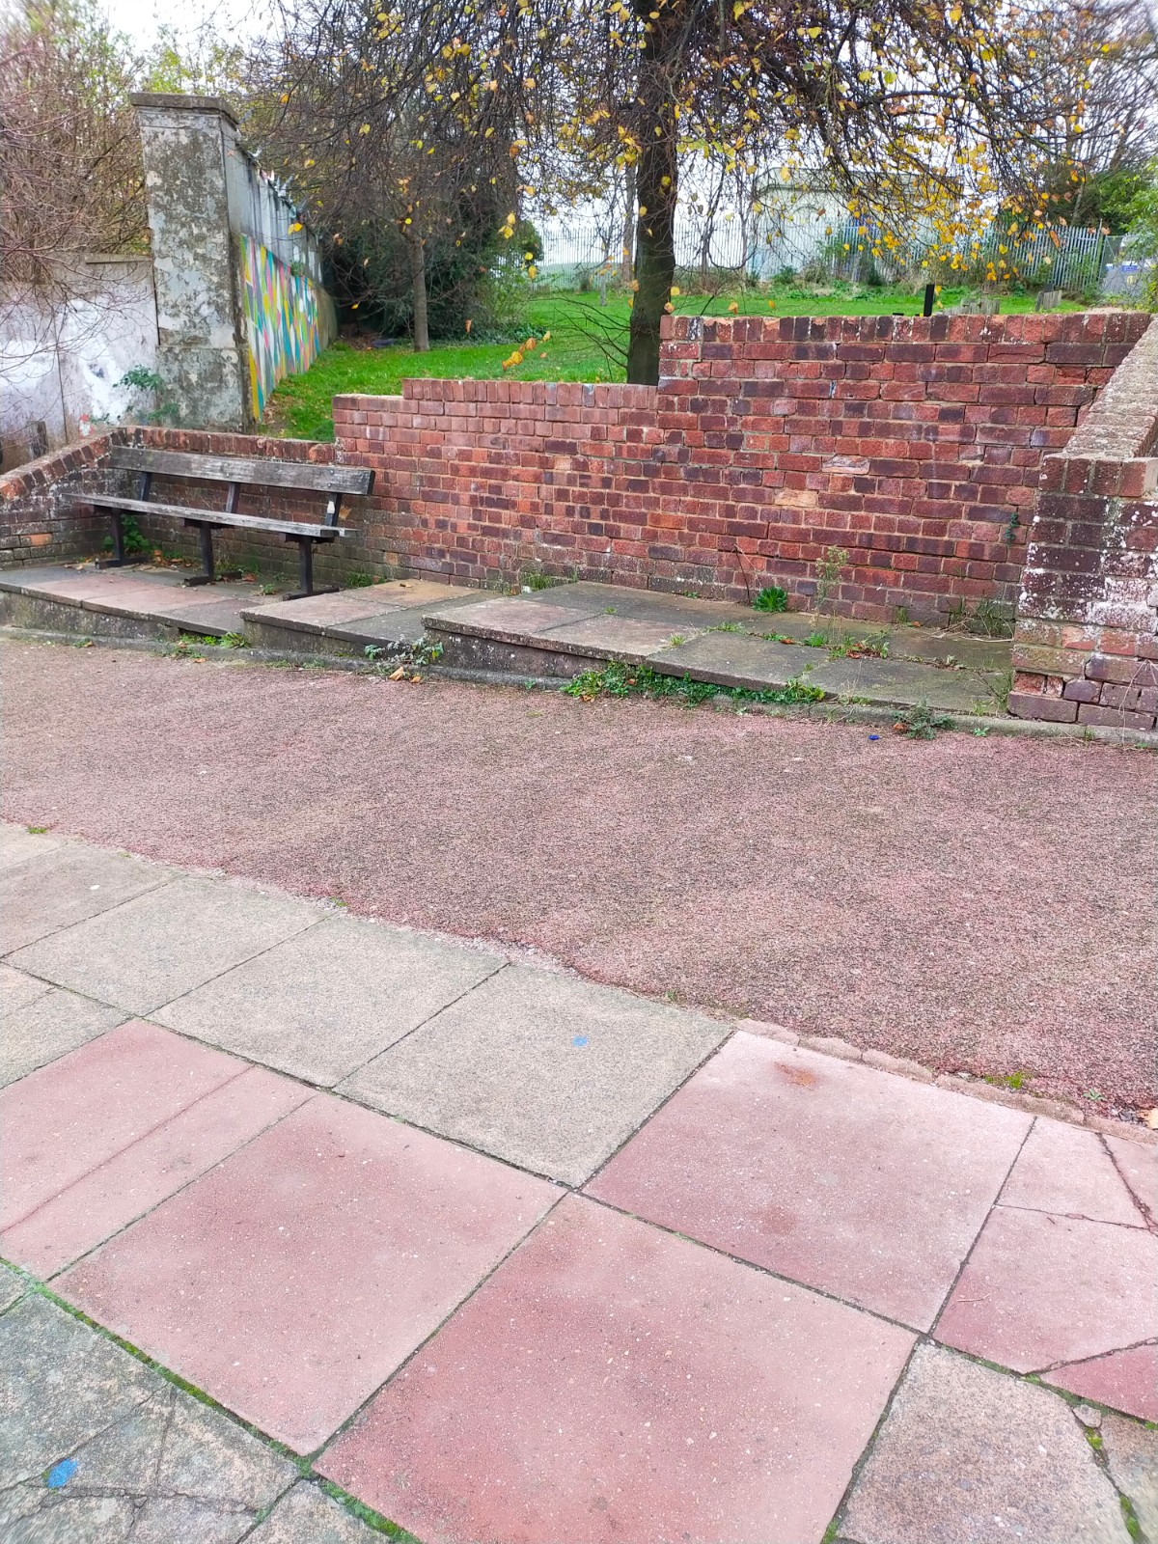
Figure 10 Site for additional and improved seating

Southampton Street
Generally this street was OK, but there were some sticking points caused by signage, bikes, bins, planters etc. which is a common issue in this whole area. This is difficult to recommend remedies for, but in general, some consistent communication with residents about causing obstructions would be welcomed.

Southover Street
One of the main issues identified on this road was the seemingly arbitrary and inconsistent placement of dropped kerbs and tactile paving. This is an issue on both sides of the road, and currently the safest way of a person with mobility issues or using a wheelchair or scooter to travel up or down this road is to continually cross the road, following the placement of where the drop kerbs are situated, which can be quite hazardous if there is traffic. We would recommend greater consistency of this on both sides of the road.
Outside of the community centre, the pathway is quite narrow, and there is a waste bin placed in the pathway. This can make passing quite difficult and greatly reduces clearance and we would recommend investigating an alternative site to resituate this.
On a positive note, we did observe that on the junction of Southover and Grove st, the pavements have been widened which makes clearance and crossing much easier and is a great addition to the area. We would recommend more of this wherever possible throughout the whole of the Hanover area.
We also observed some issues with the accessible parking bays, down from the community centre; namely that they are the older style shorter bays and are no longer regulation length. We also noted that adjacent to these bays, the removal of an old bay had not been completed and some of the signage remained, which could be confusing. However, these have been reported directly to Tony Patchett at Parking design and implementation, so no further action should be required.
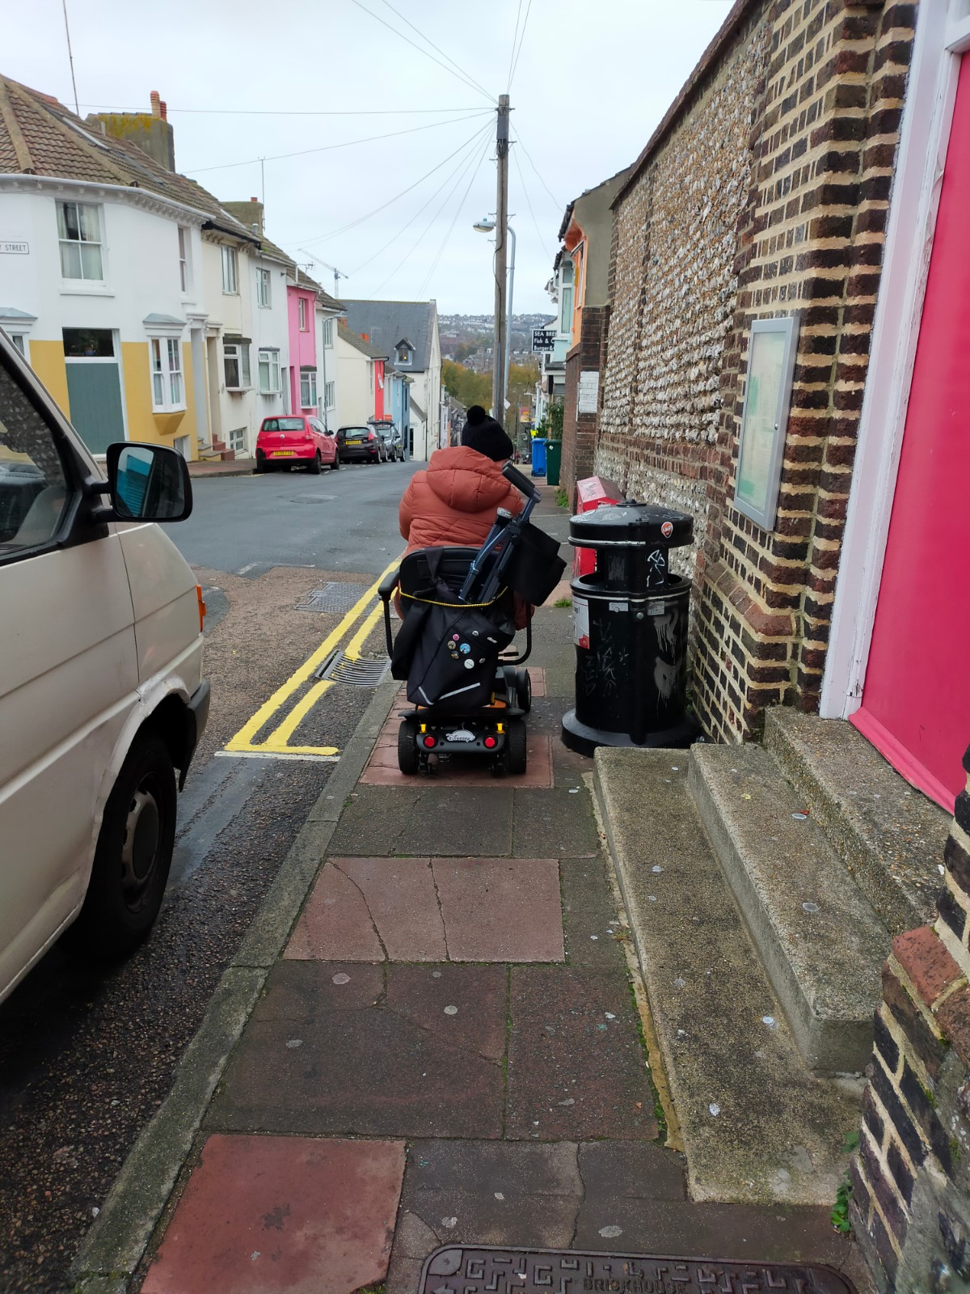
Figure 11 Bin placement causing partial obstruction on Southover Street
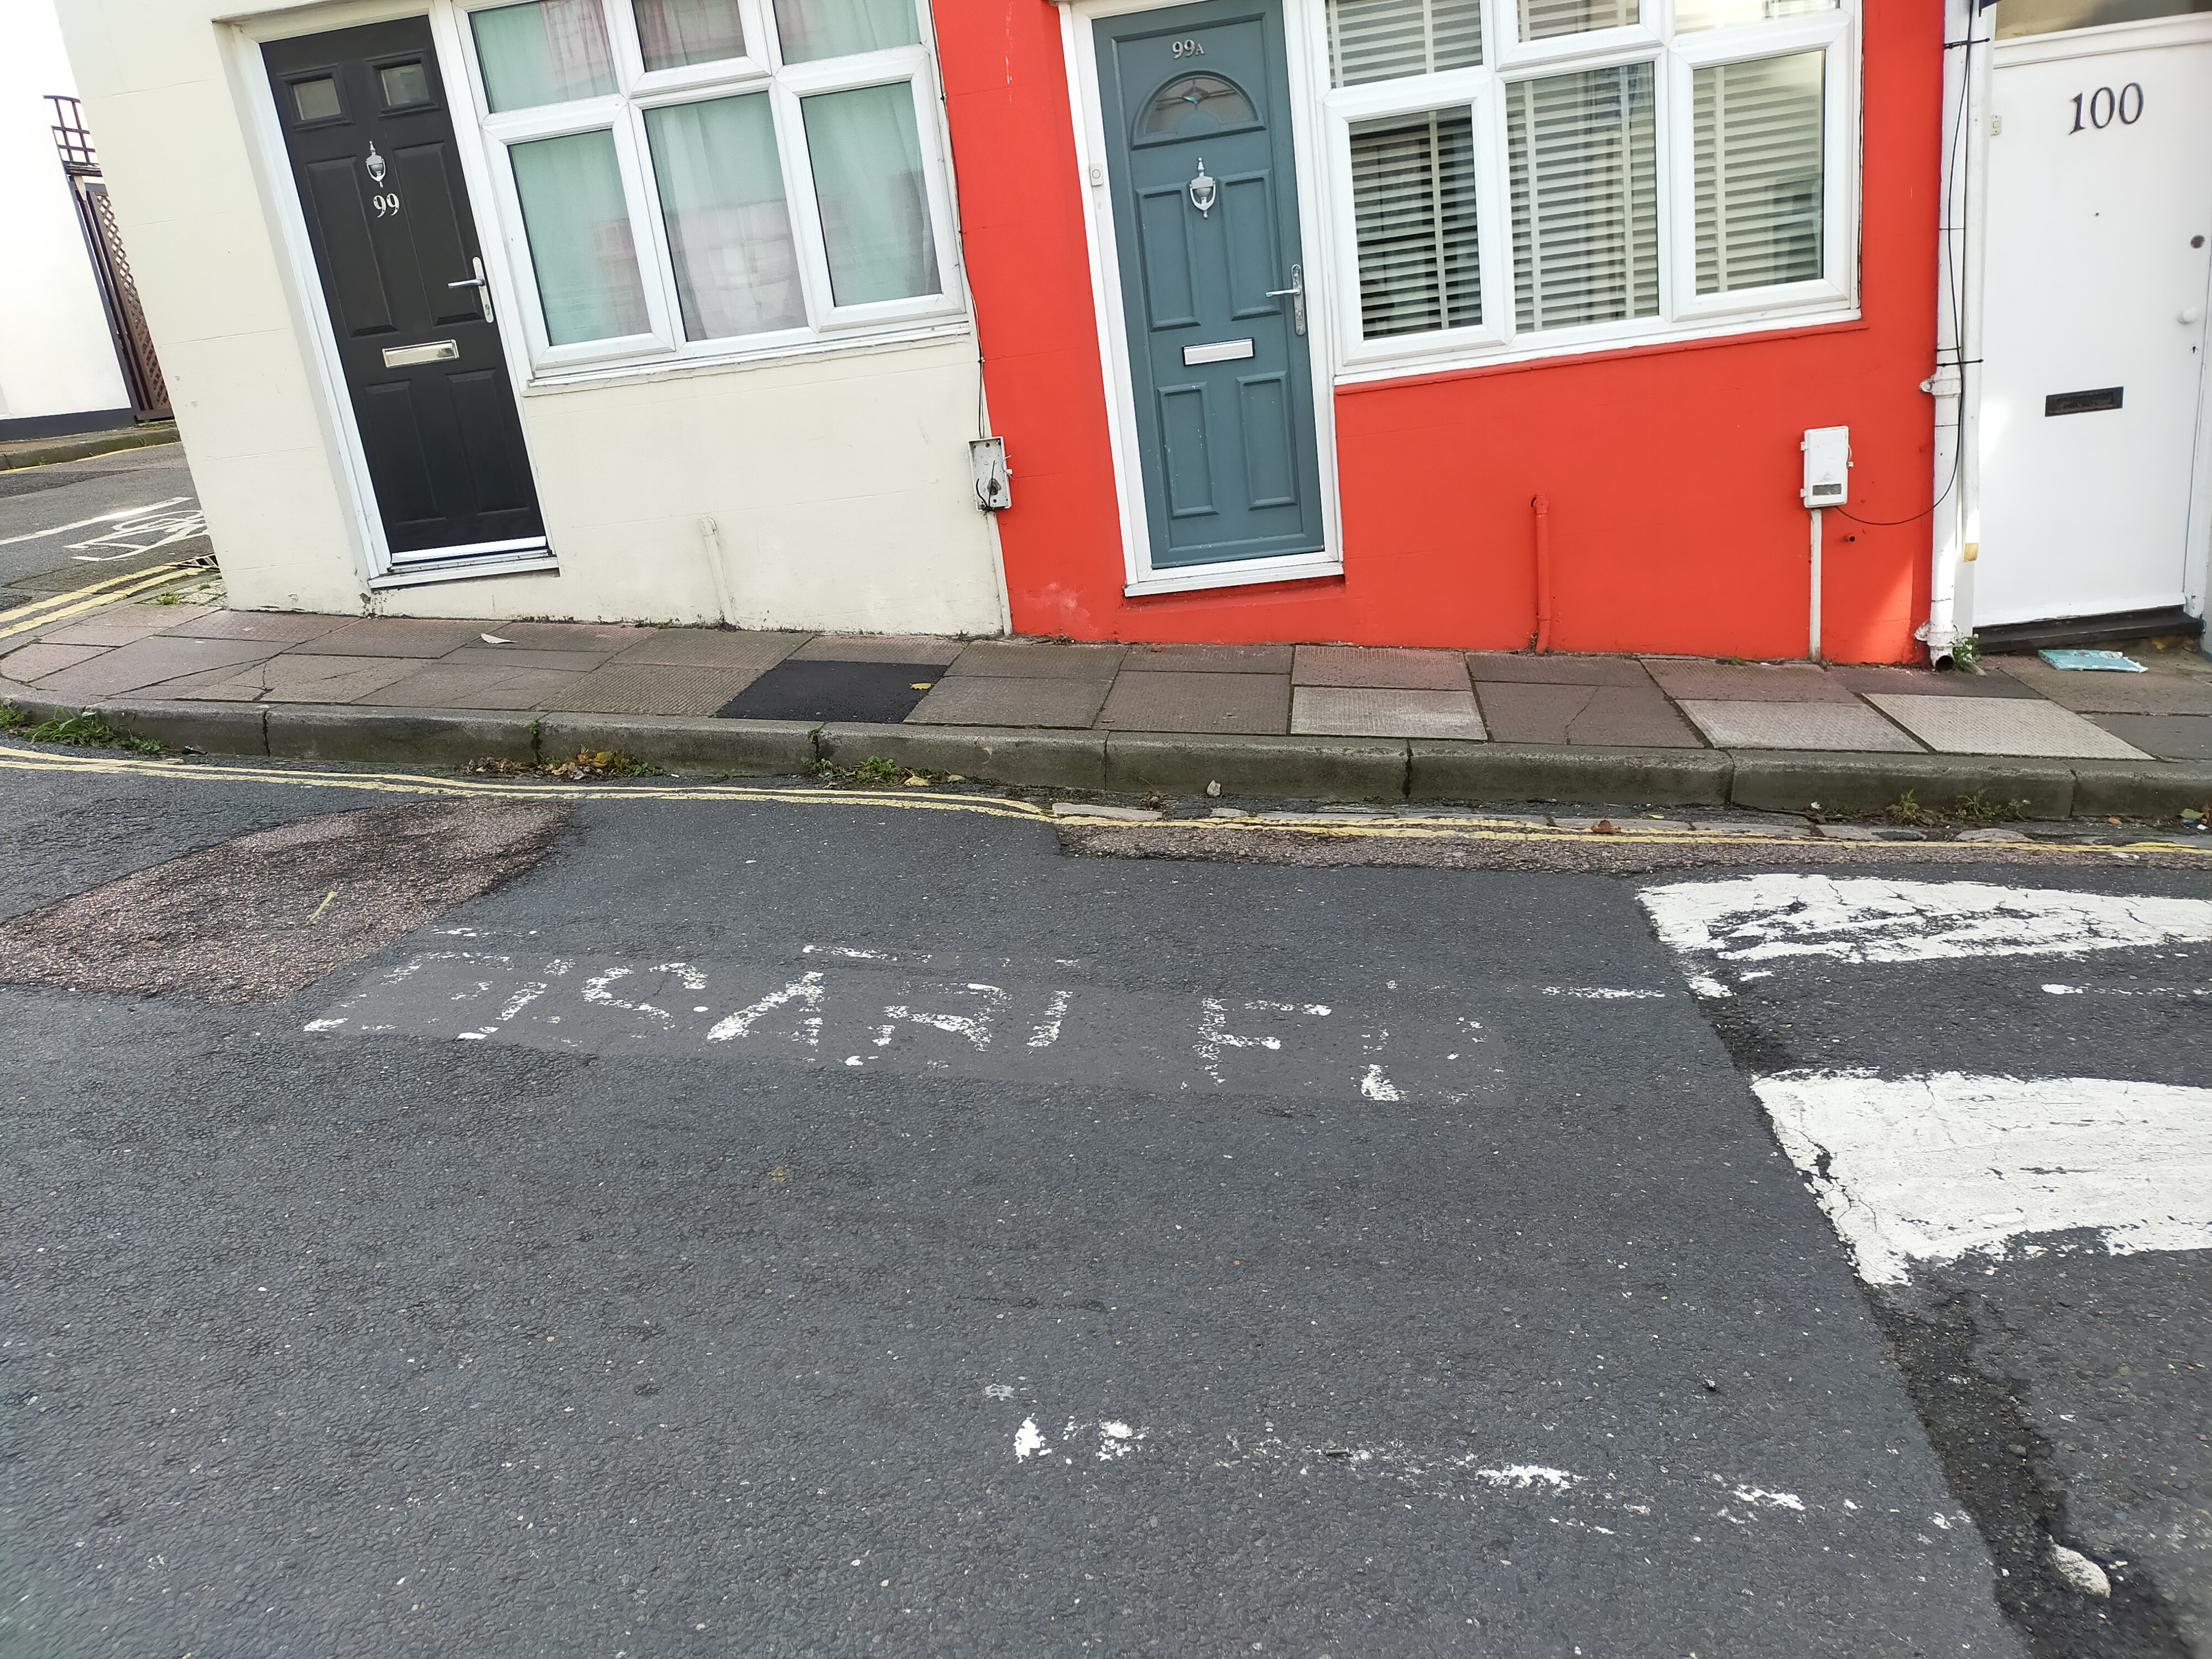
Figure 12 Remnants of former accessible parking bay

2.1 Additional Photo Examples
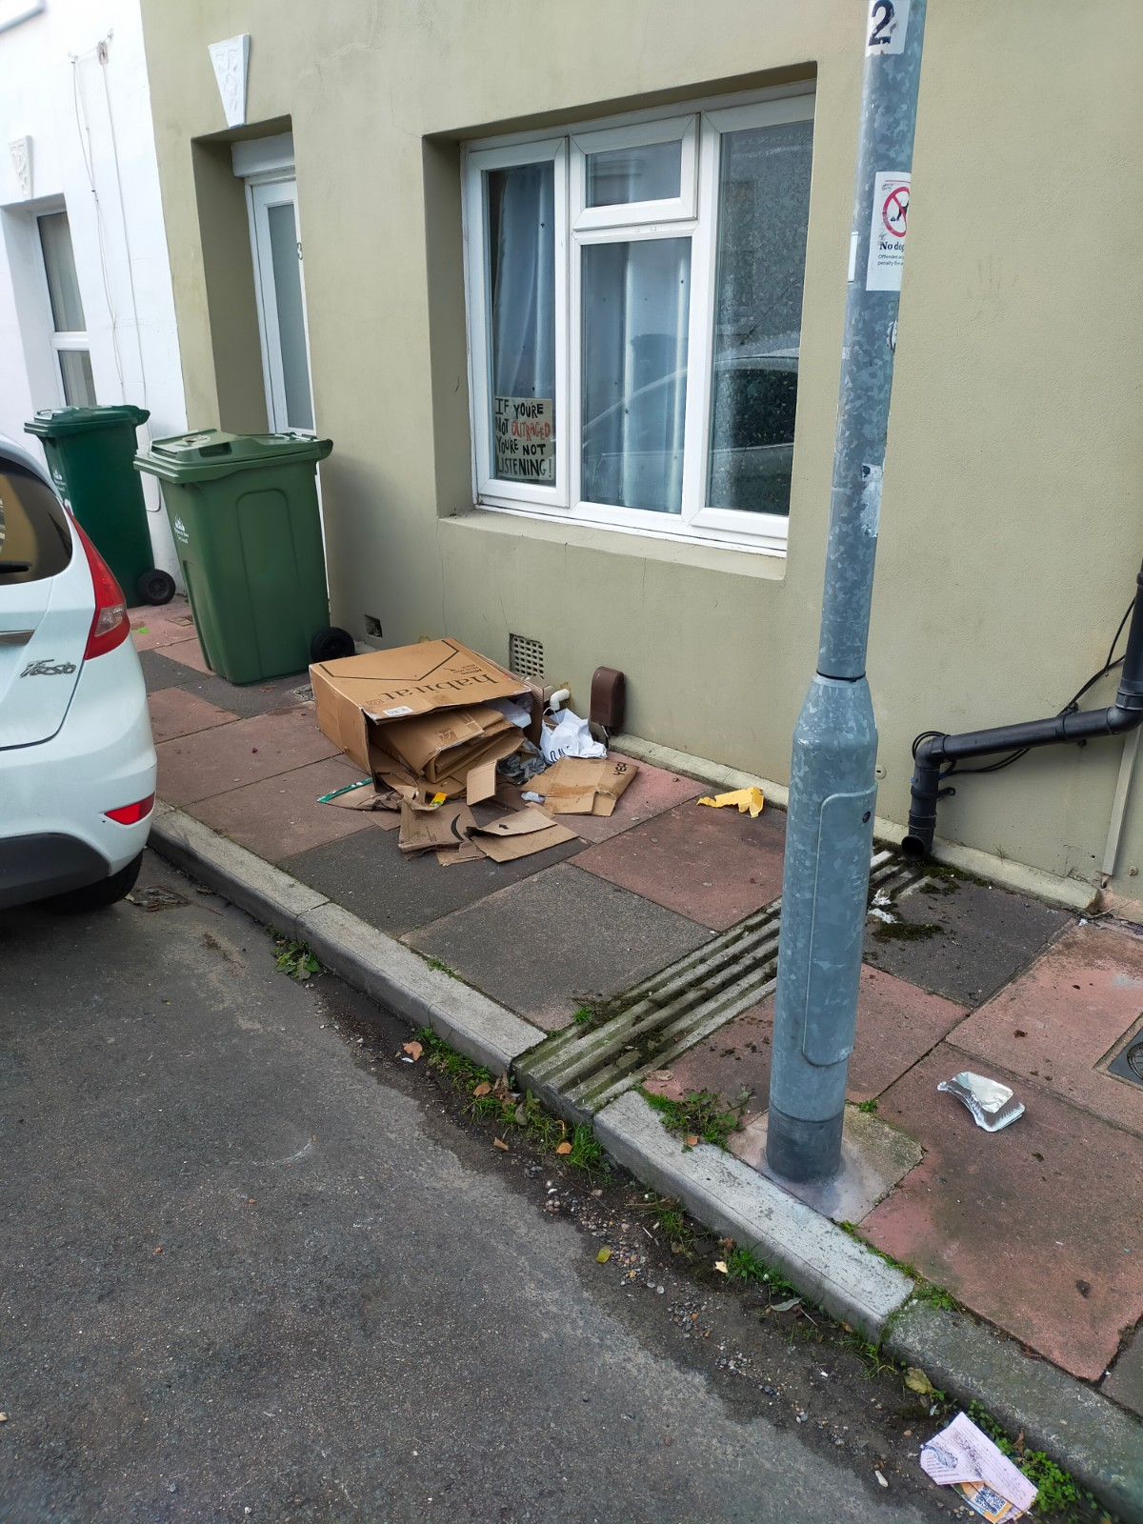
Figure 13 Obstruction caused by blown over refuse
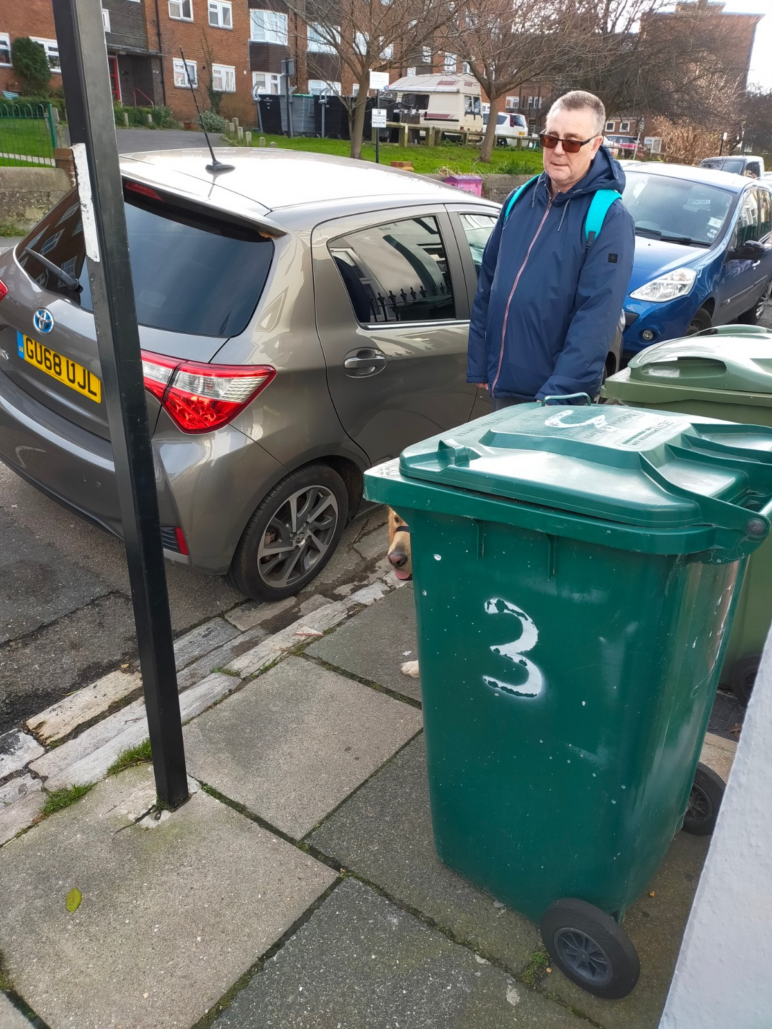
Figure 14 Lack of clearance due to bins on street
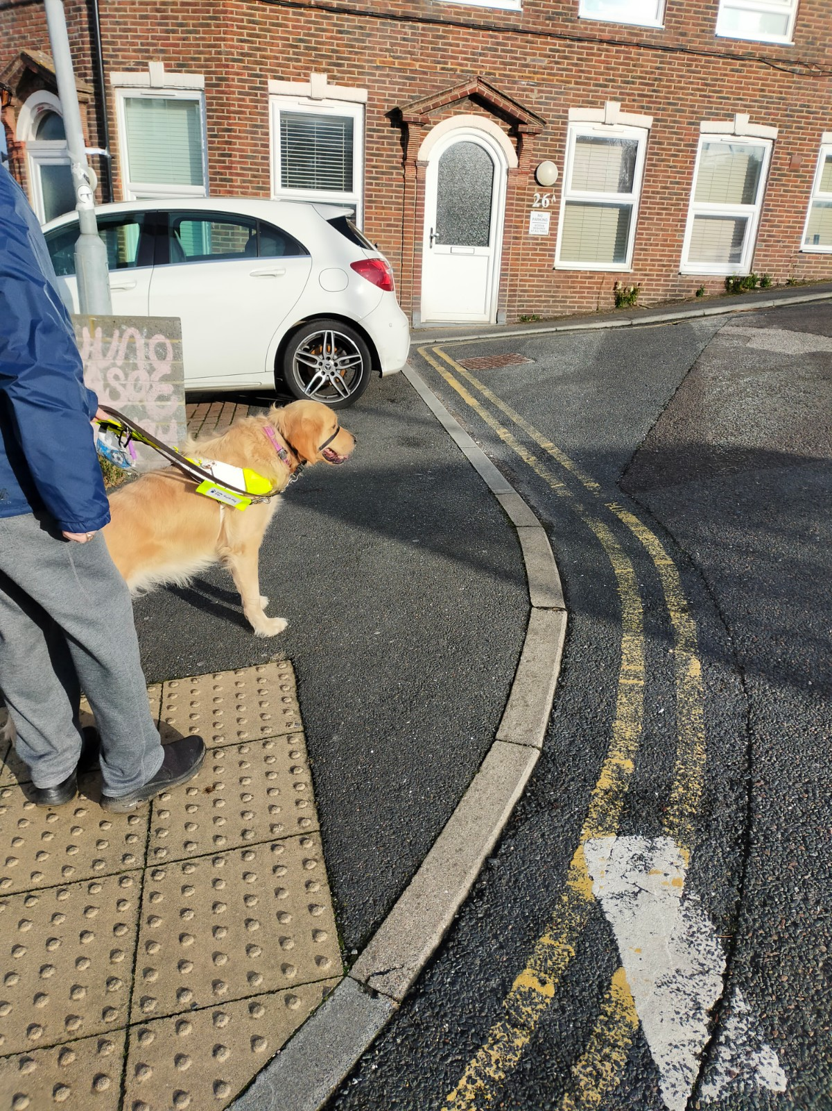
Figure 15 Car blocking walkway at bottom of Sussex Street
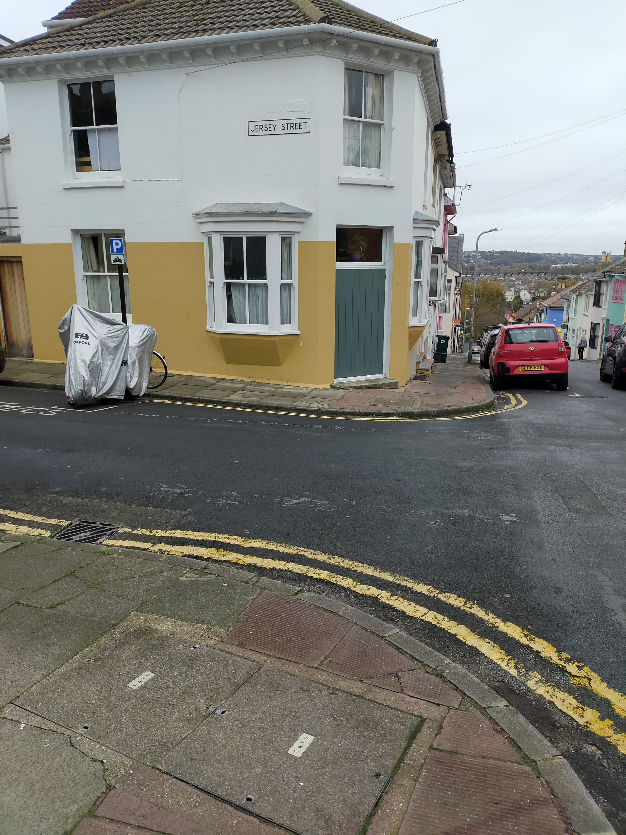
Figure 16 Lack of drop kerb
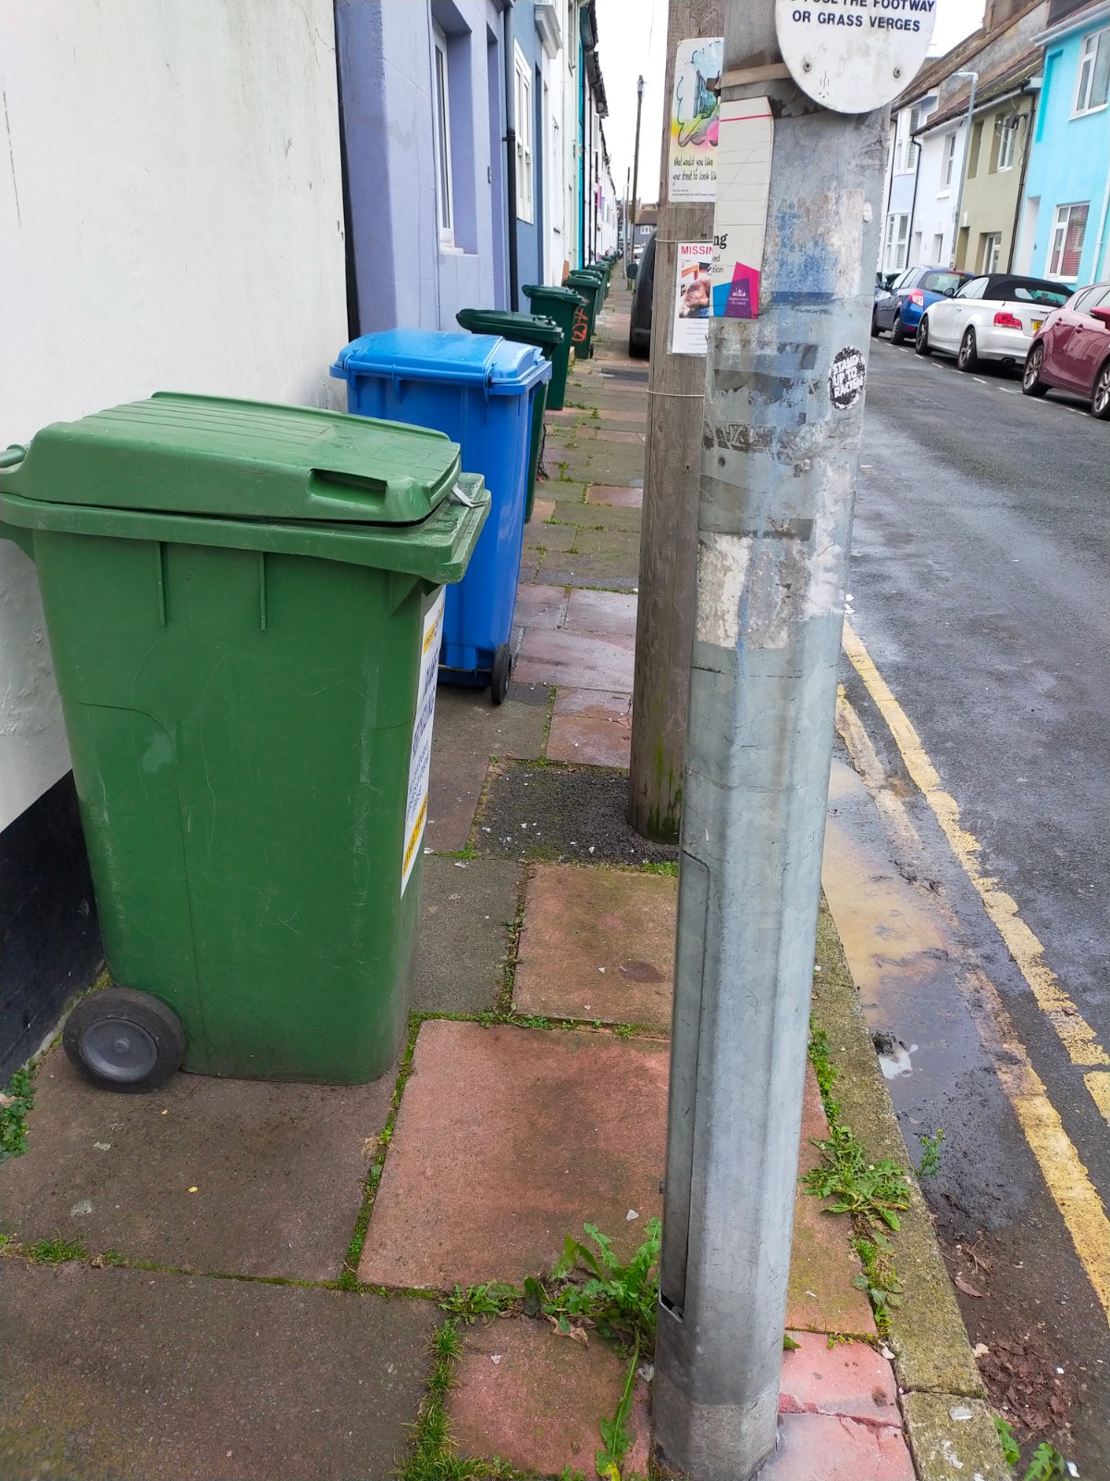
Figure 17 further obstruction due to bins
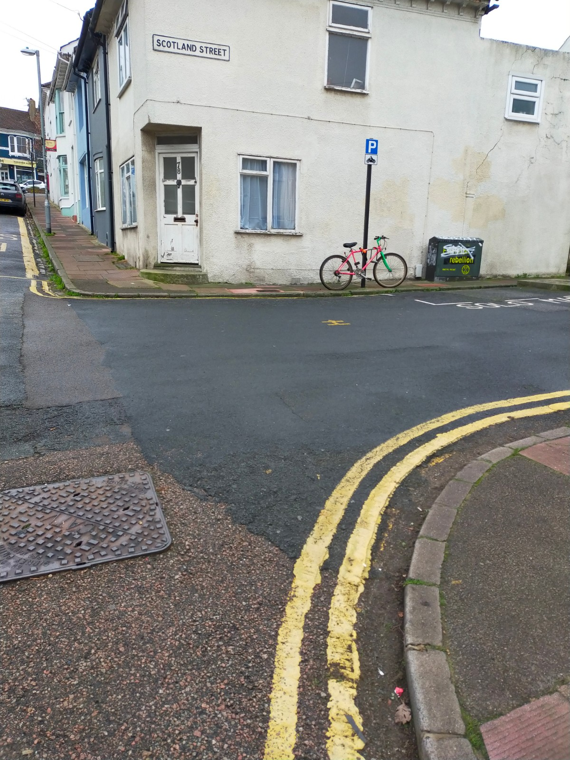
Figure 18 Lack of drop kerb
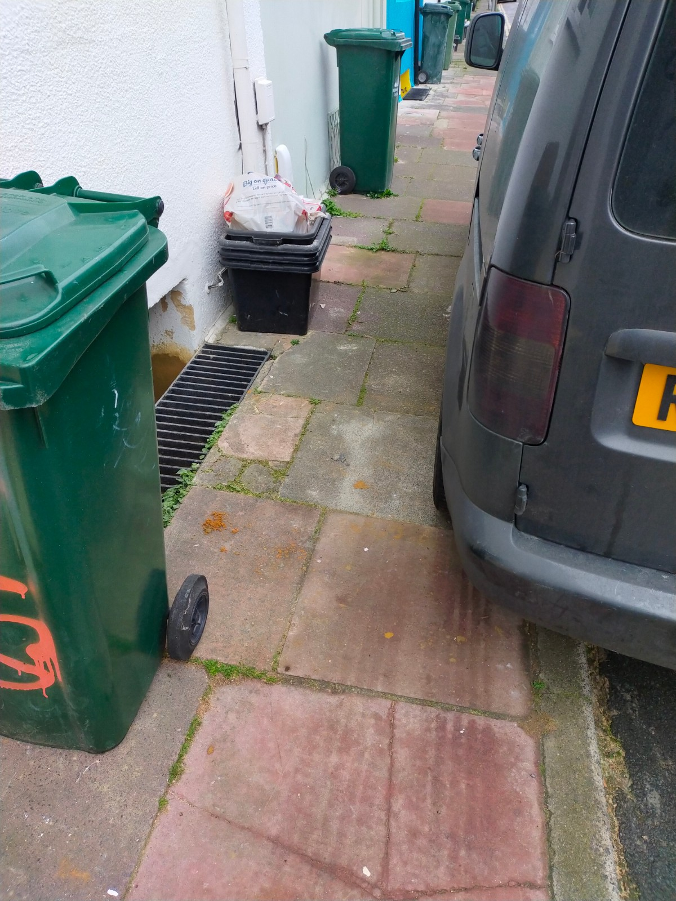
Figure 19 lack of clearance due to bins and improperly parked vehicle
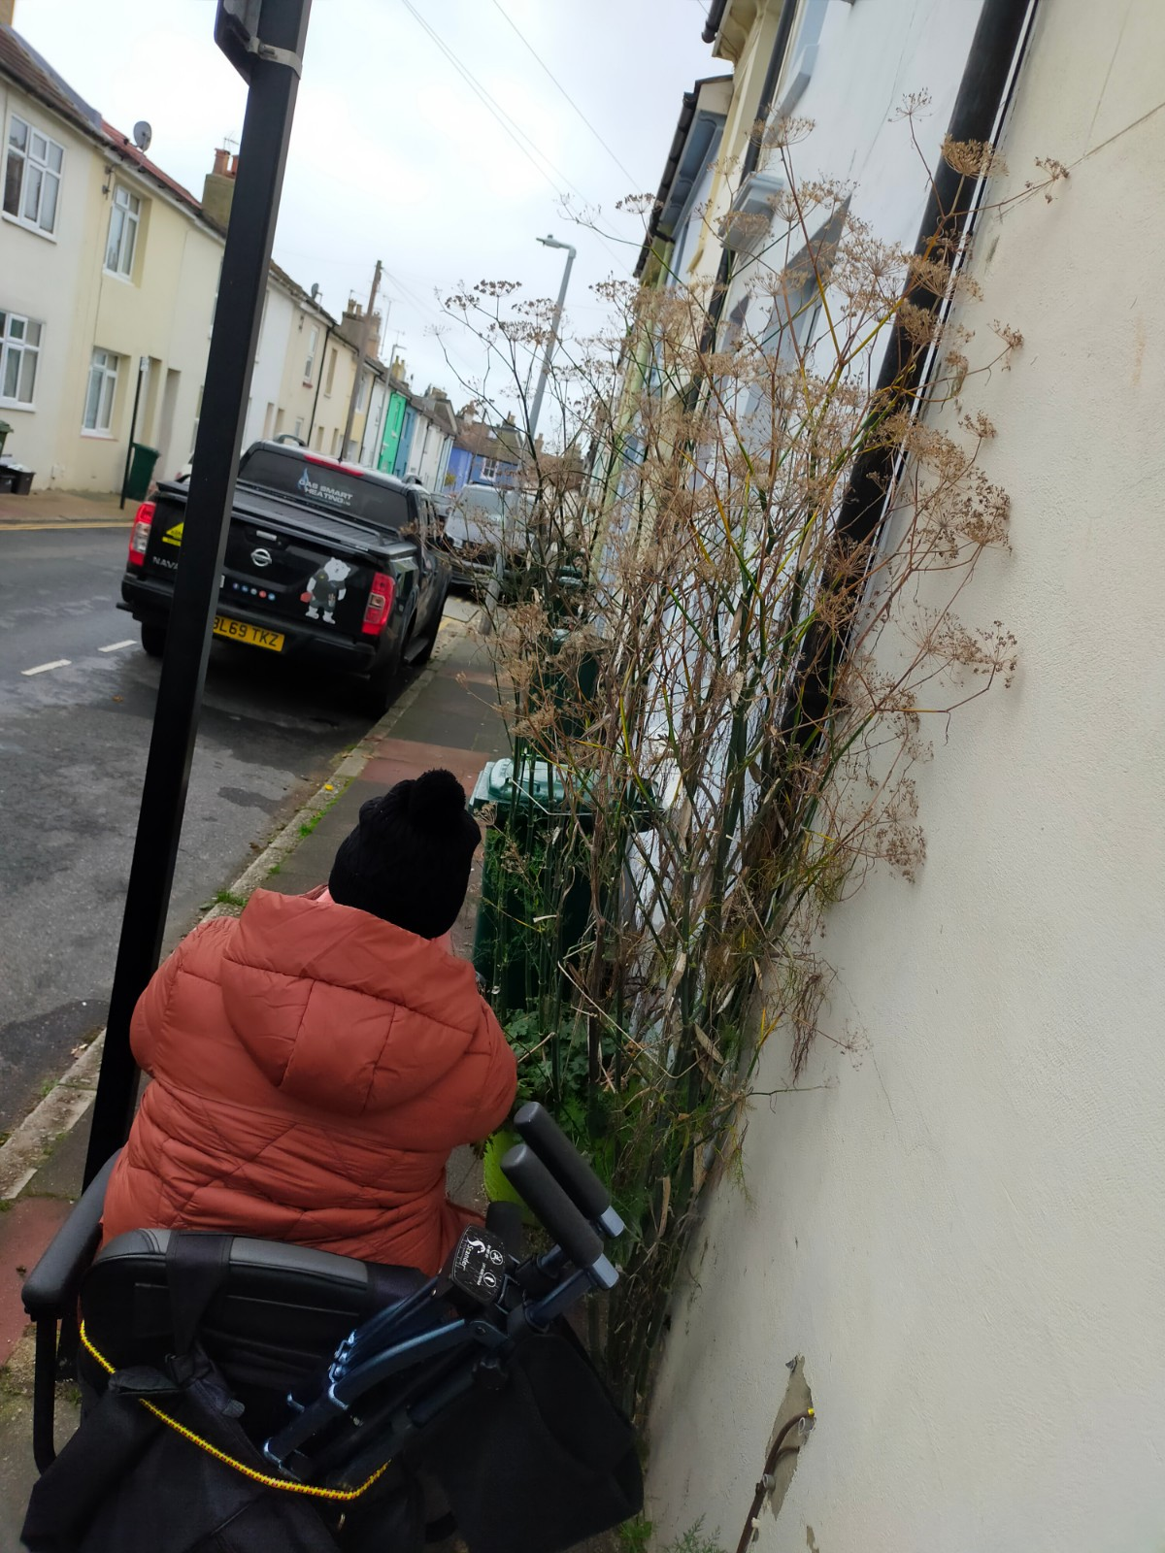
Figure 20 Lack of clearance due to bins, excess foliage and poorly placed signage

2.2 Observations from BADGE and DCUAG members on accessible parking
The Get Involved Group currently chairs and organises the Brighton & Hove Disabled Car Users Advisory Group, a forum which meets approximately every six weeks to discuss issues around driving and parking in the city, and comprises of staff and representatives from several departments within the council, including Parking Control, Blue Badge and concessionary travel, parking design and implementation as well as a wide range of disabled people, their families carers or representatives. As part of one of our recent meetings, we discussed the Hanover project and asked for feedback to include in this report.
The following is a digest of our discussion, as compiled and recorded by Pippa Hodge from the group BADGE:
“It was generally felt that it would be helpful for accessible parking bays to be included in the plans as they are drawn up for ongoing consultation, to ensure that any potential conflicts with proposed changes (or additions) can be spotted and remediated.
If parking within the scheme is to be reduced then this could reduce access for disabled people who rely on the Blue Badge and its “park as close to destination as possible” objective. Existing bays have been organised by residents and if there are reduced parking options this could put pressure on resident bays and create difficulty for those residents who need their vehicle to be right outside their home to aid mobility and access to/from home.
Additional accessible parking bays could be considered, especially around any amenities (shops, cafes, pubs etc).
Additional clarity over parking principles would be needed in order to assess whether the schemes would advantage/disadvantage disabled Blue Badge users. For example, if parking was ONLY permitted in accessible bays - and they were deemed to be inadequate without a significant loss of nearby pay & display options, then this could be considered (and challenged) as a disproportionately negative impact under Equalities Act 2010. “

3.0 Summary List of recommendations
- Explore opportunities to widen pathways on John Street (Stretch from junction of Kingswood St to top of Ashton Rise.
- Install improved drop kerbs and tactile paving at crossing to the top of Richmond Parade
- Albion Hill – Explore options for signage stating the gradient is not suitable for self propelled wheelchairs or mobility scooters etc.
- Improve seating on corner of John Street
- Contact BT ASAP for repair of inspection cover which has subsided
- Removal of unused signposts and phone boxes
- Repair and upgrading/installation of drop kerbs and uneven surfaces throughout whole area
- Greater consistency of drop kerbs, with particular emphasis on the Islingword Road area
- Repair/replace install seating in areas where this is broken, in poor repair or doesn’t currently exist
- Remove Dog Waste Bin and reposition to a site away from public seating
- Remove Broken Bicycle rack on Finsbury Road
- Reposition waste bin on Southover Street, or replace with a type that causes less obstruction of pathway
- Consider options for widening pathways on crossings, using the example of the junction of Southover and Grove st
- Explore options for reducing impact of bins/recycling vessels, loose refuse and planters/foliage outside houses as it applies to accessibility and clearance.

4.0 Summary, Acknowledgements and Closing Comments
In summary, the findings of this audit are consistent with typical findings of an audit such as this, and include improved surfaces, better signage, improved drop kerbs and tactile paving, better seating and mitigation against pavement obstructions.
In particular, our most significant finding was to improve the consistency of pavement access/crossing on both Islingword Road and Southover Street, where this tends to be both sporadic and lacking in uniformity. They are most inaccessible to disabled people in their current state.
We would like to thank the Oliver Spratley and team for their support and clear communication in embarking upon this work, Pippa Hodge and Rob Arbery from BADGE and the members of our DCUAG for giving excellent feedback on issues pertaining to these works.
Thanks also to our Auditors, Graham Oulton and Guide Dog Teddy, Kate Annetts, and all involved with making sure that this work gives disabled people a true voice and sense of ownership of the city in which they work and live.
Graeme Trelford-Davies
February 2022.

