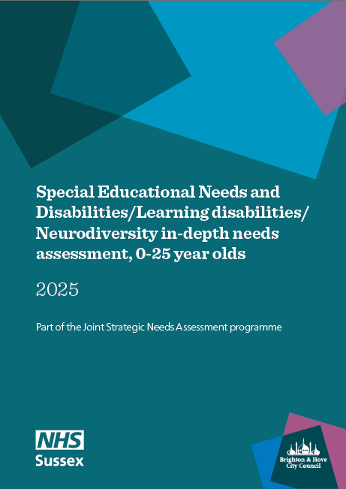

Contents
1. Summary 3
2. Acknowledgments 3
3. Background 3
4. About this needs assessment 4
5. National and local context (Policy & guidance) 11
6. Programmes and service provision 24
7. National prevalence 30
8. The level of need in Brighton & Hove 34
9. National evidence reviews on intersectionality 71
10. Parent and carer voice 78
11. Summary of findings 83
12. Recommendations 91
13. Glossary 92
References 95

Executive Summary
See accompanying Executive Summary

Acknowledgments
We would like to thank the Steering Group (SEND AP Partnership board) for advising on and guiding this needs assessment. The needs assessment was produced by a Working Group (bold below) and Project Group including:
Project Group
Name | Role | Organisation
Georgina Clarke-Green (Chair) | Director of Education and Learning (Chair) | Brighton & Hove City Council
Carolyn Bristow | Service Manager - Policy | Brighton & Hove City Council
Bernadette Alves | Lead Consultant in Public Health | Brighton & Hove City Council
Caroline Tozzi | Joint Director for Children and Young People | NHS Sussex
Nicole Nair | Head of Health, Wellbeing, Partnerships & Integration – Brighton and Hove | NHS Sussex
Tanya Brown-Griffith | Director for Joint Commissioning and Integrated Community Teams | NHS Sussex
Ros Cook | Head of Services | Amaze
Becky Robinson | Co-Chair | Parent and Carers Council
Sally Polanski | Chief Executive | Amaze
Jacqui Parfitt | Head of Commissioning | Brighton & Hove City Council
Ratna Sundrum | Consultant Paediatrician- Designated Medical Officer | Sussex Community NHS Trust
Deborah Wilson | Deputy head of children’s commissioning | NHS Sussex
Fiona Streeter | Associate Director Commissioning and Partnerships | NHS Sussex
Toby Silverman | SEND Improvement Manager | NHS Sussex
Francesca Marcelline | Public Health and Commissioning Knowledge Specialist | Sussex Health Knowledge and Libraries, NHS University Hospitals Sussex
Sarah Colombo | Programme Manager for Starting Well | Brighton & Hove City Council
Sinead Odwyer | Public Health Registrar | Brighton & Hove City Council
Kate Gilchrist | Head of Public Health Intelligence and Research | Brighton & Hove City Council
Muna Mohamed | Public Health Specialist – JSNA Lead/Manager | Brighton & Hove City Council
Grace Odiai | Public Health Information Analyst | Brighton & Hove City Council
Louise Knight | Senior Public Health Intelligence and Research Specialist | Brighton & Hove City Council
Ryan Weedon | Community Safety & Public Health Information Analyst | Brighton & Hove City Council
Clare Langford | Business Support Officer | Brighton & Hove City Council
Andy Close | Public Health Office Manager | Brighton & Hove City Council
In addition, we would like to thank all of those who provided evidence for and gave feedback on the needs assessment.
Children, young people and parent carer acknowledgement: We would like to thank the primary and secondary school children who completed the Safe and Well at School Survey 2023, and the young residents aged 18 to 24 who completed the Health Counts survey 2024 – without your participation we would not have this vital information on the health and wellbeing of children and young people across the city. We also would like to thank the parents and carers whose feedback, captured by our CVS partners, provided valuable perspectives that informed the needs assessment recommendations.

Background
Improving support for children and young people with special educational needs and disabilities (SEND), learning disabilities and neurodivergent conditions is a priority for the city. This includes children and young people who have an Education, Health and Care Plan or receive SEN support or both.
Over the last decade, the number of children and young people with SEND has risen both nationally and locally. In England, 18% of pupils had SEND in 2023/24, up from 14% in 2015/16. Numbers of children diagnosed with neurodivergence, in particular autism and attention deficit hyperactivity disorder (ADHD), has increased significantly, with over a 10-fold increase over recent years. Waiting lists for assessment and for support for children and young people with these conditions are growing.
Children and young people with special educational needs, neurodivergence and/or learning disability often experience poorer outcomes in education, care and health. They have lower levels of wellbeing, have higher rates of school absence and are more likely not to be education, employment or training from the ages of 16. Caring for a child with Special Educational Needs (SEN) or disabilities can have a significant impact on parents and carers including financial difficulties, lower physical and mental health and social isolation. There is evidence of widening inequalities in access to support and outcomes between children and young people with SEN or disabilities and those without.
Support for children and young people with SEN or disabilities is provided by a range of partners across the system including health, education, social care and Voluntary, Community and Social Enterprise (VCSE) organisations. Statutory guidance sets out the duties, policies and procedures for many of the bodies that provide support. There is a requirement that local authorities work with partner bodies across education, health and social care to make joint commissioning arrangements for the provision of services for children and young people with SEN and disabilities up to 25 years.
A joint comprehensive assessment of local needs such as a Joint Strategic Needs Assessment (JSNA) can support the system to deliver better outcomes. JSNAs, a statutory responsibility of Health and Wellbeing Boards, aim to improve health and wellbeing and reduce inequalities through developing local evidence-based priorities for commissioning and strategy development. The city’s Health and Wellbeing Board approved this needs assessment a priority topic for an in depth JSNA. More information on the JSNA prioritisation and programme at: Joint Strategic Needs Assessment JSNA Review.pdf.
There are many national and local strategies that set out priorities for support for children with SEN or disabilities. The overarching local strategy is the Brighton & Hove Special Educational Needs and Disability (SEND) Strategy 2021 to 2026. This needs assessment will be used to inform joint commissioning priorities and the development of a new city SEND strategy.

About this needs assessment

Aim and objectives
The aim of this needs assessment is to describe the current and future health, learning and care needs of children and young people (up to age 25 years) in Brighton & Hove with Special Educational Needs and Disabilities (SEND)/ Learning Disabilities (LD) / or Neurodiversity (ND). It aims to identify barriers to support and recognise the strengths and assets of children and young people in the context of parents/carers, families and wider community settings. The objectives are:
- To describe and show what is known about the prevalence, inequalities, risk factors and protective factors influencing health and wellbeing, learning, and care outcomes among SEND/LD/ND children and young people and their families
- To understand the national evidence on intersectionality and consider how it applies locally ​
- To describe outcomes in Brighton & Hove and how they compare to other areas including national data ​
- To describe current trends and anticipated needs for health, learning and care needs for children and young people and families with SEND/LD/ND in Brighton & Hove​
- To understand the views and experiences of parents and carers locally using existing voice data​
- To make recommendations based on the findings to inform future service provision, joint commissioning and strategic direction.

Governance

Steering group
The city’s SEND and Alternative Provision Partnership Board was the steering group for the needs assessment. It is jointly chaired by the local authority’s Director for Education and Learning in Brighton & Hove City Council and the Joint Director for Children and Young People, NHS Sussex. Its members include senior representation from across the system including education, social care, NHS Sussex ICB, health providers, community and voluntary sector partners and parent carer representation. The Steering Group provided strategic oversight and accountability for the needs assessment and ensured that the work aligned with city-wide strategies, including the SEND Strategy. Key responsibilities included:
- Approving the scope and approach of the assessment
- Reviewing emerging findings
- Providing sign-off on the final report and recommendations.

Project group
A project group was convened to contribute detailed knowledge, data, lived experience and service-level insight. This group included public health, service providers, health professionals, community and voluntary sector partners and parent carers. This group met approximately once every two months to discuss progress, address challenges, make strategic decisions and escalate issues. Key responsibilities included:
- Developing the scope
- Guiding implementation
- Supporting the collection of data and intelligence
- Reviewing and interpreting findings
- Development of workshops to generate actionable recommendations.

Working group
The working group was responsible for the day-to-day delivery of the needs assessment. The group met weekly and consisted of leads from public health, children services, commissioners and data and intelligence teams. Key responsibilities included:
- Co-ordinating and undertaking data collection and analysis
- Drafting report sections, including findings, recommendations and priorities
- Ensuring quality assurance
- Liaising with external contributors and analysts.

Project timeline

Table 1: Project timeline
Date | Milestone
Sept 2023 – July 2024 | Scoping phase
July 2024 | JSNA initiated  Project Initiation Document (PID) signed off by Steering Group
Aug 2025 – July 2025 | Evidence sections completed and presented to Project Group:  • Data collation and analysis  • Parent carers voice  • Literature reviews
Aug - Sept 2025 | Overarching themes identified (across all evidence)  Key findings summarised
Oct - Dec 2025 | Recommendations workshops
Jan 2026 | Report completed
Mar 2026 | JSNA signed off by Steering Group

Approach
The needs assessment drew on existing evidence, intelligence and data. It did not commission or undertaken primary data collection. This decision was taken because there was a wide range of existing data sources, including routine data, local surveys and feedback from parent and carers that had not been brought together before as actionable insight. Areas identified as requiring further investigation are highlighted in the recommendations section. The following principles were used in developing the scope to ensure rigour, inclusivity, and relevance:
- Avoid duplication: Existing robust reports and evidence reviews were used where appropriate to prevent duplication of effort
- Life course approach: Where possible, data, evidence and gaps were presented across key life stages, and transitions, to reflect a life course approach
- Social model of disability, neuro-affirmative practice and asset-based approach: The analysis was grounded in the social model of disability and informed by neuro-affirmative principles and asset-based approaches
- Socioecological context: The needs of children and young people with SEND, learning disabilities, or neurodivergence was considered within the broader context of families, communities, and systems
- Intersectionality: An intersectional lens was applied throughout, including (where possible) in data analysis, literature synthesis, and the formulation of recommendations
- Wider determinants of health: Broader social, economic, and environmental factors influencing health and wellbeing was taken into account
- Inclusive engagement: Considered how community, public, parent and carer, provider and lived experience perspectives can be embedded at each stage of the needs assessment process.
A life course approach was taken that looked at how needs, support and outcomes evolve across childhood, adolescence and early adulthood. Where available, data and analysis were presented by age bands, recognising crucial transition points:
- Early years and school readiness
- Primary to secondary education
- Post-16 education and training
- Transition to adulthood, including access to adult health services and support.
This was to ensure that the assessment captured both short term and cumulative impacts of SEND, LD and ND experiences on children and young people’s health, education and life opportunities, and identified where support can be best targeted to reduce inequalities and improve outcomes.

Definitions and terminology

SEND Code of Practice3 - categories of need
The SEND Code of Practice is statutory guidance from the Department of Education that outlines how children and young people aged 0 to 25 with SEND should be identified, assessed and supported. It sets out the legal duties for schools, local authorities and other services under the Children and Families Act 2014 and promotes a person-centred approach that involves the child or young person and their family in decision-making.
It provides an overview of four broad areas of need that should be planned for. The purpose of these four categories is not to fit a pupil into a specific group of need, but to work out what action needs to be taken. In practice, individual children or young people often have needs that cut across all these areas and their needs may change over time. A detailed assessment should ensure that the full range of an individual’s needs are identified, not only the primary need. Children and young people who have special educational needs (SEN) do not necessarily have a disability. Some disabled children and young people do not have special educational needs. However, there is a lot of overlap.
Children with long term conditions (12 months or more), will come under the Equalities Act 2010: ‘a physical or mental impairment which has a long-term and substantial adverse effect on their ability to carry out normal day-to-day activities.’ Long term conditions can include asthma, diabetes, epilepsy, and cancer.
Children and young people with such conditions do not necessarily have SEN, but there is a significant overlap between disabled children and young people and those with SEN. Where a disabled child or young person requires special educational provision, they will also be covered by the SEN definition.

Four broad areas of need:
- Communication and interaction:
  - Some children and young people with speech, language and communication needs (SLCN) have difficulty in communicating with others. This may be because they have difficulty saying what they want to, understanding what is being said to them or they do not understand or use social rules of communication.
  - Children and young people with Autistic Spectrum Condition (ASC), including Asperger’s Syndrome and Autism, are likely to have particular difficulties with social interaction. They may also experience difficulties with language, communication and imagination, which can impact on how they relate to others.
- Cognition and learning:
  - Support for learning difficulties may be required when children and young people learn at a slower pace than their peers, even with appropriate differentiation. Learning difficulties cover a wide range of needs, including moderate learning difficulties (MLD), severe learning difficulties (SLD), where children are likely to need support in all areas of the curriculum and associated difficulties with mobility and communication, through to profound and multiple learning difficulties (PMLD), where children are likely to have severe and complex learning difficulties as well as a physical disability or sensory impairment.
  - Specific learning difficulties (SpLD), affect one or more specific aspects of learning. This includes a range of conditions such as dyslexia, dyscalculia and dyspraxia.
MDL, SLD, PMLD and SpLD are terms used by the Department for Education within their SEN Census data collection and reporting.
- Social, emotional and mental health difficulties:
  - Children and young people may experience a wide range of social and emotional difficulties which manifest themselves in many ways. These may include becoming withdrawn or isolated, as well as displaying challenging, disruptive or disturbing behaviour. These behaviours may reflect underlying mental health difficulties such as anxiety or depression, self-harming, substance use, eating disorders or physical symptoms that are medically unexplained. Other children and young people may have disorders such as attention deficit disorder, attention deficit hyperactive disorder or attachment disorder.
- Sensory and/or physical needs:
  - Some children and young people require special educational provision because they have a disability which prevents or hinders them from making use of the educational facilities generally provided. These difficulties can be age related and may fluctuate over time. Many children and young people with vision impairment (VI), hearing impairment (HI) or a multi-sensory impairment (MSI) will require specialist support and/or equipment to access their learning, or habilitation support. Children and young people with an MSI have a combination of vision and hearing difficulties.

Special Educational Needs (SEN) support
SEN support means support that is additional to, or different from, the support generally made for other children of the same age in a school. It is provided for pupils who are identified as having a learning need or a disability that requires extra or different help to that normally provided as part of the school’s usual curriculum offer. A pupil on SEN support will not have an education, health and care plan.

Education, health and care (EHC) plans
A local authority may issue an EHC plan for a pupil who needs more support than is available through SEN support. It is a legal document that follows a statutory assessment process whereby the local authority considers the pupil’s special educational needs and any relevant health and social care needs; it sets out long term outcomes; and specifies provision which will deliver additional support to meet those needs.

Learning disability and learning difficulties
A learning disability is defined by Department of Health as a significant reduced ability to understand new/complex information, learn new skills (impaired intelligence), with reduced ability to cope independently (impaired social functioning), which started before adulthood.
Learning difficulties is a broad term used in education to include children who show delay and difficulty with learning which seems general, and more than a specific learning difficulty such as dyslexia. It can be moderate learning difficulties (MLD), severe learning difficulties (SLD), profound & multiple learning disability (PMLD) or Global Learning Delay (GLD).

Neurodiversity
Neurodiversity is the variation in neurocognitive ability of all people. Everyone has strengths and weaknesses. However, for some people the variation between those strengths and challenges is more pronounced, which can bring advantage but can also be disabling.
“Neurodivergent”, “neurominority” or “neurodistinct” may be used to refer to people with less typical neurotypes, such as attention deficit hyperactivity disorder (ADHD), autism, specific learning difficulty (SpLD) (dyslexia, dyscalculia, dysgraphia), dyspraxia/ developmental co-ordination disorder, foetal alcohol spectrum disorders, language disorders, attachment disorders and Tourette syndrome.
Neurodivergence is thought to be developmental, meaning people are born with them and develop in childhood and adolescence. Some of the conditions are behavioural and typically diagnosed by the health service while others are educational or practical and can be understood by specialist assessment by educational psychologists and occupational therapists working with children. Appendix 1: Neurodevelopmental conditions definitions, provides definitions including, Attention Deficit Hyperactivity Disorder (ADHD), Autism, Dyslexia, Dyscalculia, Dysgraphia, Dyspraxia, Tourette syndrome, Foetal Alcohol Spectrum Disorder (FASD).

Education provision in Brighton & Hove
Brighton & Hove has a diverse education landscape with 68 schools, including 61 maintained schools funded and managed by the local authority. These comprise 2 maintained nurseries, 48 primary schools, 7 secondary schools, 2 special schools, and 1 pupil referral unit. The remaining 7 schools (5 academies and 2 free schools) are directly accountable to the Department for Education. In addition to this, the city offers specialist provision within mainstream settings: 2 resource provisions for autism and 1 for speech, language and communication needs in primary schools and a special unit for pupils who are deaf. For secondary schools 1 resource provision for autism, 1 for developmental language disorder and autism, and 1 specialist unit for specific learning difficulties. Further details on the SEND Local Offer: Special educational needs and disabilities.

Scope
This JSNA focuses on the needs for all children and young people aged 0 to 25 with Special Educational Needs and Disabilities. It includes children and young people who have an Education, Health and Care Plan or receive SEN support or both. Children and young people without specific diagnosis are included where a support need was identified.
The needs assessment included communities as described in the four broad areas of need described within the SEND Code of Practice (COP), including, long term conditions where possible. The needs assessment covers:
- A review of the national and local context – policy and guidance
- Service provision: a review of services and the local offer.
- The level of need in Brighton and Hove, including, demand for services and educational outcomes. Where possible, outcomes in Brighton & Hove were compared with national and regional statistics. This section draws on a range of data sources, including:
  - National prevalence:
    - Family Resources Survey: disabled children and young people
    - Department for Education: Special educational needs (School census data)
  - Local prevalence:
    - School census
    - Amaze Compass register data (and parent carers survey)
    - Children social care data
  - Local health and wellbeing surveys:
    - Safe And Well at School Survey
    - Health Counts survey
  - Local services and future demand
    - NHS England autism referral waiting times (experimental statistics)
    - Pan-Sussex dashboard neurodevelopmental assessment (autism and ADHD)
  - Educational outcomes
    - Department of Education: attainment, attendance, suspensions and transitions
    - Brighton & Hove City Council: reduced timetables, electively home educated, medical needs tuition list
A list of all datasets used, and date analysed, is provided in Appendix 2.
- National evidence reviews on intersectionality: exploring how experiences are shaped when SEND children and young people also belong to protected or vulnerable groups. The intersecting factors considered were ethnicity, socio-economic disadvantage, experience of care, gender identity and sexual orientation.
- Parent carer voice: a summary of feedback from parents and carers available in existing local reports between 2020 and 2024. The summary considered what is working well, barriers and challenges and what can be improved.
Outside of scope
- Cost effectiveness review
- Literature review of effective interventions

National and local context (Policy & guidance)
Set the strategic context by identifying and describing relevant national guidance, and local policy in relation to Special educational needs/disabilities, learning disabilities and neurodiversity (SEND/LD/ND).

National context

National legislation and statutory guidance
The national context for provision for children and young people with SEND, Neurodiversity and Learning Disabilities in England has evolved over the last ten years.
The Children and Families Act (2014) set out key requirements for local authorities and partner organisations to support children and young people with SEND to achieve “the best possible educational and other outcomes” (Part 3, Section 19). It placed a greater emphasis on the requirement for integrated working across education, health and social care agencies and on the joint commissioning of services, as well as the involvement of children and young people and their families in collaborative decision-making. It also introduced a range of specific reforms including the extension of SEN provision from birth to 25 years, the introduction of Education, Health and Care Plans and Personal Budgets, and the requirement for local authorities to publish comprehensive information about support services within the area (the Local Offer).
The SEND Code of Practice (2015) supports the Children and Families Act, and provides statutory guidance to local authorities, health organisations and educational providers involved in provisions for all children and young people with special educational needs and disabilities. It sets out the principles to which local authorities must adhere when planning and commissioning services, as well as the processes for doing so.
Most recently, the SEND Review: Right support, right place, right time (2022), alongside the SEND and alternative provision improvement Plan (2023) identified key challenges and proposed additional reforms to SEND and alternative provision. These include standardising SEND provision across regions, supported by new local SEND partnerships, as well as updating EHC Plan processes and funding arrangements.,
Additional legislation and guidance support groups of children with particular needs, some but not all of whom may have a special educational need. Children and young people with a disability are protected from discrimination under The Equality Act (2010), which also requires education providers to make reasonable adjustments to facilitate equal participation and opportunity.
Similarly, Supporting pupils at school with medical conditions (2015) sets out the duty to ensure that all children with medical conditions, which will include some overlap with SEND, are supported to participate fully in school life, manage their condition, and have the opportunity to achieve their full potential.
The Down’s Syndrome Act (2022) places obligations on relevant authorities including health, social care, education and housing to meet the needs of people with Down’s syndrome. Follow up draft statutory guidance is due to be published in 2024.
The Autism Act (2009) mandates a 5-yearly autism strategy at national and local government level to improve services for autistic adults. The most recent national strategy, which runs until 2026, extends the scope to include children and young people, and includes a focus on improving access to education, supporting transitions into adulthood and employment, and tackling health and care inequalities for autistic people.
Current position
Nationally, the SEND system continues to face significant pressure, characterised by rising demand for Education, Health and Care Plans, increasing complexity of need, and persistent delays in assessment and provision. The Government’s SEND Review and subsequent White Paper set out a national ambition to create a more consistent, inclusive, and financially sustainable system, proposing national standards, improved multi‑agency working, and strengthened accountability. Building on this, the SEND and Alternative Provision (AP) Change Programme is now driving phased implementation, testing reforms such as national standards, strengthened early intervention, and new local inclusion plans through regional Change Programme partnerships. These national reforms reflect widespread recognition that the current system is fragmented and difficult for families to navigate, and they signal a long‑term policy commitment to improving outcomes, reducing variation, and ensuring that support is delivered earlier and more effectively across education, health, and care.

Joint commissioning and the Local Offer
The SEND Code of Practice sets out in detail the requirement that local authorities work with partner bodies across education, health and social care to make joint commissioning arrangements for the provision of services for children and young people with SEN and disabilities up to 25 years. This should be based on a comprehensive assessment of local needs as identified in the Joint Strategic Needs Assessment and Joint Health and Wellbeing Strategy.
The SEND Local Offer is the name used for all the information, support and services available for children and young people aged 0 to 25 who have SEND, and their families:
- services relating to health, education, social care, the community and voluntary sector
- information about Education, Health and Care (EHC) Plans and the law around SEND
Figure 1: SEND Code of Practice: population needs and procurement, 2015
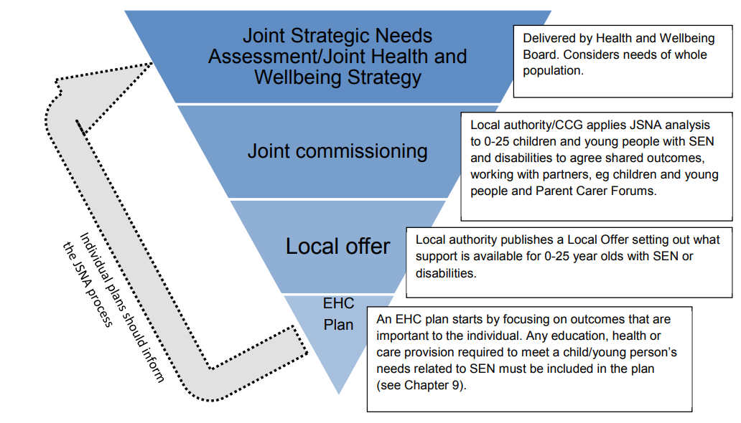Source: Department for Education, SEND Code of Practice, 2015

Funding
High Needs Funding is provided to local authorities through the Dedicated Schools Grant to enable the provision of additional resources for students with SEND to support participation in education up to the age of 25 (excluding those aged 19-25 without an EHC plan).
The health provision in Section G of the EHC Plan is funded and delivered by the NHS.

Inspection of SEND provision
Local arrangements are inspected by the Care Quality Commission and Ofsted, who launched an assessment framework in 2023. The core principles assessed fall into two categories:
- The first evaluates the experiences and outcomes of children and young people with SEND. This includes timely identification of needs and provision of support; that children and young people are valued and included in their communities; that they are prepared for next steps and to achieve strong outcomes; and that they and their families participate fully in shared decision making.
- The second category relates to how local area partners work together. It evaluates the extent to which leaders are: ambitious for children and young people with SEND; understand needs and aspirations and commission services to meet them; and engage in effective multi-agency practice and ongoing improvement to services.

Early identification of children and young people with SEND/LD/ND
National guidance places an emphasis on early identification of need and effective support for children and young people with SEND, the recognised benefits of which are improved long-term outcomes. Parents, early years providers, schools and colleges, and the NHS play a key role in early identification. Particular care should be given to children whose first language is not English, and for all children other causal factors such as housing or domestic circumstances should be considered.
Improved understanding and early identification of autism is also a key focus for the most recent national Autism Strategy, with a particular focus on identification and support for autistic girls.
Before the age of two years, health services working with families are of primary importance in identifying possible SEN, and support at this stage may include Health Visitors and Speech and Language Therapy. The Early Years Foundation Stage Framework supports early years practitioners in assessing learning and development from 0 to 5 years. It sets out two assessment points – a progress check between two and three years old, and an assessment at the end of reception year to identify any emerging needs.
Beyond this, mainstream schools must have arrangements in place to identify and respond to possible SEN and disabilities, which should be set out as part of the Local Offer. Further education establishments should also have mechanisms to support students where SEN become apparent at this stage.,
Mainstream early years providers and schools must have a designated Special Educational Needs Coordinator (SENCO). Their role is to work with children, teachers, and parents or carers, to identify need, facilitate assessment, and to support implementation and review of agreed supportive measures. In colleges there should be a named person with oversight of SEN provision who acts in a similar way.

Educational support
Once a potential special educational need has been identified, for children and young people at any stage of education the first step should be to offer special educational supportive measures as described in the Ordinarily Available Inclusive Practice guidance.
At all stages this should be targeted to their areas of need, and does not require a formal diagnosis. The majority of children and young people with SEN or disabilities can have their needs met within mainstream settings. Examples of support include special learning programmes, extra individual help or smaller group work, or support with physical or personal care difficulties.
If there is additional need for support beyond this, providers, in consultation with parents or carers, should consider involving specialists and consider an Education, Health and Care (EHC) needs assessment. This can be requested by the child’s parent, a young person aged 16-25, or an educational representative, however anyone can notify the local authority if they believe a child or young person may need an assessment.
The EHC assessment determines the need for an Education Health and Care Plan (EHC Plan). This is a legal document which should be made with the involvement of children and young people and their parents. It describes the special educational, health and social needs of the child or young person, and the extra support that will be provided to support them to achieve their ambitions and prepare for adulthood. It may also include a plan for education within a specialist setting. Once requested, local authorities have a statutory obligation to respond within six weeks, and to issue a final EHC Plan, if one is appropriate, within 20 weeks.
Children and young people with an EHC Plan can request a Personal Budget to support educational, health or social care needs. EHC Plans can continue up to the age of 25 if there are ongoing special educational needs and the young person remains in education or training.

Provisions for those who experience additional barriers and challenges
The SEND Code of Practice sets out additional considerations and statutory duties in relation to the support of particular groups of children and young people with SEN. These include groups who may face compound disadvantage and inequalities, such as looked after children, care leavers, those with social care needs, those in alternative provision, those educated at home or out of area, those in hospital, children of service personnel, and children or young people in youth custody.

Transition points
The SEND Code of Practice emphasises early preparation for transitions between educational stages and into adulthood. SEN support should include proactive information sharing as the child moves into another school, to ensure that their needs are understood and met. This should be done in collaboration with young people and parents/carers.
Children and young people should be supported from an early age to make choices for themselves, and to realise their ambitions in higher education, employment or training, living as independently as possible, and being part of their communities.
From Year 9 onwards preparing for adult life should be included in educational support, and EHC plans from this point must consider future planning. This might include preparations for further education, employment, or training, transition to adult health and social care services and wider support such as with housing, navigating transport systems and engaging with social and community activities.
Supporting positive transitions into adulthood is also a national strategic priority for children and young people with autism. This entails improving access to employment or higher education opportunities, alongside improved welfare support for those unable to work.

Health and social care
Many children and young people with SEND, LD and ND may also have health and social care needs. The 2014 Children and Families Act and SEND Code of Practice requires the integrated working of education, health and social care agencies and the co-commissioning of services to meet these diverse needs.
Multi-disciplinary health services have a key role in early identification of SEN and in support of children and young people with long-term conditions or disabilities. Healthcare professionals should work with the person and their family to optimally manage their health needs, including support with transition plans, coordination of care and referrals to other services. Within educational settings, children and young people who have SEN and medical conditions will usually have individual healthcare plans to support their needs; for those with EHC plans this will be formalised through the plan.
There should be a Designated Medical or Clinical Officer (DMO / DCO) whose role is to maintain an oversight of local needs and provision of health services for children and young people with SEND, and to engage with social, education and health care providers, as well as children, young people and their families and carers, to support joined up working across these networks.
Social care teams must ensure that children with SEN or disabilities who have additional social care needs have appropriate provision and are assessed and reviewed within statutory timeframes and in line with their EHC plan. A designated social care contact is required to provide advice for educational providers, and social care teams must work closely with Virtual School Heads to coordinate provision for looked‑after children. For young people turning 18 years old, there must be appropriate planning and support for the transition into adult services, including support for parent carers as young people leave full‑time education.
Where young people are likely to need care and support in adulthood, they or their parents can request the local authority conduct a Child Needs Assessment as they approach the age of 18, whether or not they have an EHC plan (The Care Act, 2014, Section 58).
The role of Designated Social Care Officer is in development nationally to improve the integration of social care with the SEND system and may become embedded into the Code of Practice.
National guidance recognises disparities in health and social outcomes for children and young people with SEND, LD and ND.
Autistic young people
Autistic children and young people often experience higher risk. The National Suicide Prevention Strategy identifies autistic people, including children and young people to be at higher risk of dying by suicide. An analysis of 37 prevention of future death reports for suicides in children in England and Wales from January 2015 to November 2023, 25% had a diagnosis of autism or Asperger’s. Analysis identified that reports raised a lack of training available for staff working with children with additional needs such as autism and noted that delays in receiving diagnoses for conditions such as autism and access to specialist services for these conditions resulted in delays to support and inappropriate support.
In addition, a disproportionate number of autistic children and young people, children and young people with learning disabilities, or both, are inpatients in mental health facilities. Recent guidance targets improved diagnostic pathways, reducing the gap in life expectancy and other health outcomes, and improving social care, mental health and housing support, to prevent autistic people reaching crisis point and requiring inpatient care.,
The NHS Ten-Year Health Plan includes actions on reducing waiting times for specialist services and developing tailored support for children with learning disabilities, autism or neurodevelopmental disorders, including a designated keyworker for those with most complex needs. It also commits to tackling morbidity and preventable deaths, via the expansion of targeted health checks and campaigns such as STOMP-STAMP (stopping over medication of people with a learning disability and autistic people [STOMP] and supporting treatment and appropriate medication in paediatrics [STAMP]).
Alongside this is an emphasis on workforce training. The Health and Care Act 2022 introduced a requirement for all health and care professionals to undergo training in learning disabilities and autism. The Oliver McGowan mandatory training programme that supports this aims to ensure that health and social care professionals “understand the needs of people with a learning disability and autistic people, and how to make adjustments to their care”. The Department of Health & Social Care publishes guidance on SEND resources for commissioners, health and wellbeing boards and health service providers and professionals, which covers a wide range of conditions.

Local context – Brighton & Hove and Sussex

Local inspection outcomes
In the Area SEND inspection of Brighton & Hove Local Area Partnership in March 2023 Ofsted and the Care Quality Commission (CQC) inspection outcome noted that arrangements ‘typically lead to positive experiences and outcomes for children and young people with special educational needs and/or disabilities (SEND).’ The report included findings about what is effective, and what it needs to do better.
What is the partnership doing that is effective?
- Practitioners, managers and leaders are ambitious for children and young people with SEND. Partnership working in the early years is strong
- Leaders have an accurate, shared understanding of needs, and strategies and new professional roles across services reflect this
- Co-production is a strength, evidenced in strategic and operational examples across the city. The voices of parents, carers and children and young people influence service and strategy development
- Recent adaptations to forums that support children and young people have improved multi-agency support for those with complex needs
- Leaders have changed the culture so that provision is better matched to needs across different communities
- Improved training and understanding in education is helping school leaders to reduce suspension and improve attendance across the city
- Plans are in place to increase the number of special school places for Autism Spectrum Condition or social, emotional and mental health concerns.
What does the area partnership need to do better?
- Improvement in preparation for adulthood is needed, including earlier identification and planning, and addressing specific gaps in provision
- EHC plans are not specific enough to the needs of the individual
- Some children requiring alternative provision do not receive placements that are well enough tailored to their needs
- Some children and young people wait too long to find a specialist school place
- The role of designated medical/clinical officer for SEND is under-resourced, limiting improvements to health planning and practice
- Better communication is needed between the partnership, children and families and wider partners about the improvements being made and the pace of change.
Actions are taken forward through single agency work and via joint local area partnership workstreams and / or via the SEND and AP Partnership Board.

Progress since the Area SEND Inspection
The area has achieved significant progress in strengthening inclusion, co‑production, and the quality of SEND provision. The launch of the Ordinarily Available Inclusive Practice framework and the co‑produced “Principles of Belonging” have begun to embed more consistent inclusive practice across schools, with children and young people directly shaping the approach. Early outcomes from the SEND Graduated Response model are positive, particularly through the pilot of Inclusion Intervention Spaces, which has led to improved attendance, emotional regulation, and curriculum engagement; this work is now expanding to additional schools with targeted investment. Additional inclusion funding has been provided to city Secondary Schools for Tier 1 support.
A strong culture of co‑production has continued to deliver tangible benefits, with the Parent and Carers’ Council (PaCC) influencing strategic decisions and health partners contributing to improved joint working across autism, SEND health pathways, and wider system planning. Despite rising demand and workforce pressures, the area has maintained momentum in developing inclusive mainstream practice and has taken proactive steps to understand and respond to increasing Section 19 requests.
Significant improvements have also been made in Alternative Provision (AP), including the establishment of an AP Specialist Taskforce, the successful delivery of new specialist pathways, and strengthened governance through an AP Steering Group and emerging quality assurance framework. Preparation for adulthood has advanced through a new transitions strategy, improved cross‑council collaboration, and positive feedback from families on the impact of this joined‑up approach.
Monitoring of the SEND strategy shows encouraging system‑level outcomes: exclusion rates have fallen, attainment has improved, and reliance on out‑of‑city SEMH placements has reduced. Health outcomes have also strengthened, with shorter waiting times and increased completion of annual health checks. The Designated Clinical Officer has played a key role in improving timeliness and coordination across the system.
Leadership and governance have been further strengthened through the appointment of a Director of Education and Learning, enabling closer alignment between education and SEND, more consistent co‑production, and clearer oversight through strategic boards. SEND has been identified as a priority across the wider Pan‑Sussex system, supporting a more coherent regional focus on improving outcomes for children and young people.

Local policies and guidance (Brighton & Hove and Sussex)
Health services across England are changing. As part of these national changes, NHS England’s work will move into the Department of Health and Social Care.
From 1st April 2027, NHS Sussex and NHS Surrey Heartlands will become one organisation and take on a more focused role as strategic commissioners. This will help deliver the ambitions in the new Ten-Year NHS Health Plan and improve long-term health outcomes. It will reduce costs and strengthen the way services work together. It will continue to work closely with families and partners to make sure care and support for children and young people with special educational needs and disabilities stays consistent, joined up, and centred on what each child needs.
SEND, neuro-developmental pathways and children’s mental health remain as three of four key priority areas for the Multi-Agency Pan Sussex Children’s Board, reflected in the Sussex Children’s Metric Dashboard covering: 0-5s, mental health, physical health, SEND and vulnerable groups. Performance is tracked on a monthly basis and published quarterly.
Sussex have used findings from the three Sussex Joint Area SEND inspections (Brighton and Hove, East and West Sussex) and ongoing consultation with partners to develop five priority areas for SEND for 2025 onwards, with progress is monitored through strategic boards including place SEND Partnership Boards:
- Waits for health services (including in pathway waits): Therapy Servies; Wheelchairs; ND Pathways; Emotional and Mental Health; and Video Fluoroscopy
- Health input into Education Health and Care Plans – EHCNAs Timeliness and Quality; Annual Reviews; and Tribunals
- Transition Pathways – Early Years and Post 16
- Inclusion in Education and Other Settings – Special School Nursing; Managing medical Conditions in Education and Other Settings; Education Based Prevention Work
- Advice, Support and Engagement – Co-production with Parent Carers and Children and Young People; SENDIASS and Mediation; Support Whilst Waiting Offers.

Brighton & Hove Special Educational Needs and Disability (SEND) Strategy 2021 to 2026
The current Brighton & Hove SEND strategy is co-produced between local providers and commissioners of services in local authority, health and education, the city’s Parent and Carer Council (PaCC), partners in the voluntary and community sector, and families.
It sets out six key priorities to enhance the outcomes and life chances of children and young people with SEND and adults with Learning Disabilities (Figure 2).
Each priority is underpinned by detailed actions and outcomes, and delivery is overseen by the SEND Partnership Board.

Figure 2: Brighton & Hove SEND Strategy 2021-2026, key priorities

Brighton & Hove Transition to Adulthood Strategy 2024-2027
A co-produced plan to support the transition of young people with additional needs to adulthood and independence. It sets out the need to address gaps in current provision, for earlier planning, and to deliver coordinated support to children and young people and their parents and carers. Five key care pathways are included in this strategy: Learning Disabilities; Physical Disabilities & Complex Health Needs; Mental Health needs; Neurodiversity; Looked after children approaching leaving care. The strategy sets out nine key standards and associated plans to address gaps in provision (Figure 3).
Figure 3: Brighton & Hove Transition to Adulthood Strategy 9 key priorities, 2024-27

SEND and AP Change Partnership Programme
Brighton & Hove are part of the South-East partnership, alongside Portsmouth, West Sussex and East Sussex. This is one of nine regional Change Programme Partners set up in England to test proposed reforms under the SEND and Alternative Provision Improvement Plan published by the Department for Education in 2023.
Across the four local authority areas, ten proposed reforms will be tested, and feedback shared with the Change Programme.

Brighton & Hove Adult Learning Disability Strategy: The Big Plan 2021-2026
This co-produced strategy is for people over the age of 18 who have a learning disability. It is of relevance to this JSNA work in its application to young people aged 18-25 years and includes a focus on transitions between services.
The strategy has been developed to enhance the outcomes of adults with learning disabilities and sets out six key priorities to deliver this, with progress monitored by the Adult Learning Disability Partnership Board and the SEND Partnership Board (Figure 4).

Figure 4: Brighton & Hove Adult Learning Disability Strategy 2021-26, key priorities

Brighton & Hove Adult Autism Strategy and Action Plan 2023-2028
Developed by Brighton & Hove Autism Partnership Board in consultation with local partners, autistic people, families and carers. It aims to improve the lives of autistic adults without a learning disability, their carers and support networks.
There are six priority areas with underpinning action plans (Figure 5).
Figure 5: Brighton & Hove Adult Autism Strategy & Action Plan 2023-2028 priorities

Whilst it is an adult strategy, it is relevant as considers issues that affect autistic people of all ages, and in outcomes targeted towards people aged 18-25 years. It includes an action plan for local universities to co-produce a review on support for mental health and wellbeing of autistic students, and the development of guidelines to support autistic young people without a learning disability in transition between Children’s and Adult Social Care Services.

Sussex NHS Commissioners All Age Learning Disability and Autism Strategy 2021-24
Has three key objectives to reduce health inequalities (Figure 6) and reviews Sussex’s progress against the NHS Long Term Plan 2019 and sets out detailed priorities for action.
Figure 6: Sussex NHS Commissioners All Age Learning Disability and Autism Strategy 2021-24, three key objectives

Sussex All Age Neurodevelopmental Pathway Programme
A programme that brings together NHS, local authority, voluntary, community and social enterprise organisations, and people with lived experience, to make longer-term improvements to services and support for Autism, ADHD and other neurodevelopmental conditions. It includes a focus on a “needs based approach to support children and young people, irrespective of diagnosis”. It prioritises improving assessment processes and access to services and support.

Sussex Health & Care Improving Lives Together. Ambition to Reality: Our Shared Delivery Plan. 2023
This Integrated Care Strategy sets out improvement priorities for health and care in Sussex over the next five years and beyond. It includes four key delivery areas. One of these focusses on continuous improvement areas, of which addressing mental health, learning disabilities and autism service improvements is a key strand.
In Brighton and Hove, children and young people are one of five priority areas. Ambitions include improving and expanding access and existing support for mental health, emotional wellbeing, autism, ADHD and other neurodevelopmental conditions.

Brighton & Hove Joint Health & Wellbeing Strategy 2019-2030
Sets out the ambition for Brighton and Hove in 2030 that:
- People will live more years in good health
- The gap in healthy life expectancy between people living in the most and least disadvantaged areas of the city will be reduced.
The high-level outcomes are to improve health and wellbeing across key life stages: starting well, living well, ageing well and dying well.

Integrated Community Teams
This initiative integrates health, social care and health-related services across local communities in Integrated Community Teams, formed to develop a core offer that meets the specific needs of the particular community. They have a specific focus on addressing health inequalities, taking preventative actions and working with local partners. In Brighton and Hove there is a focus on better supporting people with multiple compound needs and their carers, who face significant health inequalities.

Additional local policies, strategies and reports
- Learning from the Lives and Deaths of People with a Learning Disability and Autistic People (LeDeR) – NHS Sussex annual reports
- Brighton & Hove SEND guide for professionals
- Health and Adult Social Care Delivery Strategy 2023-2027
- Brighton & Hove’s Hidden Children Strategy
- Brighton & Hove City Council. Our plan 2020-2023: A fairer city, a sustainable future.

Programmes and service provision

Introduction
This section provides an overview of the current Special Educational Needs and Disabilities (SEND) programmes and service provision in Brighton & Hove, bringing together a summary of the main programmes, assessment pathways and support services available across the city, detailing their specific service criteria, referral routes, and access requirements. A list of services and links to further information is provided in Appendix 3: Links to local service provision.

Alternative Provision
The Change Programme involves 32 local areas (including Brighton & Hove) undertaking a ‘test and learn’ approach to changes across their local system, collaborating in Change Programme Partnerships (CPPs) in each of the nine regions of England. Originally set up to test reforms set out in the SEND and Alternative Provision Improvement Plan, the Change Programme is now working with local areas to test a range of programmes collectively to strengthen the inclusion support offered to mainstream settings.
Building on earlier phases, the programme now covers continued work on the use of Alternative Provision through a 3-tier model of interventions and extending the Early Language Support for Every Child pathfinders that are enabling earlier identification and intervention for speech, language and communication needs. In the extension, the Change Programme has strengthened links with two other existing initiatives from the DfE: Alternative Provision Specialist Taskforces (APST) and the Programme for Inclusion of Neurodiversity in Schools (PINS) so that more areas can test these models.
Change Programme areas also have the opportunity to test Assistive Technology ‘lending libraries’ that give schools the ability to test the effectiveness of these tools for their students so that they can make best use of funds to meet need.
The programme involves working collaboratively with local areas and alongside partners from health, education and social care, as well as parent carers, children and young people, recognising that their insights and expertise are key to creating any new system.
The Change Programme also works in parallel with other DfE programmes and wider work that is happening in the SEND sector, such as the Family Help reforms and Ofsted’s curriculum and assessment review, acknowledging the significant potential that these changes and initiatives have to be complementary. It’s anticipated that learning from the Change Programme work will directly impact on government decisions made in relation to any future national reform of SEND.

Best Start Family Hubs
Family Hubs offer support for all families from conception to aged 19 and up to 25 years for those with SEND. All families with children with SEND or on the pathway for assessment can access support through their midwife, health visitor, school or school nurse or through another professional, or can self-refer. There are four tiers of support offered:
- Open access and invitation only groups and events to reduce isolation and provide peer and professional support
- Groups and courses specifically to support parents and carers with children with SEND
- Short term support from a support worker to help with home learning, parenting, poverty, adult and child mental health and parental conflict
- Targeted early help providing whole family support for up to 9 months to help with all aspects of family life.

Assessment services
Sussex Partnership Foundation Trust (SPFT): Provides a range of specialist assessment, mental health, and neurodevelopmental services across Brighton & Hove:
- Autism assessments for children and young people aged 11–18 and ADHD assessments 6–18 years are delivered by the Child and Adolescent Mental Health Service (CAMHS) Neurodevelopmental Service, with 18+ assessments provided through the Adult Neurodevelopmental Service
- CAMHS offers mental health assessment, therapeutic intervention, and ongoing support, plus ADHD medication management & psychoeducation through Neurodevelopmental pathways. Digital resources, including waiting-list support, webinars, and post-assessment information are available on the CAMHS website
- More specialist services include Learning Disability Child and Adolescent Mental Health Services (LD CAMHS) for children with learning disabilities, Tier 4 inpatient care at Chalkhill Hospital, and the Sussex Family Eating Disorder Service (SFEDS)
- Brighton & Hove Wellbeing Service provides accessible mental health support for children, young people, and families as part of the wider local offer.
Sussex Community NHS Foundation Trust (SCFT):
- Seaside View Child Development Centre (CDC) completes developmental assessments for ages 0–18 and autism assessments for ages 0–11, alongside a structured post-diagnostic offer that includes group-based interventions such as play skills groups
- Universal health services form a core part of the local SEND system, with Health Visiting and School Nursing providing early identification, monitoring, and family support
- A broad therapy offer is available across the city, including Children’s Speech and Language Therapy (SALT), Occupational Therapy (OT), Physiotherapy, and adult Talking Therapies for those aged 18+
- A range of specialist health services further supports children and young people with complex needs, such as Chailey Clinical Services, the Continence Team, Audiology, the Learning Disabilities Liaison and Facilitation service, the Wheelchair and Specialist Seating Service, and Children and Young People’s Community Nursing.
Together, these services form an integrated health pathway that underpins early intervention, ongoing support, and multidisciplinary care across Brighton & Hove.
NHS Sussex Integrated Commissioning Board (ICB)
Within the wider commissioning landscape, NHS Sussex ICB plays a central role in overseeing and coordinating specialist health provision for children and young people with SEND across Brighton & Hove. This includes the Children and Young People’s Continuing Care Service, which assesses and arranges bespoke packages of care for those with significant, complex, or rapidly changing health needs that cannot be met through universal or specialist community services alone.
Patient journey example

Child F was seen by a local GP after parents had concerns around his development. The GP assessed the child and suggested the family contacted the Health Visitor (SCFT) to arrange an early developmental assessment. The parents did this and the child was then referred to the local Child Development Centre (Seaside View, SCFT). The child was seen in a stage 1 clinic with a paediatrician and placed upon the Autism Assessment pathway. In the meantime, the family were signposted to Amaze to seek some support whilst they were waiting for an assessment.
Following the assessment the family were told that the child may also have ADHD and that a referral to CAMHS (SPFT) could be made by the school, GP or themselves when the child was 6. In the meantime, they can continue to access support via Amaze, their school and local educational support offer (BHISS) and a post diagnostic appointment would be offered by the child development centre shortly.
Service contact points:
- Primary Care – GP practice
- SCFT – Health Visitor service
- SCFT – Child Development service
- Amaze – CVS support service
- BHISS – Education support service
- SPFT – CAMHS referral when aged 6

Commissioned services

Commissioning processes and cycle
NHS Sussex commissioning cycle is shown in Figure 7. The commissioning cycle describes a continuous life cycle of commissioning aligned to three key functions: needs assessment, procurement, and monitoring and evaluation, and puts patients at the heart of all activity.
All parts of the system have an important contribution to make and need to work together to assess need and determine best practice; to engage with stakeholders on planning and designing services and to ensure these are well monitored to deliver effective outcomes.
Brighton & Hove’s SEND/LD/ND commissioning cycle is to first assess needs (through the JSNA SEND needs assessment), set joint SEND strategy and commissioning intentions, market-shape & procure (co-produced), contract & mobilise, and monitor, review and re-shape. All governed through Joint Commissioning Boards, statutory joint arrangements (Children & Families Act duties) and, where appropriate, pooled s.75 arrangements between the LA and NHS Sussex.

Figure 7: NHS Sussex commissioning cycle
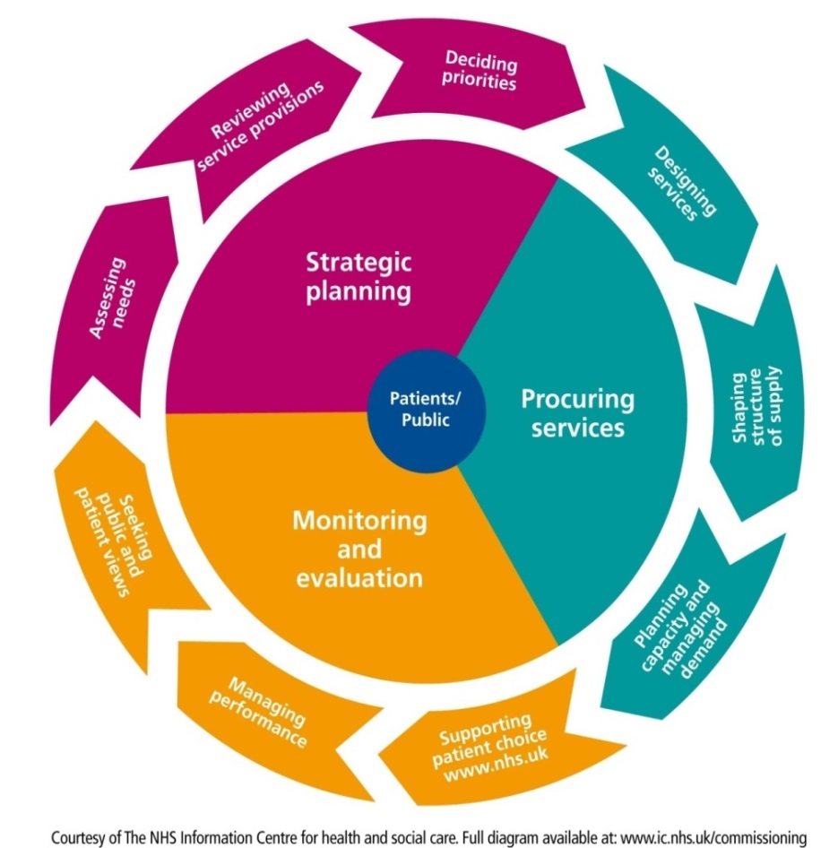

NHS and LA commissioned support services
Brighton & Hove Inclusion Support Service (BHISS): Provides schools, early years settings, and families with access to a broad team of highly skilled professionals including specialist teachers, educational psychologists, and practitioners across key areas of need, including Autism and Language, Early Years, Educational Psychology, Early Language Support, Literacy Support, Sensory Needs (Deafness and Visual Impairment), Social, Emotional and Mental Health (SEMH), and Social Communication. By offering targeted assessment, consultation, intervention, and capacity-building support, BHISS plays a vital role in promoting inclusion, enabling early identification, and ensuring that children and young people with SEND receive timely, specialist input within their educational settings.
Schools Mental Health Service: Works with all maintained schools and colleges in the city, supporting young people 1-1 and in groups, offering workshops and support to parents/carers and providing training, advice and sharing resources to schools as part of the Whole School Approach around mental health and wellbeing.
Brighton & Hove City Council Commissioning, Health and Social Care: Services form a core component of the wider SEND system, delivering statutory support, early help, and specialist pathways for children, young people, and their families. Key elements include:
- The Transforming Care Keyworker programme for children and young people with the most complex needs, ensuring coordinated, family-centred support
- Short Breaks offer provides a range of opportunities including access to personal assistants to support disabled children and give families valuable respite, and residential provision within Children’s Services for those requiring more intensive support
- Social Care and Family Help services, including the Family Information Service, Family Hubs, and the Front Door for Families, offer assessment, guidance, group work, early help interventions, online support and outreach to families across the city
- Schools are supported through the Schools Mental Health Service, delivering group interventions, therapeutic support, staff training, and whole-school approaches to emotional wellbeing
- Adult Social Care provides assessment from age 18, with eligible individuals accessing community-based support, Direct Payments, and carer services.

Wider support services (community and voluntary sector)

Amaze
Amaze plays a pivotal role in supporting families of children and young people with SEND across the city, offering a range of independent information, advice and guidance (Figure 8). These services form a vital layer of community-based support, empowering families, strengthening participation, and promoting positive outcomes throughout the SEND journey.
Figure 8: Amaze support for families of children and young people with SEND in Brighton & Hove

Other community and voluntary sector services
A strong network of community and voluntary-sector organisations complements statutory SEND provision in Brighton & Hove, offering specialist support, peer engagement, and accessible pathways for children, young people and families. Together, these organisations contribute to a rich, community-based ecosystem that enhances inclusion, wellbeing and resilience across the SEND pathway:
- Parent Carers’ Council (PaCC) plays a central role in co-production and parent-carer engagement, ensuring that lived experience informs local policy and practice.
- Mental health and wellbeing support is strengthened through charities such as Mind in Brighton & Hove, which provides workshops, mentoring, advocacy and direct advice
- A range of youth-focused services enhance outcomes for young people, including YMCA mentoring for those in education, employment or training
- Allsorts Youth Service delivers groups, activities, one-to-one support, family programmes and anti-LGBT-phobia training
- Peer-support networks such as mASCot offer valuable connection for parent carers and neurodivergent children
- Spiral and Carousel provide clubs and activities for adults with learning disabilities.
- Young Minds (national organisation) provides further guidance through helplines, digital resources and training
- The Youth Employability Service supports young people preparing for the world of work
- Brighton & Hove Recovery College provides free courses on topics such as “Understanding Autism” and “Autism and Employment” for autistic adults and those who support them
- Additional adult peer-support communities, including Brighton Autistic Movement, Brighton Neurodivergent Community and ADHD Aware, offer safe, identity-affirming spaces for autistic and neurodivergent adults.

Gaps in service provision and opportunities for development
Despite the breadth of SEND provision in Brighton & Hove, several gaps and opportunities for development remain:
- Neurodevelopmental (ND) assessments and support are heavily focused on Autism and ADHD, creating inequalities for individuals with other ND profiles, such as Tourette’s, Fetal Alcohol Spectrum Disorder (FASD), Avoidant/Restrictive Food Intake Disorder (ARFID), sensory processing differences, specific learning difficulties, or developmental coordination disorder
- Existing data may not reflect the complexity of need, as Autism is often recorded as the primary need even when it forms part of a broader SEND profile
- Opportunities exist to enhance joint working between providers, e.g. through combined Autism and ADHD assessments, and to create more integrated pathways and care oversight for individuals with complex or multiple needs
- Additionally, there is a need for clearer assessment guidance and more consistent support across adult services for those with less commonly recognised ND conditions.
Addressing these gaps would improve equity, early identification, and coordinated care for all children, young people, and adults across the city.

National prevalence

Disabled children and young people – the Family Resources Survey 2022-2023
The Department for Work and Pensions Family Resources Survey (FRS) is an annual survey, representative of private households, that provides information about the incomes and living conditions of households and families in the UK, including disability. The latest survey was in 2022/23 and had just over 25,000 respondents.
The terms used are those defined within the Family Resources Survey. FRS defines disability in accordance with the Equality Act 2010. A person is considered to have disability if they have a physical or mental impairment that has ‘substantial’ and ‘long term’ negative effects on their ability to do normal daily activities.
Disability prevalence by age: 11% of children in the UK had a disability, an increase from 7% in 2012-2013.
Disability prevalence by gender: For those aged 14 years and younger, there was a higher proportion of disabled males than disabled females (Table 2). There was a higher proportion of disabled females than disabled males for those in those aged 15-19 years (13% of males and 16% of females) and 20-24 years (15% of males and 19% of females). The FRS only considered binary gender.
Table 2: Prevalence (%) of people who are disabled aged 0-24 years by age and gender, average of 2020 to 2021, 2021 to 2022, and 2022 to 2023, UK
Age group | % disabled  (all people) | % disabled  (male) | % disabled  (female)
0 to 4 years | 5% | 7% | 2%
5 to 9 years | 10% | 12% | 7%
10 to 14 years | 14% | 15% | 12%
15 to 19 years | 14% | 13% | 16%
20 to 24 years | 17% | 15% | 19%
Source: Family Resources Survey 2022/23 Table 4.3b
Disability prevalence by impairment type (by age): Among disabled children, the most common impairments are social or behavioural (50%), followed by learning disability (32%) and mental health impairment (30%) (Table 3).

Table 3: Prevalence of disability by impairment type in children, 2022 to 2023, UK
Impairment type | % children
Social/ behavioural | 50%
Learning | 32%
Mental health | 30%
Mobility | 17%
Stamina/ breathing/ fatigue | 15%
Other | 14%
Memory | 11%
Dexterity | 9%
Vision | 6%
Hearing | 5%
Source: Family Resources Survey 2022/23 Table 4.6

Special Educational Needs in England
This section is summarised from the Department for Education publication on Special educational needs in 2023/24. It therefore uses the terms and breakdowns available within that publication. This report is based on England school census data released annually, see reference for latest updates.
In 2023/24, 18% of all pupils in England have special educational needs (SEN) - over 1.6 million pupils. This is an increase from 14% (over 1.2 million pupils) in 2015/16 (Figure 9). This includes the number of pupils with an education, health and care plan (EHC Plan) and the number of pupils with SEN support, both of which continue a trend of increases since 2015/2016. In 2023/24:
- The percentage of pupils with an EHC Plan has increased to 5%, from 3% in 2015/16
- The percentage of pupils with SEN (SEN support) but no EHC Plan has increased to 14%, from 12% in 2015/16 (Figure 9).

Figure 9: Percentage of pupils with special educational needs (SEN), by SEN type of provision, all schools, 2015/16 to 2023/24, England
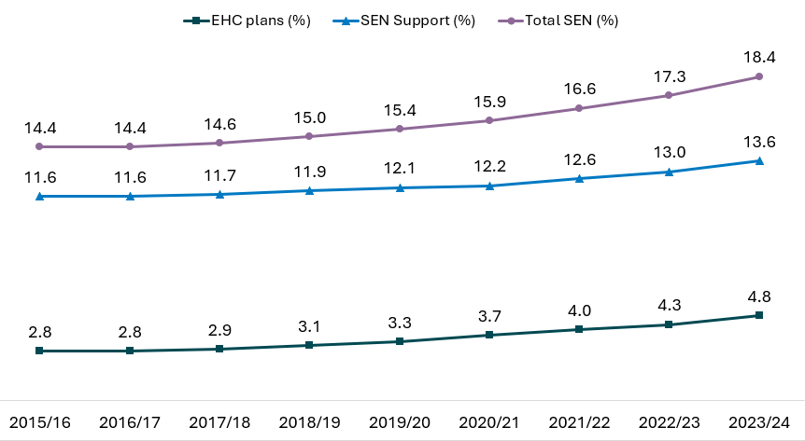
Source: Department for Education, Special educational needs in England, 2023/24
By demographics and protective characteristics:
- SEN support is most prevalent at age 9: The percentage of pupils who have SEN support increases during primary school age, reaching a peak of 16% of pupils at age 9. This then steadily declines through secondary ages, to 13% at age 15
- The percentage of pupils with an EHC plan also increases with age: from 4% at age 5, up to a peak of 6% at age 11 before slowly declining to 5% at age 15
- SEN support and EHCPs continue to be more prevalent in boys than girls: 72% of pupils with an EHC Plan are male, and 62% of pupils with SEN support are male. The proportion of pupils with SEN that are male has fallen very slightly in recent years (73% of pupils with an EHC Plan in 2015/16 were male, and 65% of those with SEN support)
- The most common type of need for those with an EHC plan is autistic spectrum condition: 33% of EHCP pupils have a primary need of ASC, followed by speech, language & communication needs (20%) & social, emotional & mental health (16%)
- The most common type of need for those with SEN support is speech, language and communication needs: The primary need identified for one in four pupils is speech, language and communication needs (26%). This is followed by social, emotional and mental health needs (22%) and moderate learning difficulty (16%)
- Pupils with SEN are more likely to be eligible for free school meals: 42% of pupils with an EHC plan and 38% of pupils with SEN support are eligible for free school meals in 2023/24. This compares to 21% of all pupils in schools without SEN
- Pupils with SEN have higher rates English as a first: 84% of pupils who have SEN support and with an EHC plan have a first language known or believed to be English, compared to 79% of all pupils
- SEN is most prevalent in the Traveller of Irish heritage ethnic group: 33% of pupils recorded as Traveller of Irish heritage ethnic group had SEN support or an ECHP in 2023/24, followed by Gypsy/Roma pupils (28%), Mixed – White and Black Caribbean pupils (24%) and Black – Black Caribbean pupils (24%). The lowest rate for SEN support and ECHP is in the Chinese ethnic group (7% of pupils) (Figure 10).
Figure 10: Percentage of pupils with EHC plan or SEN Support, by ethnicity, England, 2023/24
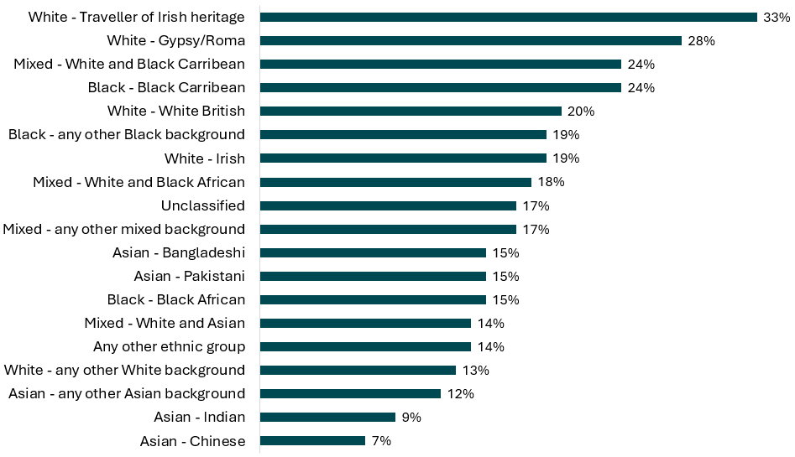
Source: Department for Education, Special educational needs in England, 2023/24
Children Looked After, Children in Need (CIN) and Children on a child protection plan were over twice as likely to have SEN than the overall pupil population. This data is for 2022/23 as has not yet been published for 2023/24 at the time of production. They were over two and a half times more likely to have an Education, Health, and Care (EHC) plan than the overall pupil population and roughly twice as likely to have SEN support.
- Children Looked After for at least 12 months were over seven times more likely to have an EHC plan than the overall population (this is similar to previous years). Additionally, the proportion of CLA for at least 12 months with a statement or EHC plan has risen by over 4 percentage points to 30.8% over the seven years covered in this data
- Of all the key social care groups, Children Looked After for at least 12 months had the highest proportion of children with SEN (58%) compared to those with a child protection plan (41%), which had the lowest proportion. 17% of all pupils had SEN. The percentage of pupils with SEN across the key social care groups is broadly stable in the seven years covered in this data though rising slightly for some groups over the last two years. The largest rises were in the Children in Need and Children on a child protection plan, with increases of over 2 percentage points compared to the previous year.
This data is not available for other characteristics.

The level of need in Brighton & Hove
Analysis of local data for the needs assessment took place between May 2024 and May 2025. Appendix 2 Key datasets analysed as part of the needs assessment, shows the key data sources identified, along with when they were analysed. These may not be the latest data at the time of publication of the needs assessment. They include local data from surveys, Compass (the voluntary register for children and young people (CYP) with disabilities in Brighton & Hove), education data and neurodevelopmental assessments, and national data from the Department of Education and NHS.

Local prevalence data

SEN provision data
All pupils Over the years, for all school age pupils, there have been more pupils on SEN support than on an EHC plan. In 2023/24, of all pupils, 434,354 (5%) were on an EHC plan in England, 74,809 (5%) in South-East and 1,697 (5%) in Brighton and Hove. There were 1,238,851 (14%) pupils on SEN support in England, 207,768 (14%) in South-East (14%) and a little higher percentage for Brighton & Hove with 5,045 (17%).
In the same year, the percentage of all pupils with no identified SEN was 82% (7,418,868) in England, similar to the South-East at 81% (1,221,234), and 78% (27,561) in Brighton & Hove.
Table 4: Special educational needs for all pupils, Brighton and Hove, South-East and England, 2022/23 and 2023/24
 | England | England | South-East | South-East | Brighton & Hove | Brighton & Hove
 | 2022/23 | 2023/24 | 2022/23 | 2023/24 | 2022/23 | 2023/24
% of all pupils with EHC plan | 4% | 5% | 5% | 5% | 4% | 5%
% of all pupils with SEN support | 13% | 14% | 13% | 14% | 16% | 17%
% of all pupils with no identified SEN | 83% | 82% | 82% | 81% | 80% | 78%
Source: SEN provision for pupils in all schools in Brighton & Hove, South-East and England, 2022/23 to 2023/24

Schools Census
Each year Brighton & Hove, and all upper tier/unitary local authorities, conduct a January (Spring) School Census. Data from the January 2025 Census were used for this needs assessment, rather than the SEN2 survey, a statutory data collection, as there were data issues with the submission at the time of production of this needs assessment and so this could not be used. In addition the SEN2 survey only collects information on EHC Plans, not SEN Support.
The schools census data is from 61 of the 68 Brighton & Hove Schools. These 61 are maintained schools (those funded and controlled by the local authority), including 2 maintained nurseries, 48 primary phase schools, 7 secondary schools, 3 special schools and 1 Pupil Referral Unit. For 7 schools (5 Academies and 2 Free schools), which are directly accountable to the Department for Education, they are not included within these figures. The benchmark used England 2024, data.
In January 2025, there were 30,566 pupils on roll, a decrease from 32,296 pupils in January 2020.
Brighton & Hove has a higher percentage of pupils with SEN than England:
- 24% (7,263) of pupils attending Brighton and Hove schools, were recorded on school special educational needs registers (either SEN Support or EHC Plan) - above the England 2024 SEN figure of 18%
- 18% (5,492) of Brighton & Hove pupils were receiving ‘SEN Support’, which means they are on the SEN register, but do not have an Education, Health & Care Plan (England 14%)
- 6% (1,771) of Brighton & Hove pupils have an Education, Health & Care Plan (England 5%).
Numbers of pupils with SEN have been increasing, against the pattern of overall falling pupil numbers in the city:
- The number of pupils with SEN support has been steadily increasing since January 2020 – from 4,374 pupils to 5,492 pupils (a 26% increase)
- The number of pupils with an EHC Plan has been increasing from January 2015. Since January 2020, the number of pupils with an EHC Plan increased from 1,164 to 1,771 pupils in January 2025 (a 52% increase)
- This equates to an increase in all pupils with SEN from 5,538 in January 2020 to 7,263 in January 2025 (31% increase) (Figure 11).

Figure 11: Number of children with Special educational needs (SEN), Brighton and Hove Schools, January 2015 to January 2025
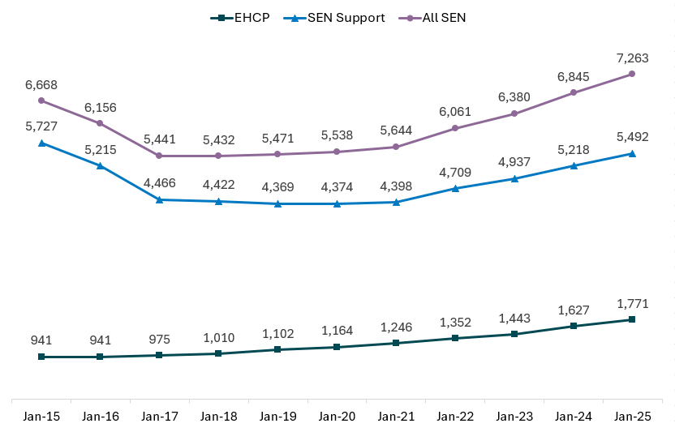
Source: Brighton and Hove Schools Census, January 2025
Primary need:
- Among Brighton and Hove pupils receiving SEN Support, the most common primary need is a social, emotional and mental health need (26% compared to 22% for England), followed by specific learning difficulty (22%, England 14%) and speech language and communication (21%, England 26%), which was the most common need across England in 2024 (Figure 12)
- The most common primary SEN need of Brighton and Hove pupils with an EHC Plan, is Autistic Spectrum Condition (48%), much higher than England (33%), though it is also the most common primary need across England. Followed by Speech, Language and Communication needs (16%, England 20%), and social, emotional and mental health (16 both areas) (Figure 13).
For any SEN:
- The number of pupils with Autistic Spectrum Conditions (ASC) have increased sharply since 2015, from 289 pupils in January 2015 to 1,930 in January 2025. The large increase in numbers could be attributed to the increase in ASC diagnosis over the years (Table 5)
- The number of pupils with social, emotional and mental health need have also increased since 2015 by 43% from 1,177 to 1,681. This increase is also seen nationally as the number of pupils with social, emotional, and mental health need increased by 80% from 194,691 in January 2016 to 350,534 in January 2025 (Appendix 2)
- All other SEN type of need has either declined or remained unchanged as a primary need.
Figure 12: Percentage of pupils receiving SEN Support, by primary SEN need, in Brighton & Hove (January 2025) and England (2024)
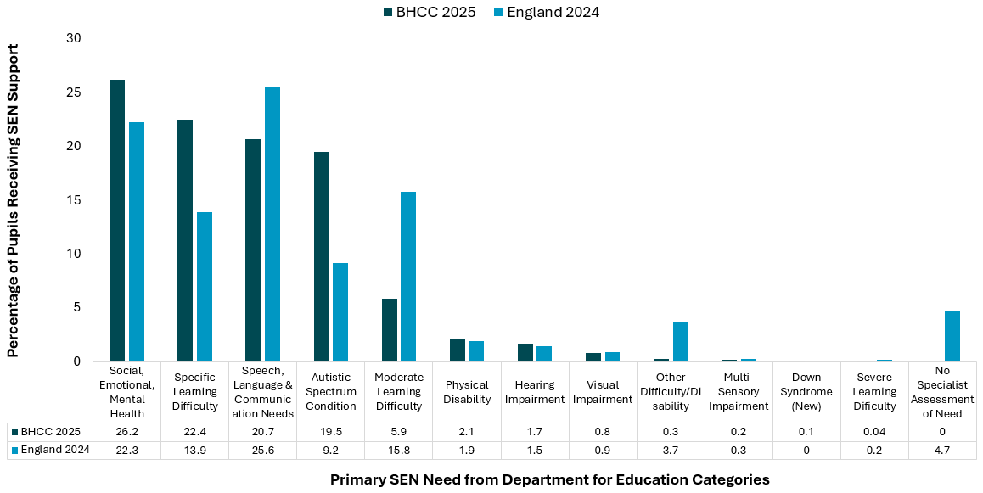 Source: Department for Education. Schools, pupils and their characteristics: January 2024, Special Educational Needs in England, 2023/24, Brighton and Hove Schools Census, January 2025
Figure 13: Percentage of pupils with an EHC Plan by primary SEN need in Brighton & Hove (January 2025) and England (2024)
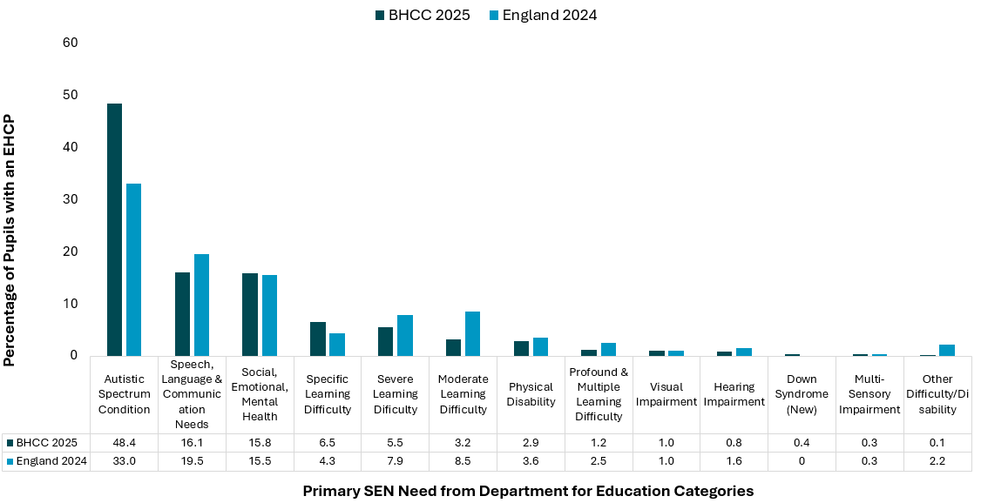 Source: Department for Education. Schools, pupils and their characteristics: January 2024, Special Educational Needs in England, 2023/24 and Brighton and Hove Schools Census, January 2025
Table 5: All SEN primary need, Brighton & Hove, January 2015 to January 2025
Source: Brighton and Hove Schools Census, January 2025
Figure X: Percentage of pupils in Brighton & Hove with SEN by primary SEN SEN Primary Need – All SEN pupils | Jan-15 | Jan-16 | Jan-17 | Jan-18 | Jan-19 | Jan-20 | Jan-21 | Jan-22 | Jan-23 | Jan-24 | Jan-25
Autistic Spectrum Condition | 289 | 308 | 333 | 417 | 529 | 768 | 874 | 1,060 | 1,251 | 1,629 | 1,930
Social, Emotional & Mental Health | 1,177 | 1,129 | 909 | 1,033 | 1,067 | 1,126 | 1,178 | 1,249 | 1,385 | 1,512 | 1,681
Speech, Language & Communication Need | 1,374 | 1,334 | 1,280 | 1,236 | 1,194 | 1,176 | 1,213 | 1,339 | 1,406 | 1,427 | 1,421
Specific Learning Difficulty | 1,774 | 1,542 | 1,231 | 1,264 | 1,402 | 1,236 | 1,226 | 1,251 | 1,229 | 1,343 | 1,347
Moderate Learning Difficulty | 777 | 809 | 681 | 593 | 583 | 596 | 579 | 553 | 538 | 421 | 382
Physical Disability | 152 | 161 | 147 | 151 | 224 | 222 | 210 | 213 | 188 | 172 | 166
Hearing Impairment | 128 | 117 | 115 | 114 | 97 | 104 | 96 | 97 | 109 | 105 | 106
Severe Learning Difficulty | 171 | 164 | 172 | 167 | 180 | 145 | 156 | 142 | 133 | 109 | 99
Visual Impairment | 62 | 54 | 47 | 50 | 52 | 55 | 58 | 66 | 65 | 59 | 61
Profound & Multiple Learning Difficulty | 43 | 45 | 44 | 44 | 36 | 39 | 35 | 35 | 30 | 28 | 22
Other Difficulty/Disability | 352 | 220 | 311 | 254 | 82 | 47 | 35 | 22 | 19 | 16 | 21
Multi-Sensory Impairment | * | 7 | 10 | 15 | 17 | 23 | 21 | 30 | 27 | 24 | 17
Down Syndrome (New 2025) |  |  |  |  |  |  |  |  |  |  | 10
No special assessment of need | 365 | 266 | 161 | 94 | 8 | * | * | * | 0 | 0 | 0
*The numbers in the cells with asterisk have not been disclosed for confidentiality as they are less than 5.
By demographics and protective characteristics:
Some groups of pupils are more likely to have SEN (Table 6, 7, Figure 14 and 15):
- There are more male pupils with SEN (28%) compared to female pupils (19%) (Table 6, Figure 14)
- Pupils eligible for free school meals are twice as likely to have SEN as those not eligible for free school meals: 38% of pupils eligible for free school meals compared with 19% of pupils not eligible for free school meals
- Pupils living in the most deprived 20% of areas in the city are almost twice as likely to have SEN as those living in the least deprived 20% of areas: 34% of pupils living in the 20% most deprived areas in the city compared with 18% of those in the least deprived 20% (based on the Index of Deprivation Affecting Children Index) (Table 6)
- When looking at EHC Plan by IDAC deprivation across deciles, there are more EHC Plan pupils living in the 40% most deprived areas in the city, with those in decile 1 (most deprived) being the highest (6.4%), compared to decile 2 (5.7%), decile 3 (5.8%) and decile 4 (4.6%) compared to decile 10 with only 2.3% (see Appendix 2)
- White British pupils are more likely to have recorded SEN than Black and Racially Minoritised pupils: 26% of White British pupils (or those with no ethnicity recorded), compared to 19% of Black and Racially Minoritised pupils
- Pupils who do not have English as an additional language compared to those with English as an additional language: 25% of pupils who do not have English as an additional language compared to 18% of pupils who do.
- Within more detailed breakdowns by ethnic group (Table 7) almost half (46%) of White Gypsy, Roma or Irish Traveller pupils had SEN, followed by 26% of White British pupils, and 23% of pupils from Mixed/Multiple ethnic group
- The percentage of pupils with SEN increases from 15% for Reception year pupils, to 29% for year 6 pupils, and decreases slightly in secondary schools down to 25% in Years 10 and 11 (Figure 15).
Table 6: Percentage of pupils with SEN, by pupil characteristics, Brighton and Hove, January 2025
 | Total number of pupils | Number of pupils with EHC Plan | % of pupils with EHC Plan | Number of pupils with SEN Support | % of pupils with SEN Support | Number of All SEN pupils | % of pupils All SEN
Male | 15,880 | 1,274 | 8.0% | 3,207 | 20.2% | 4,481 | 28%
Female | 14,686 | 497 | 3.4% | 2,285 | 15.6% | 2,782 | 19%
Eligible for free school meals (FSM) | 8,032 | 850 | 10.6% | 2,167 | 27.0% | 3,017 | 38%
Not eligible for free school meals (FSM) | 22,534 | 921 | 4.1% | 3,325 | 14.8% | 4,246 | 19%
IDACI quintile 1 (most deprived) | 6,053 | 537 | 8.9% | 1,503 | 24.8% | 2,040 | 34%
IDACI quintile 2 | 5,840 | 404 | 6.9% | 1,113 | 19.1% | 1,517 | 26%
IDACI quintile 3 | 6,685 | 337 | 5.0% | 1,113 | 16.6% | 1,450 | 22%
IDACI quintile 4 | 7,175 | 313 | 4.4% | 1,056 | 14.7% | 1,369 | 19%
IDACI quintile 5 (least deprived) | 4,718 | 172 | 3.6% | 695 | 14.7% | 867 | 18%
Black or Racially Minoritised pupils | 9,831 | 509 | 5.2% | 1,403 | 14.3% | 1,912 | 19%
White British or not stated | 20,735 | 1,262 | 6.1% | 4,089 | 19.7% | 5,351 | 26%
English as an additional language (EAL) | 5006 | 251 | 5.0% | 625 | 12.5% | 877 | 18%
Not English as an additional language (EAL) | 25,560 | 1,520 | 5.9% | 4,867 | 19.0% | 6,386 | 25%
Source: Brighton and Hove Schools Census, January 2025

Figure 14: Percentage of pupils with special educational needs (SEN), by pupil characteristics, Brighton & Hove schools, January 2025
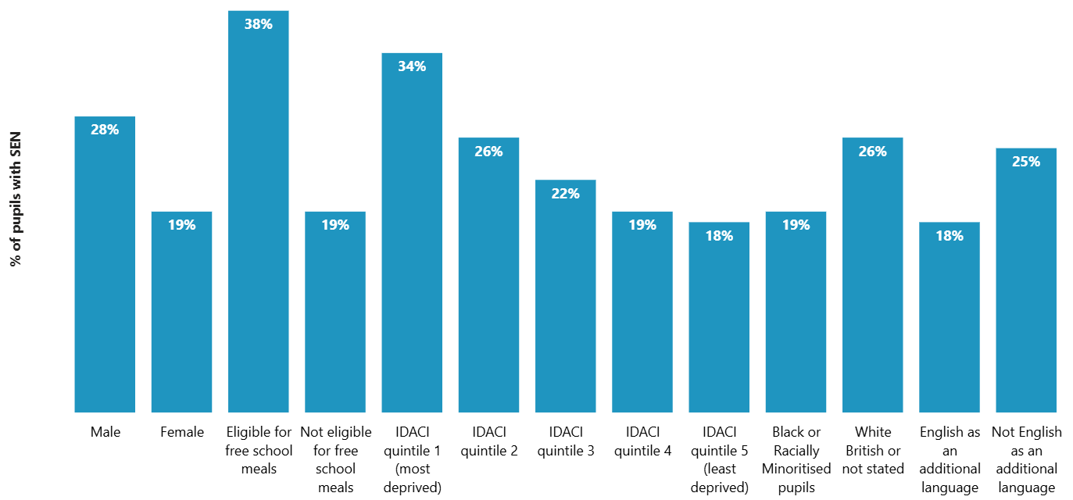
Source: Brighton and Hove Schools Census, January 2025
Table 7: Percentage of pupils with special educational needs (SEN) by ethnicity, Brighton & Hove January 2025
 | Number of pupils with SEN | Total number of pupils | % with SEN
Asian or Asian British | 297 | 1,751 | 17%
Black or Black British | 167 | 914 | 18%
Mixed/multiple ethnicity | 758 | 3,307 | 23%
White British | 5289 | 20,443 | 26%
White Gypsy, Roma or Irish Traveller | 22 | 48 | 46%
White Irish or White other | 476 | 2,800 | 17%
Arab | 108 | 573 | 19%
Other ethnic group | 84 | 438 | 19%
Source: Brighton and Hove Schools Census, January 2025

Figure 15: Percentage of pupils with special educational needs (SEN), by year group, Brighton and Hove Schools, January 2025
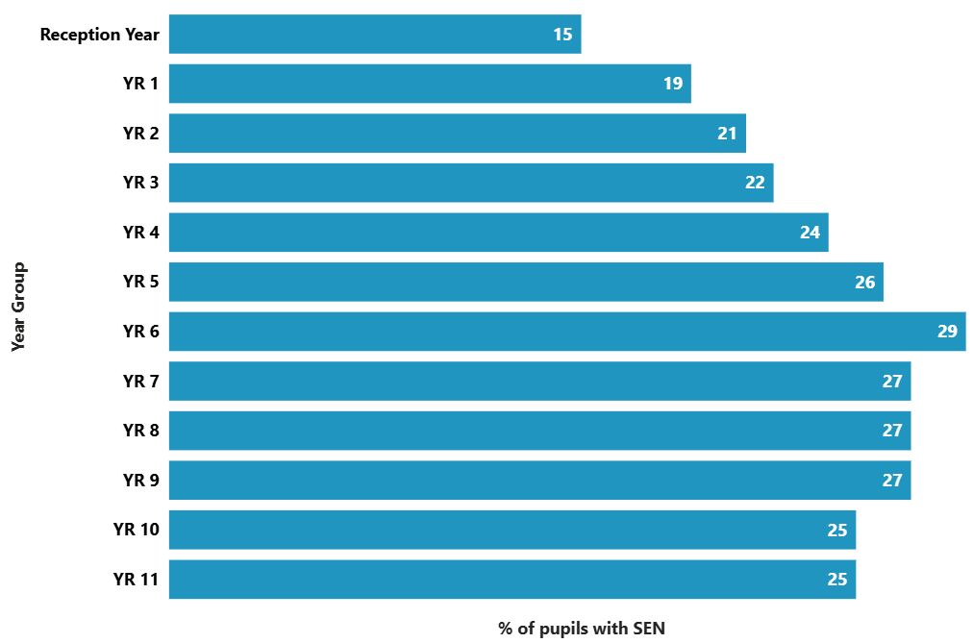 Source: Brighton and Hove Schools Census, January 2025

Amaze - Compass register
Compass Brighton & Hove is a register held by Amaze, commissioned by Brighton & Hove City Council, with details of children and young people aged 0 to 25 years, living or going to school/college in Brighton and Hove who have a/multiple disability/ies which have a significant impact on their daily life.
When registering for a Compass Card, applicants provide information about the child/young person’s circumstances and needs. The card then entitles the child/young person to access local leisure venues with discounts and special offers.
The data presented here is for children and young people who registered or renewed their Compass card in the three years up the end of March 2024. Ages are taken as at the time of registering/renewing their card. Tables provided in Appendix 2.
As at March 2024 there were:
- 2,535 children and young people on the register – 3% of the population aged 0-25 years in Brighton & Hove
- Most children and young people on the register live in the city (96%, 2,443 people), 2% in East Sussex, and 1% in West Sussex
- The largest number and rate of children and young people on the Compass register are secondary school age, 11-16 years (1,027, 6% of 11-16 year olds) followed by primary school age, 5-10 years (778, 5% of 5-10 year olds)
- Males are more likely to be on the register (1,624 people, 4% of those aged 0-25 years in Brighton & Hove), followed by females (849 people, 2% of those aged 0-25 years in Brighton & Hove). Population figures are not available for non-binary and other gender identities
- The highest rate was in children and young people from White British and Mixed/multiple ethnic groups (both 3%) and lowest in Asian or Asian British ethnic groups (1%). The majority of people on the register are White British (78%), followed by Mixed/multiple ethnic background (8%) and White Irish or White other (5%), and Asian or Asian British (3%)
- The main needs were moderate to severe behaviour that challenges (1,375 people), learning difficulty or disability (1,181 people), or moderate to severe mobility issues or wheelchair user (826 people), followed by moderate or severe visual problems or registered blind (471 people), moderately to severe hearing problem or profoundly or totally deaf (141 people)
- The most common diagnosis for children and young people on the compass register was Autism (1,621, 13% of total diagnoses), followed by Speech and language difficulties including developmental language disorder (DLD) (1,605, 12% of total diagnoses), and anxiety (1,265, 10% of total diagnoses). There were 167 children who had testing/assessment in progress.
- Based on statistical analysis using the IDACI score (%) and the percentage of children and young people living in each ward on the compass register, there isn’t a significant correlation between deprivation and the percentage of CYP living in each wards. This could be as a result of the growing awareness and diagnosis of neurodivergent conditions.
- 20% live in households where the household relies solely on benefits
- 61% of all CYP on the register had at least one of the following indicators of need: living in the 10 wards with the lowest deprivation indexes, CYP on or needing direct payments or personal budgets and households where they rely completely on income from benefits.

Impact on parent carers of children and young people on Compass register
Parent/carer questionnaires, completed by 1,282 parent carers in 2023/24 in Brighton & Hove and East Sussex, show the significant impact of caring for a child or young with SEN or disabilities. Parents and carers reported financial difficulties, poor sleep, impacts on physical and mental health and wellbeing and social isolation:
Parents and carers responses to the Amaze survey reported financial difficulties, poor sleep, impacts on physical and mental health and wellbeing and social isolation:
- 36% of parent carers were single parent households
- 6% stated that another language was spoken at home (this might be in combination with English or several languages)
- One in five parent carers (21%) spend 100 hours or more per week caring – with over one in three (36%) caring for 50 hours or more per week
- One in three parent carers (33%) said they never have time away from their caring role, with a further one in five (21%) not having had a break in the last year
- Two in three parent carers (65%) do not usually get a good night’s sleep
- 93% of parent carers had not been offered a Carer’s Assessment in the last year
- Almost one in three parent carers (31%) have a carer’s card
- One in four parent carers (24%) said that they have little or no social contact with people they like and that they feel socially isolated
- Over one in three parent carers (35%) have experienced physical ill-health due to their caring role
- Half of parent carers (51%) have experienced mental ill-health as a result of their caring role (e.g. depression or stress-related condition)
- One in three parent carers (35%) have a disability, learning difficulty or long-term health problem themselves - 27% of these parent carers are in receipt of Disability Living Allowance (DLA) or Personal Independence Payment (PIP) for themselves
- One in four (25%) are in receipt of Universal Credit, Employment and Support Allowance (ESA) or tax credits, with 27% of households relying entirely on benefits
- Over two in three parent carers (71%) either do not work, have reduced their hours or the seniority of their work role due to their caring responsibilities
- Almost one in five (18%) responded yes to “Do you ever reduce the size of your meals or skip meals for the family because there isn’t enough money for food?”

Children supported by Social Care
Children’s Social Care (CSC) exists to support children and families to keep children safe and intervene if there is a risk of harm and provide care for those who need it. There are three groups of children that fall under CSC:
- Children in need (CiN, including children formerly in need) – children that require additional help from CSC services to support or maintain their health and well-being and/or who are disabled
- Child protection plans (CPPs, those on or formerly on child protections plans) - a plan is as a result of local authority child protection investigations, where a child is known or suspected to be suffering or at risk of suffering significant harm
- Children looked after (CLA, including children formerly looked after) – children who live away from their family.
Children in Need excluding children on a child protection plan and children looked after (CiNO)
Overall, in Brighton & Hove, a greater proportion of children in need have EHC plan and SEN support than in England and the South-East. Proportions in Brighton and Hove increased between 2022/23 and 2023/24.
In 2023/24, there were more CiNO on an EHC plan compared to SEN support. In England, there were 40,240 (30%) CiNO with an EHC plan compared to 29,680 (22%) on SEN support. In the South-East region, there were 7,010 (33%) on an EHC plan compared to 4,590 (22%) on SEN support, and in Brighton & Hove, these figures were 289 (38%) compared to 195 (26%), respectively.
For the same year, there were 48% (65,200) CiNO with no identified SEN in England, a higher average than in the South-East at 45% (9,560) and was lowest for Brighton & Hove at 36% (272).
Table 8: Special educational needs for children in need (excluding children on a child protection plan and children looked after - CiNO) Brighton and Hove, South-East and England, 2022/23 and 2023/24
 | England  2022/23 | England  2023/24 | South-East  2022/23 | South-East  2023/24 | Brighton & Hove  2022/23 | Brighton & Hove  2023/24
% of pupils with EHC plan | 28% | 30% | 30% | 33% | 35% | 38%
% of pupils with SEN support | 28% | 22% | 21% | 22% | 20% | 26%
% of pupils with no identified SEN | 51% | 48% | 49% | 45% | 46% | 36%
Source: Special education need for CiNO at 31 March in Brighton & Hove, South-East and England, 2022/23 to 2023/24
Care experienced children (Children Looked After (CLA))
Overall, in Brighton and Hove, a greater proportion of children looked after have an EHC Plan than in England and the South-East. This increased between 2022/23 and 2023/24.
In 2023/24, there were more CLA on an EHC plan compared to SEN Support. There were 13,170 (32%) CLA with an EHC plan in England compared to 11,390 (28%) on SEN support. In the South-East region, there were 1,980 (37%) CLA on an EHC plan compared to 1,380 (26%) on SEN support. In Brighton & Hove, the figures were 73 (47%) and 41 (26%), respectively.
For the same year, there were 41% (16,730) CLA with no identified SEN in England, a higher average than the South-East at 37% (1,990) and was lowest for Brighton & Hove at 27% (42).
Table 9: Special educational needs for children looked after, Brighton and Hove, South-East and England, 31 March 2022/23 and 2023/24
 | England  2022/23 | England  2023/24 | South-East  2022/23 | South-East  2023/24 | Brighton & Hove  2022/23 | Brighton & Hove  2023/24
% of pupils with EHC plan | 31% | 32% | 36% | 37% | 43% | 47%
% of pupils with SEN support | 27% | 28% | 26% | 26% | 29% | 26%
% of pupils with no identified SEN | 42% | 41% | 38% | 37% | 28% | 27%
Source: Special education need for CLA at 31 March in Brighton & Hove, South-East, and England, 2022/23 to 2023/24
Children on Child Protection Plan (CPPO) excluding children looked after
Brighton and Hove have the highest proportion of children on child protection plan with SEN support than in England and South-East, and it increased between 2022/23 and 2023/24.
There are more CPPO pupils on SEN support compared to an EHC plan. In 2023/24 there were 9,100 (30%) CPPO on SEN support in England and 3,680 (12%) with an EHC plan. In the South-East, this was 1,250 (31%) and 550 (14%) and in Brighton and Hove 60 (41%) and 23 (16%) for SEN support and EHC Plan respectively.
For the same year, there were 58% (17,130) CPPO pupils with no identified SEN in England compared to 55% (2,190) in the South-East and was lowest for Brighton & Hove at 44% (65).
Table 10: Special educational needs for children on child protection plan, Brighton and Hove, South-East and England, 31 March 2022/23 and 2023/24
 | England | England | South-East | South-East | Brighton & Hove | Brighton & Hove
 | 2022/23 | 2023/24 | 2022/23 | 2023/24 | 2022/23 | 2023/24
% of pupils with EHC plan | 11% | 12% | 13% | 14% | 13% | 16%
% of pupils with SEN support | 30% | 30% | 31% | 31% | 38% | 41%
% of pupils with no identified SEN | 60% | 58% | 57% | 55% | 49% | 44%
Source: Special education need for CPPO at 31 March in Brighton & Hove, South-East, and England, 2022/23 – 2023/24

Local health and wellbeing surveys

Safe and Well at School Survey (SAWSS) 2023
The Safe and Well at School Survey is undertaken every second year across primary schools and secondary schools in the city and in some sixth form colleges. The survey is a partnership between Brighton & Hove City Council and the University of Sussex. In 2023:
- 7,802 young people aged 11-16 took part in 10 secondary schools (63% of pupils)
- 5,807 primary school children aged 8-11 years took part across 43 schools (76%).
It should be noted that this does not include children in special school provision.
Pupils are asked if they receive extra help from a person like a teaching assistant who works with them. The question explains that extra help could include help getting around, with reading and writing, speaking and listening, medicine, or helping stay calm.
This indicator is used as a proxy for children with SEN and EHC Plan plans, but it is not the case that all children who say they receive extra help are within these groups and not all pupils with SEN may have said they receive extra help. Therefore, the figures given here are not directly comparable with figures for EHC Plans. Looking at pupils in mainstream schools which took part in the Safe and Well at School Survey:
- There were 23.3% of children in primary school years 4-6 who said they received extra help – which was close to the 23.8% of pupils with either EHC Plan or SEN support (4.2% of pupils had an EHC Plan (302 pupils) and 19.6% (1,405 pupils) had SEN support) (Table 11)
- There were 6.7% children in school years 7-11 who said they received extra help, much lower than the 22.4% of children with an EHC Plan or SEN support. This figure was closer to the 4.0% of children with an EHC Plan (18.4% with SEN support).
Table 11: Comparison between the % of pupils getting SEN support, having an EHC Plan, and self-reported figures of extra help in the Safe and Well at School Survey (SAWSS), in mainstream schools that took part in the survey, Brighton & Hove, SAWSS 2023 and school census January 2024
 | % EHC Plan pupils | % SEN support pupils | % receiving extra help SAWSS | % point difference of those receiving extra help in SAWSS with EHC Plan | % point difference of those receiving extra help in SAWSS with SEN support
Secondary (Year 7 – 11) | 4.0%  (518 out of 12,860 pupils) | 18.4%  (2,360 out of 12,860 pupils) | 6.7%  (631 out of 7,751 that responded) | + 2.7% | -15.7%
Primary (Year 4 – 6) | 4.2%  (302 out of 7,153 pupils) | 19.6%  (1,405 out of 7153 pupils) | 23.3%  (1,352 out of 5807 that responded) | + 19.1% | + 3.6%
Source: Safe And Well at School Survey 2023, Brighton & Hove City Council and University of Sussex, and School Census January 2024, Department for Education
The proportion of students responding “Yes” to the extra help question has remained fairly stable since 2013, with a decrease in 2023 from 2021 in KS4, falling from 9% to 5% (Figure 16) (Appendix 2 for figures from 2013).
Figure 16: Percentage of pupils reporting extra help by key stage, Brighton & Hove Safe and Well at Schools Survey, 2016 to 2023
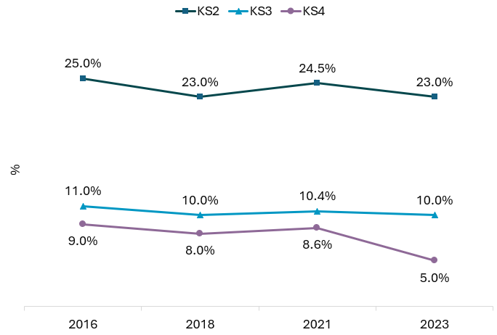
Source: Safe and Well at School Survey, Brighton & Hove City Council and University of Sussex
Note: KS2 = Key Stage 2 (Years 4-6), KS3 = Key Stage 3 (Years 7-9), KS4 = Key Stage 4 (Years 10-11)
In 2023, students who answered “Yes” to this question were also asked what type of help they received. The most common type of help received was help with reading and writing, which over half of extra help students at all key stages said they received (KS2: 66.7%, KS3: 51.6%, KS4 58.8%), followed by help to stay calm (KS2: 31.7%, KS3: 42.9%, KS4: 41.9%) (Figure 17).
Figure 17: Type of help received by pupils receiving extra help (%) by key stage, Brighton & Hove Safe and Well at Schools Survey, 2023
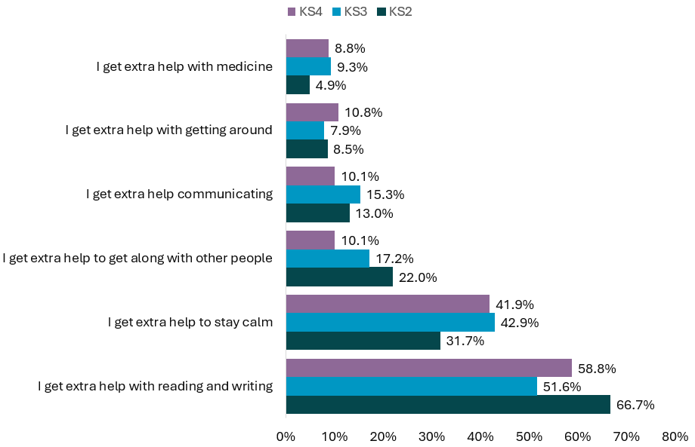Source: Safe and Well at School Survey, Brighton & Hove City Council and University of Sussex, 2023
Demographics: A higher percentage of the following groups of students reported receiving extra help: ​
- Students who were adopted (KS2: 61%, KS3: 41%, KS4: 26%), young carers (KS2: 37%, KS3: 25%, KS4: 15%), or care experienced (KS2: 57%, KS3: 35%, KS4: 20%)
- Students in the category experiencing the most financial hardship (KS2: 34%, KS3: 13%, KS4: 7%)
- Boys (KS2: 25% & KS3​: 10%)
- Students that do not identify with the gender they were assigned at birth (KS3: 18% & KS4: 11%)
- LGB+ students compared to heterosexual students (KS3: 13% & KS4: 8%)
Students that said they received extra help of any kind respond differently to health and wellbeing questions throughout the survey compared with students who said they did not receive extra help.
Experiences of school: Children and young people receiving extra help are less likely to agree that people like them do well at school, to feel they belong in their school, to feel safe in school, enjoy learning, and enjoy coming to school. This is seen at all three key stages. They are also more likely to say they have been bullied in the last term:
- KS2: 25% compared to 18%
- KS3: 33% compared to 18%
- KS4: 34% compared to 14%
Most common reasons for bullying given by pupils receiving extra help in were:
- KS2 and KS3: schoolwork, appearance, disability and other reason
- KS4: appearance, schoolwork, disability and gender identity
Children and young people receiving extra help in KS2 are more likely to have helped someone who was being picked on, and more likely to have helped someone who was hurt (only asked in KS2).
Emotional health and wellbeing: At all key stages, those receiving extra help are less likely to agree that they had often been happy recently (KS2: 84% versus 90%, KS3: 70% versus 85%, KS4: 70% versus 81%) and are more likely to agree they have often felt sad (KS3: 64% versus 54%, KS4: 76% versus 60% - asked at secondary school only).
Healthy lifestyles: Key Stage 2 students who said they received extra help are less likely to meet physical activity recommendations than those who do not receive extra help (26% compared with 29%), though this is not seen at secondary school age. They also are less likely to say they have eaten 5 fruit or vegetables in the previous day at Key Stage 2 (64% compared with 71%) and Key Stage 3 (57% compared with 62%).
In secondary schools, a higher proportion of extra help students said they had ever smoked, tried drugs and tried vaping, and in KS3 a higher proportion ever had an alcoholic drink before (Table 12).
Table 12: Proportion (%) of pupils that have ever tried smoking, vaping, drugs or alcohol by key stage and whether they were receiving extra help, Brighton & Hove Safe and Well at School Survey, 2023
 | KS2  Extra help | KS2  No extra help | KS3  Extra help | KS3  No extra help | KS4  Extra help | KS4  No extra help
Ever tried drugs |  |  | 10% | 6% | 30% | 23%
Ever had an alcoholic drink |  |  | 37% | 30% | 62% | 64%
Ever tried cigarettes |  |  | 14% | 6% | 44% | 28%
Ever tried vaping |  |  | 33% | 21% | 56% | 47%
Does 1hr physical activity every day | 26% | 29% | 21% | 23% | 19% | 17%
Ate 5+ portions of fruit or veg prev. day | 64% | 71% | 57% | 62% | 46% | 51%
Source: Safe and Well at School Survey, Brighton & Hove City Council and University of Sussex

Health Counts Survey 2024
Health Counts is a health and wellbeing survey of Brighton & Hove residents conducted once a decade. It asks questions about the health and lifestyle issues local people experience and provides important evidence of inequalities in parts of the city and faced by particular groups.
The 2024 Health Counts survey was conducted by researchers at the University of Brighton, in collaboration with Brighton & Hove Medical School, NHS Sussex, Healthwatch Brighton & Hove, Brighton & Hove Federation and Brighton & Hove City Council Public Health Intelligence team. It was funded by Public Health and had ethics approval from the NHS and University.
The previous surveys were postal survey. In 2024 this moved to an online survey. The main route of invitation was through GP practice text message invitation for all registered patients aged 18 years or over, without a national data opt out. There was also wider promotion and supported completion in some settings, targeted to include those that might be more likely not to be registered with a GP practice and groups who might face digital exclusion.
There were 16,729 respondents to the survey, 7.2% of the resident population aged 18 years or over. Results are weighted for age, gender and deprivation quintile to be more representative of the city.
There were 2,821 respondents aged 18-24 years (weighted base). This large sample enables us to do more inequalities analysis than in previous surveys.
The survey used the 2021 Census questions with people who assessed their day-to-day activities as limited by long-term physical or mental health conditions or illnesses classified as disabled. This definition of a disabled person meets the harmonised standard for measuring disability in line with the Equality Act (2010). We recognise that there are limitations with this question –it was used as allows comparability with the Census.
In this initial analysis we included anyone who said they had a long-term condition but did not exclude those who said activities were not limited. This will be the next stage of analysis.
We then used the breakdown from the Brighton & Hove City Council equalities monitoring form for physical and mental health and neurodiversity.
It should be noted that the survey was not available in an easy read format and so prevalence of some conditions may be lower in the survey. This may be particularly the case for people with learning disabilities.
There were 1,530 respondents aged 18 to 24 years (54% of respondents aged 18-24) who said that they had a physical, mental health condition or illness or neurodivergent.
The most commonly reported were mental health (1,016, 36% of respondents in this age group), Autism and/or learning difference (764, 27%) followed by physical illness/condition (320, 11%) (Figure 18).
Neurodivergent young people include those that ticked the Autism and/or learning difference (e.g. ADHD, Dyslexia, dyspraxia) question options in the survey.
Figure 18: Percentage of people with physical or mental health conditions or illnesses lasting or expected to last 12 months or more, respondents aged 18-24 years, Health Counts survey, Brighton & Hove, 2024
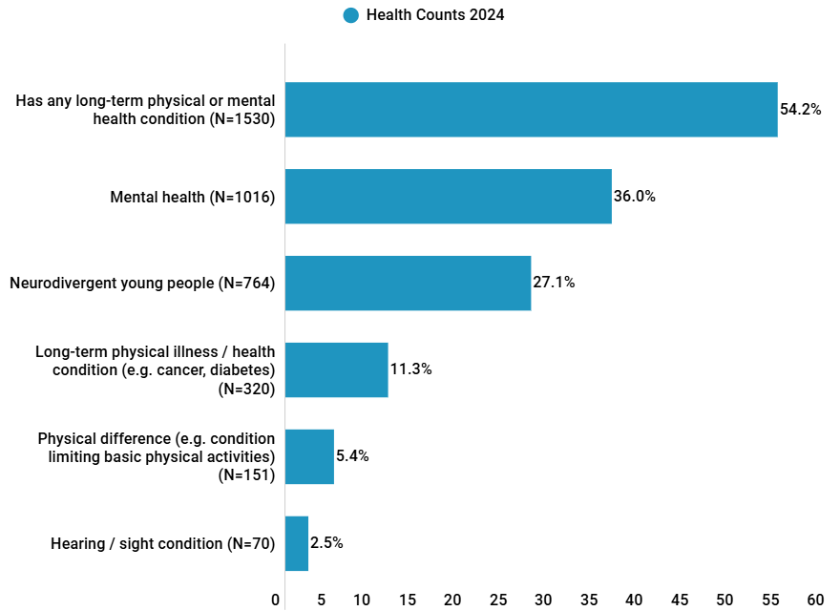
Source: Health Counts 2024, University of Brighton, Brighton and Sussex Medical School and Brighton & Hove City Council
As the sample of those with a learning disability is very small, and the survey was not available as an easy read survey, results for those with a learning disability are not presented, but this group is included within the overall group of those with long-term physical or mental health conditions.
Demographics
Respondents aged 18-24 years with a long-term physical or mental health condition were more likely, than all respondents aged 18-24, to:
- Live in more deprived areas: 24% of respondents with long-term physical or mental health conditions live in parts of the city in the 20% most deprived areas of England, compared to 21% of all 18-24 year old respondents. This was significantly higher for those with a sensory impairment (36%), neurodivergent (31%) or a long-term physical illness/condition (28%)
- Be Lesbian, Gay, Bisexual, Queer or other non-heterosexual sexual orientation (LGBQ+): Almost half (49%) of all respondents aged 18-24 years were LGBQ+. Nearly two-thirds (63%) of 18-24 year olds with a long-term physical or mental health condition or neurodivergent respondents identified as LGBQ+. Neurodivergent (72%), mental health issue (71%), physical difference (69%) and sensory impairment (68%) were most likely to be LGBQ+
- Be Trans, Non-binary or Intersex (TNBI): 15% of all respondents aged 18-24 years are TNBI. A fifth (22%) of 18-24 year olds with a long-term physical or mental health condition or neurodivergent respondents identified as TNBI. Neurodivergent young people (35%) were most likely to identify as TNBI
- There was less difference for ethnicity: 28% of all 18-24 year old respondents were Black and Racially Minoritised (BRM) and significantly higher for those with a physical difference (40%) and significantly lower for those with a long-term physical illness/condition (21%)
General health
Respondents aged 18-24 years with a long-term physical or mental health condition were less likely, than all respondents aged 18-24, to be in good or better health: 67% of all respondents were in good or better health, compared to 51% of those with a long-term physical or mental health condition (Figure 19).
This was lowest for those with a physical difference (33%), followed by those with a long-term physical health condition (39%).
Figure 19: Percentage of people in good or better health by long-term physical and mental health conditions, respondents aged 18-24 years, Brighton & Hove Health Counts survey, 2024
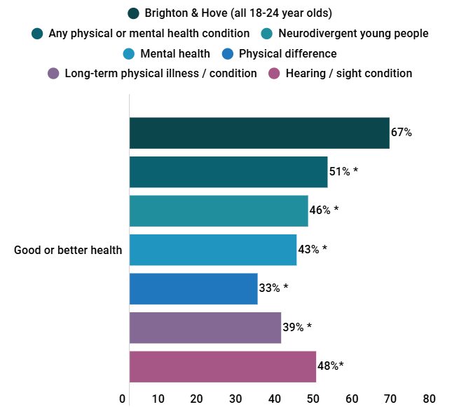
Source: Health Counts 2024, University of Brighton, Brighton and Sussex Medical School and Brighton & Hove City Council
*Denotes significantly different from Brighton & Hove
Emotional wellbeing, self-harm, suicidal thoughts and attempts
- Respondents aged 18-24 years with a long-term physical or mental health condition were more likely, than all respondents aged 18-24, to have a low happiness score – 41% for all 18-24 year olds, compared to 50% for 18-24 years with a long-term physical or mental health condition. The low happiness score was highest in those with a physical difference (71%), mental health condition (62%) or hearing or sight impairment (61%).
- Having self-harmed in the last 12 months was also significantly higher for 18-24 year olds with a long-term physical or mental health condition – 39% of 18-24 years with a long-term physical or mental health condition compared to 27% of all 18-24 year olds. Self-harming was highest in 18-24 year olds with mental health conditions (49%), Autism or learning difference (44%) or a physical difference (40%).
- Almost half of all 18-24 year olds said that they had thought of taking their life in the last 12 months even though they would not actually do it. This was higher for 18-24 year olds with a long-term physical or mental health condition at 63%, and highest for those with a mental health condition (78%), Autism or learning difference (67%), physical difference or hearing/sight impairment (both 60%).
- Respondents aged 18-24 years with a long-term physical or mental health condition were more likely to have ever attempted suicide at 35% compared to 23% of all 18-24 year olds.
Healthy lifestyles
- There was little difference in alcohol risk for 18-24 year olds with a physical or mental health condition (50%) compared to all 18-24 year olds (51%).
- Respondents aged 18-24 years with a long-term physical or mental health condition were more likely, than all respondents aged 18-24, to have used non-prescription drugs in the past 12 months – 35% for all 18-24 year olds, compared to 41% for 18-24 years with a long-term physical or mental health condition. It was highest in those with Autism or learning difference (47%), a physical difference (47%), or mental health condition (45%).
- Respondents aged 18-24 years with a long-term physical or mental health condition were less likely, than all respondents aged 18-24, to be a healthy weight – 52% for all 18-24 year olds, compared to 45% for 18-24 years with a long-term physical or mental health condition.
Social support, safety and harassment
- Respondents aged 18-24 years with a long-term physical or mental health condition were as likely, than all respondents aged 18-24, to say that if they were ill in bed that they had someone they could ask for help – 68% for all 18-24 year olds, compared to 64% for 18-24 years with a long-term physical or mental health condition. This was significantly lower for 18-24 year olds with Autism or learning difference (61%), or mental health condition (59%).
- Respondents aged 18-24 years with a long-term physical or mental health condition were less likely, than all respondents aged 18-24, to feel very or fairly safe walking alone at night in their local area – 52% for all 18-24 year olds, compared to 42% for 18-24 years with a long-term physical or mental health condition. This was lowest for 18-24 year olds with a hearing/sight condition (23%), physical difference (33%) or long-term physical illness/condition (35%).
- Respondents aged 18-24 years with a long-term physical or mental health condition were more likely, than all respondents aged 18-24, to have been insulted or shouted at by a stranger in a public space – 39% for all 18-24 year olds, compared to 44% for 18-24 years with a long-term physical or mental health condition. This was highest for 18-24 year olds with a physical difference (50%), mental health condition (48%), Autism or learning difference (45%). There was a similar pattern for having felt physically threatened by a stranger in a public place.
- 8% of respondents aged 18-24 years with a long-term physical or mental health condition feel fairly/very worried about being targeted by perpetrators of hate crime because of their disability or assumed disability. This was highest for those with a physical difference (20%), Autism or learning difference (14%).

Local referrals
This section summarises local data available on open autism referrals for 0-25 year olds (provided by NHS England) and neurodevelopmental assessment referrals for autism and ADHD (available on Pan-Sussex dashboard).

Autism and ND assessment

NHS England autism waiting times
NHS England provide data on open referrals based on the time between a referral for suspected autism and the first care contact associated with that referral. Monthly data is provided on a group of measures by age group. These are experimental statistics (official statistics in development) published by NHS Digital.
Child and adolescent mental health (CAMH) services data is reported alongside adult mental healthcare activity in the Mental Health Services Dataset (MHSDS). Activity in community paediatric services is reported through the Community Services Dataset (CSDS), this is currently not included in this data report. For Brighton & Hove, there are low numbers of open referrals for those aged under 10 years (breakdowns available are under 10, 10-17 and 18+ years), which suggests that it does not include data from community paediatric services and so is not included with this summary.

Sussex Integrated Care System Children and Young People’s dashboard
There has previously been a lack of consistent data on autism assessment pathways. The Sussex Integrated Care System now has a Children and Young People’s dashboard which is bringing together information on the pathway for those aged 0-17 years. Note that 18–24-year-olds are not included within these figures.
This information is only available from this source since June 2023, but shows that between September 2023 and September 2024:
- New referrals for Neurodevelopmental assessment (Autism and ADHD) have fallen from 1.6 per 1,000 people in September 2023 to 0.8 per 1,000 population in September 2024 (Figure 20)
- The average wait time in weeks for neurodevelopment assessment in children increased from 23 weeks in September 2023 to 27 weeks in June 2024 (Figure 21)
- The number of children aged 0 to 17 years in Brighton & Hove with an open suspected Autism referral (waiting for assessment) has increased by 185% since September 2023. In September 2023, there were 170 children with an open suspected autism referral, compared to 485 in September 2024. This could be attributed to an increased awareness about Autism from parent carers, school and health professionals (Figure 22)
- The percentage of autism assessments open for more than 13 weeks varies month on month and as of September 2024 was 91% of open assessments (Figure 23).
Figure 20: New referrals for neurodevelopmental assessment per 1,000 people aged 0-17 years, Brighton & Hove, September 2023 to September 2024
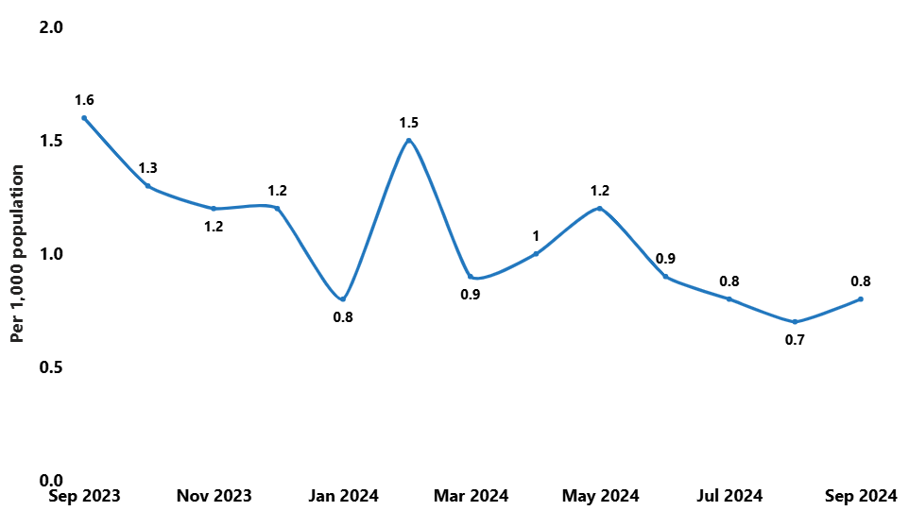Source: Pan Sussex Children’s Metrics Dashboard, Sussex health and care, 2024
Figure 21: Average wait time (weeks) for neurodevelopmental assessment, people aged 0-17 years, Brighton & Hove, Sept 2023 to June 2024
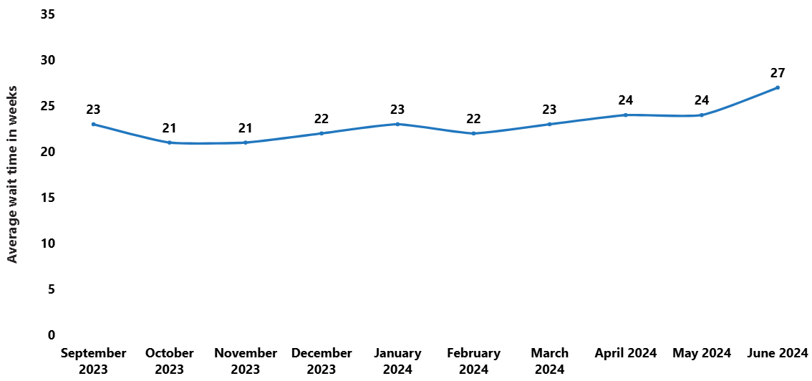Source: Pan Sussex Children’s Metrics Dashboard, Sussex health and care, 2024
At the time of collating this data, there was no available data for the average wait time for July to September 2024.
Figure 22: Number of patients aged 0 to 17 years with an open suspected autism referral by month, Brighton & Hove, September 2023 to September 2024
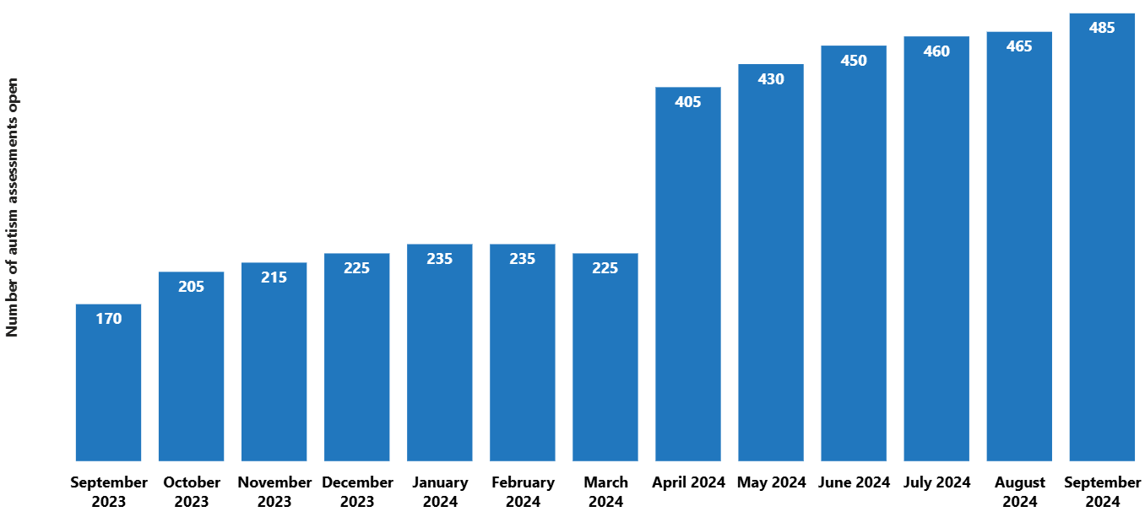
Source: Pan Sussex Children’s Metrics Dashboard, Sussex health and care, 2024
Figure 23: Percentage of patients aged 0 to 17 years with an open suspected autism referral that has been open for at least 13 weeks, Brighton and Hove, September 2023 to September 2024
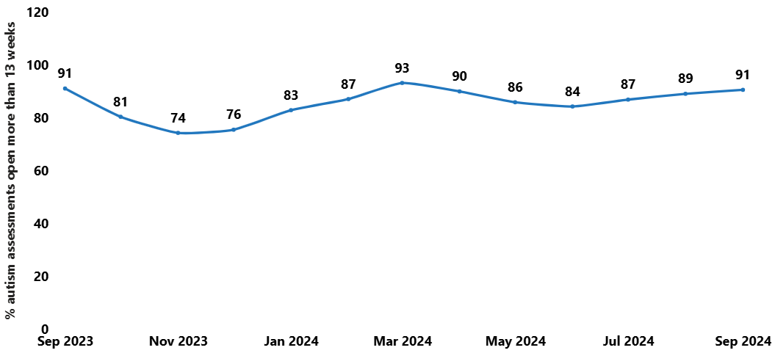Source: Pan Sussex Children’s Metrics Dashboard, Sussex health and care, 2024

Projected future demand for Education and Health Care Plans (EHC Plan)
Brighton & Hove City Council undertook analysis in March 2025 to provide projections of children and young people aged 0 to 25 with EHC Plans for each year from 2026 to 2032 by Autistic Spectrum Disorder and Social, Emotional and Mental Health categories of need using a linear regression model. This is for the Brighton and Hove resident population of children and young people, not for those attending education establishments within the city.
Table 13 shows the EHC Plan projections from 2026 to 2032. It should be noted that these estimated were derived before publication of the 2022 based subnational population projections from the Office for National Statistics in June 2025.
The number of children and young people aged 0-25 with an EHC Plan is projected to increase from 2,948 in 2025 to 4,427 in 2032, an increase of 50% in terms of the number of children and young people. Or an increase from 4.0% to 6.1% of 0–25-year-olds (Table 13).
Table 13: Projected number, and percentage, of children and young people aged 0-25 with an EHC Plan, Brighton & Hove residents, 2025 to 2032
Year | Actual numbers of EHC Plan used to fit models | Projected number | Population age 0 to 25 | Projected percentage of 0-25 year olds
2025 | 2,948 | 2,886 | 72,112 | 4.0%
2026 |  | 3,108 | 72,238 | 4.3%
2027 |  | 3,332 | 72,195 | 4.6%
2028 |  | 3,554 | 72,242 | 4.9%
2029 |  | 3,769 | 72,230 | 5.2%
2030 |  | 3,990 | 72,171 | 5.5%
2031 |  | 4,214 | 72,210 | 5.8%
2032 |  | 4,427 | 72,134 | 6.1%
Source: Brighton & Hove City Council education team
By primary need, it is projected that:
- The number of autistic children and young people aged 0-25 years (ASD) as their primary need will increase from 1,058 in 2025 to 1,912 in 2032 – an 81% increase. Or an increase from 1.5% to 2.7% of all 0-25 year olds
- The number of children and young people aged 0-25 years with social, emotional or mental health (SEMH) needs as their primary need will increase from 598 in 2025 to 973 in 2032 – a 63% increase. Or an increase from 0.8% to 1.3% of 0-25 year olds
- The number of children and young people aged 0-25 years with other primary needs will increase least, from 1,230 in 2025 to 1,432 in 2032 – a 16% increase. Or an increase from 1.7% to 2.0% of all 0-25 year olds.

Educational outcomes
This section shows a range of educational outcomes for all pupils, those with SEN support and those with EHC Plans at city and national level.

Key stage 1 phonics attainment
For 2023/24 academic year, 80% of all year 1 pupils in England met the expected standard in the phonics screening. This was much lower for pupils with SEN at 44% (52% for those with SEN Support and 20% for pupils with an Education, Health and Care plan).
For Brighton & Hove (Figure 24):
- Overall attainment was the same as for England (80%) for all pupils in the city
- Attainment for pupils with any SEN at 45% was similar to 44% for England
- A higher percentage of pupils with SEN support met the expected standards compared to England (Brighton & Hove 55%, England 52%)
- For pupils with an EHC plan, 14% met the expected standards in Brighton & Hove, lower than the 20% for England.
Figure 24: Percentage of pupils in year 1 meeting the expected standard in the phonics screening check, by SEN status, Brighton & Hove and England, 2023/24

Source: Department for Education, Phonics screening check attainment Year 1, 2023/24

Key stage 2 attainment
For 2023/24 academic year, 61% of all year 6 pupils in England met the expected standards in reading, writing and maths (combined). This was much lower for pupils with SEN at 22% (26% for those with SEN Support and 9% for pupils with an Education, Health and Care plan).
For Brighton & Hove (Figure 25):
- Overall attainment was similar to England (60% for all pupils in the city compared to 61% for all pupils in England), attainment for pupils with any SEN was slightly higher in the city at 25% compared to 22% for England
- More pupils with SEN support met the expected standards than England (Brighton & Hove 25%, England 22%)
- For pupils with an EHC plan, 7% met the expected standards in Brighton & Hove, slightly lower than the 9% for England.
Figure 25: Percentage of pupils in year 6 meeting the expected standards in reading, writing and math (combined), by SEN status, Brighton & Hove and England, 2023/24

Source: Department for Education, Key Stage 2 attainment figure, 2023/24

Key Stage 4 Average Attainment 8 score
Average attainment 8 score measures the average achievement of pupils in up to 8 qualifications., For the 2023/24 academic year (Figure 26):
- The average attainment 8 score for all KS4 pupils in England was 46. This was much lower for pupils with SEN at 28 (33 for those with SEN support and 14 for pupils with an EHC Plan)
- Average attainment 8 score for all KS4 pupils in Brighton and Hove (48) is similar to England (46)
- Average attainment 8 score for pupils with any SEN was higher in the city at 30 compared to 28 for England
- The average attainment 8 score for pupils receiving SEN support was 37 compared to 33 for England
- Pupils with an EHC plan had an average attainment 8 score of 13 in Brighton and Hove, similar to England (14).
Figure 26: Average attainment 8 score of Key Stage 4 (KS4) pupils by SEN status, Brighton & Hove and England, 2023/24

Source: Department for Education, Key Stage 4 Performance figure, 2023/24

Attendance
Overall absence
In Brighton & Hove, the overall pupil absence rate is 8%, similar to England (7%) in 2023/24. For pupils without SEN the city figure is also similar to England (7% and 6%, respectively) (Figure 27).
However, there are higher rates of overall absence for pupils with SEN Support (12% Brighton & Hove, 10% England) and with an EHC Plan (16% Brighton & Hove, 13% England).
The overall absence rate in Brighton & Hove increased from 5% in 2017/18 to 8% in 2023/24. The overall absence rate increased by more in those with SEN Support or an EHC Plan than in pupils with no SEN (Figure 28, note England figures not shown on the figure):
- Increased from 4% to 7% of pupils with no SEN (England from 4% to 6%)
- Increased from 7% to 12% of pupils with SEN Support (England from 7% to 10%)
- Increased from 10% to 16% of pupils with an EHC Plan (England from 9% to 13%)

Figure 27: Overall absence rate (%) in school pupils, by SEN status, Brighton & Hove and England, 2023/24
Source: Department for Education Pupil absence in schools in England, 2023/24
Figure 28: Overall absence rate (%) by SEN status, Brighton & Hove, 2017/18 to 2023/24
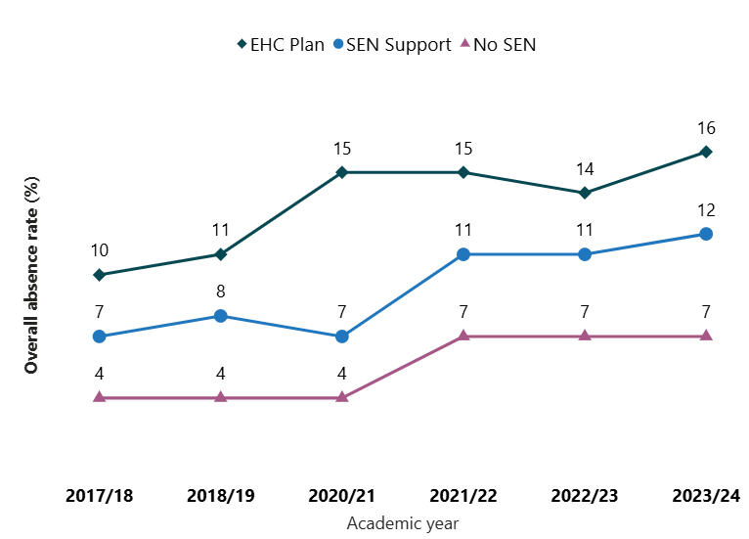
Source: Department for Education, Pupil absence in schools in England, 2023/24
Persistent absence
In Brighton & Hove 22% of pupils were persistently absent in 2023/24 (missed 10% or more sessions), higher than England (20%). This is lower for pupils with no SEN (18% Brighton & Hove, 17% England) (Figure 29).
Persistent absence is much higher for pupils with SEN support or an EHC plan, and rates in Brighton & Hove are higher than for England:
- SEN support: 34% for Brighton & Hove compared to 30% for England
- EHC plan: 43% for Brighton & Hove compared to 36% for England.
Figure 29: Rate (%) of persistence absence, by SEN status, Brighton & Hove and England, 2023/24
Source: Department for Education Pupil absence in schools in England, 2023/24
The persistent absentee rate in Brighton & Hove increased from 9% in 2017/18 to 18% in 2023/24. It increased for pupils with any SEN as well as for pupils with no SEN during/post the Covid19 pandemic and remains higher in those with an EHC Plan and SEN Support than those with no SEN (Figure 30):
- Increased from 9% to 18% of pupils with no SEN (England from 9% to 17%)
- Increased from 21% to 34% of pupils with SEN Support (England from 18% to 30%)
- Increased from 31% to 43% of pupils with an EHC Plan (England from 25% to 36%).
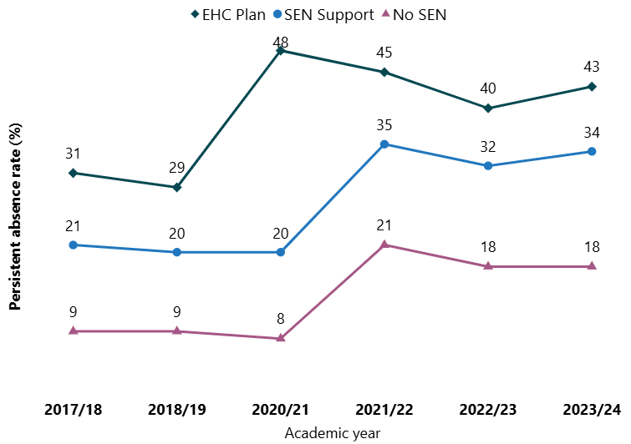
Figure 30: Persistent absence rate (%) by SEN status, Brighton & Hove, 2017/2018 to 2023/2024
Source: Department for Education Pupil persistent absence in schools, England

Reduced timetables
All pupils of compulsory school age are entitled to a full-time education suitable to their age, aptitude and any special educational needs they may have.
In very exceptional circumstances, where it is in a pupil’s best interest, there may be a need for a school to provide a pupil of compulsory school age with less than full-time education through a temporary part-time timetable to meet their individual needs (a reduced timetable). For example, where a medical condition prevents a pupil from attending school or another setting full-time and a part-time timetable is used to help the pupil access as much education as possible.
A part-time timetable should not be used to manage a pupil’s behaviour, requires written agreement from a parent/carer, should be an exceptional measure and have a proposed end date that takes into account the circumstances of the pupil, after which the pupil is expected to attend full-time, either at school or an alternative provision.
The reduced timetables (RTT) data is available for pupils from reception year to year 11 across all schools - including academies, special schools, and the Pupil Referral Unit (PRU), except for private schools. The data is provided directly by schools. There is no comparative data for England available. Tables are available in Appendix 2.
Total pupils: In 2024 2.3% (726) of pupils in Brighton & Hove were on reduced timetables register, in 2023 1.9% (595) and 2022, 2.1% (662).
SEN pupils: In 2024, 9% of SEN pupils were on reduced timetables (601 of 6,845), 16% of pupils on EHC Plan (255 of 1,627) and 7% pupils on SEN Support (346 of 5,218). This had increased slightly from 8% of SEN pupils in 2023 (490 of 6,380) and 8% in 2022 (506 of 6,061).
By identified SEND need: In 2024, there was a total of 551 pupils (EHC Plan or SEN Support) with a primary need recorded on the register (out of 601 total SEN recorded) – those with a known primary SEND need makes up 76% of those on reduced timetables. An increase from 401 (67%) in 2023 and 482 (73%) in 2022. In 2024 32% of pupils on reduced timetables were identified as having social, emotional, and mental health need as their primary need, 27% with a communication and interaction need, 10% with a cognition and learning need (10%) and 3% with a sensory and physical need.
By school type: While the percentage of special school pupils on reduced timetables is higher than those in primary and secondary schools, this has reduced 3-fold from 18% of pupils in 2022 to 6% in 2024. The percentage of secondary school pupils has remained unchanged at 3% as has primary school pupils at 1%. The Pupil Referral Unit (PRU) have the highest percentage of children and young people with reduced timetables and has increased from 40% of pupils in 2022 to 53% in 2024.
By school for pupils on SEN support: A higher percentage of pupils in secondary schools on reduced timetables have SEN Support (30%, 221 pupils) than in primary schools (17%, 125 pupils). These figures have increased from 26% and 10% respectively since 2022.
By school for pupils on EHC Plan: In 2024, 130 pupils on EHC Plan were on reduced timetables in secondary schools (18%), similar to primary schools with 125 pupils (17%). In 2022, 26% of pupils on EHC Plan were accessing reduced timetables in secondary schools and 15% in primary schools.
By gender: There are more males on reduced timetables in Brighton & Hove Schools than females - in 2024, 279 females (38%) and 445 males (61%). This has increased from 235 females (35%) and 422 males (64%) on reduced timetables in 2022.

Electively home educated pupils
Elective home education is where a parent or carer removes their child from school roll, or never has them enrolled, in order to take on full responsibility for their education. For children with Special Educational Needs parents/carers can choose to educate their child at home. If the child goes to a special school, parents/carers need permission to take them out of school.
As of September 2025, there were 499 children and young people (2% of all pupils in primary and secondary) being electively home educated in Brighton & Hove. Most are secondary school phase (69%, 343 people, with 156 primary school phase). There is variation throughout the year, but there is no clear trend in the figures.
There were 17 children with an EHC Plan who are electively home educated. Information is not held on SEN status, except for children with EHC Plans.

Medical Needs Tuition list
Medical needs tuition is the educational provision available for children who are unable to go to school due to health needs, including illness, recovery from an operation or pregnancy and motherhood. The majority of the children receiving this provision have a diagnosis related to mental health needs. Provision is arranged by the City Council to ensure continued education and support them in returning to school.
As of September 2025, there were 70 children and young people (0.2% of all pupils in primary and secondary) receiving medical needs tuition in Brighton & Hove. Most are secondary school phase (fewer than five primary school phase). There were 14 children with an EHC Plan who are on the medical needs tuition list. Information is not held on SEN status, except for children with EHC Plans - all staff work in a way that is SEN needs led to ensure that the curriculum is fully accessible to all students. There is variation throughout the year, whilst no consistent trend, the number of children on the medical needs tuition list has fallen since the peak in Q1 2024/25 (Figure 31).

Figure 31: Number of children and young people on medical needs tuition list, Brighton and Hove, Quarter 3 2023/24 to Quarter 3 2024/25
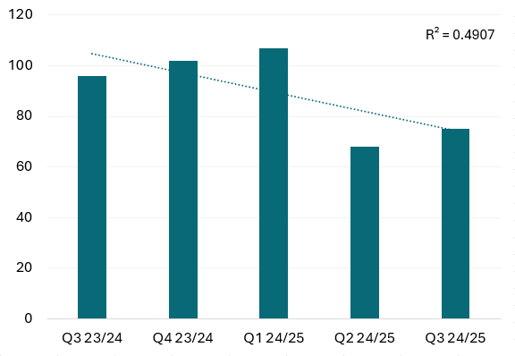
Source: Brighton & Hove City Council

Suspensions and permanent exclusions
The latest published data is for the Autumn term of 2023/24, when (Figure 32):
- There were no permanent exclusions in Brighton & Hove. The permanent exclusion rate in England was 0.05%
- 2.3% of pupils were suspended, lower than the suspension rate for England (4.1%)
- For Brighton & Hove, the suspension rate was 1.2% for pupils with no SEN, but 5-6 times this for pupils with SEN Support (6%) or an EHC Plan (8%)
- The suspension rate in Brighton & Hove is lower than for England pupils with no SEN (England 2.7%), with SEN Support (England 11%) or an EHC Plan (England 10%).
Brighton & Hove has not seen the increase in suspension rates for pupils with SEN Support or an EHC Plan which have been seen across England. Between Autumn 2019/20 to Autumn 2023/24:
- The overall suspension rate in Brighton & Hove increased from 1.8% to 2.3% (England from 2.2% to 4.1%)
- The suspension rate for pupils with SEN Support remained similar, from 7% to 6% (England increased from 7% to 11%)
- The suspension rate for pupils with an EHC Plan remained at 8% (England increased from 7% to 10%)
- The suspension rate for pupils with no SEN increased from 0.7% to 1.2% (England from 1.4% to 2.7%).
There have been no more than three exclusions in Brighton & Hove in any term since Autumn 2019/20 when the data was available – and so no further breakdown is provided.

Figure 32: Rate (%) of suspension by SEN status, Brighton & Hove and England, Autumn term 2023/24

Source: Department for Education Suspensions and permanent exclusions in England.

16-17 year olds Not in Education, Employment or Training (NEET)
In 2023/24, 4.1% of 16-17 year olds in Brighton & Hove were known to not be in education, employment or training (NEET), compared to 3.2% for England (Figure 33). In the city this increased from 3.0% in 2019/20, and for England from 2.6%.
Brighton & Hove has higher rates of NEET in those with an ECHP and SEND support than England, with rates changing little between 2019/20 and 2023/24:
- 13% of 16–17-year-olds with an ECHP (9% England), from 12% in 2019
- 8% of 16–17-year-olds with SEN support (6% England), from 7% in 2019
- 2.8% of 16–17-year-olds without SEN (2.5% England), from 2.2% in 2019.
Figure 33: Percentage of 16-17 year olds who are Not in Education, Employment or Training (NEET), by SEN status, Brighton & Hove and England, 2023/24
Source: Department for Education Participation in education, training and NEET age 16 to 17 by local authority, 2023/24

Destination beyond 16-18 years
The Department of Education provides data on the destination of students beyond the age of 16-18 years, that is if they are in sustained education, sustained employment or sustained apprenticeships. The latest data available is for 2022/23.
In Brighton & Hove, 77% of students with SEN who left 16-18 years education in 2022 were in sustained education, employment or apprenticeship in 2022/23. This is higher than students without SEN (69%). Fewer students both with and without SEN in the city go on sustained education, employment or apprenticeship (combined) than for England 82% for those with SEN (Figure 34) and 88% for those without SEN across England.
In Brighton & Hove, students with special educational needs (SEN) are less likely to have a sustained education destination than those without SEN (36% compared to 43%, respectively). However, students with SEN are more likely than students without SEN to be in sustained employment (33% compared to 24%) or apprenticeship (8% compared to 2%).
Figure 34: Percentage of pupils with identified SEN in state-funded mainstream schools leaving 16-18 level study to sustained education, employment or apprenticeship (combined), in Brighton & Hove and England, 2017/18 to 2022/23
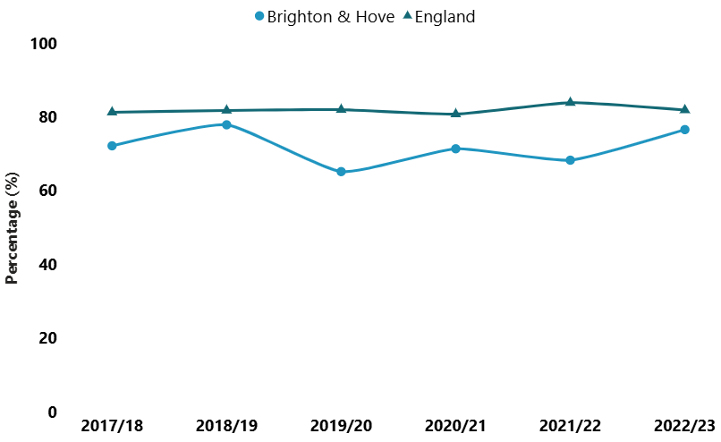
Source: Department of Education. Destination beyond 16-18 years, 2017/18 to 2022/23

Widening Participation in Higher Education (HE) & High Tariff Higher Education (HTHE)
This section shows the trends of progression to higher education (HE) and high tariff higher education (HTHE) by age 19 for state-funded pupils by special educational need (SEN) status at England and then Brighton & Hove level.
Progression to higher education
In England, there is a wide gap between the progression rate for pupils with SEN and those with no SEN provision: only 9% of pupils with an EHC Plan progressed to higher education by age 19 compared to 25% of pupils with SEN support and 51% for pupils with no SEN provision. The progression rate for pupils with SEN support increased from 11% to 25%, from 6% to 9% for pupils on EHC Plan, and from 39% to 51% for pupils with no SEN provision for the years 2009/10 and 2022/23, respectively. The absolutely inequality gap for England between SEN pupils and no SEN pupils narrowed slightly from 28 to 26 percentage points.
In Brighton & Hove, the progression rates for pupils with SEN falls well below those for pupils with no SEN provision. In 2022/23, just 17% of pupils with SEN progressed to HE, compared with 55% of pupils without SEN. Generally, the progression rate has increased - for pupils with SEN increased from 5% to 17%, and from 33% to 55% for pupils with no SEN since 2009/10 (Figure 35). Whilst there has been an improvement for both groups, the absolutely inequality gap between SEN pupils and no SEN pupils widened from 28 to 38 percentage points in the city.
Figure 35: Progression to higher education by age 19, by SEN provision, Brighton & Hove, 2009/10 to 2022/23
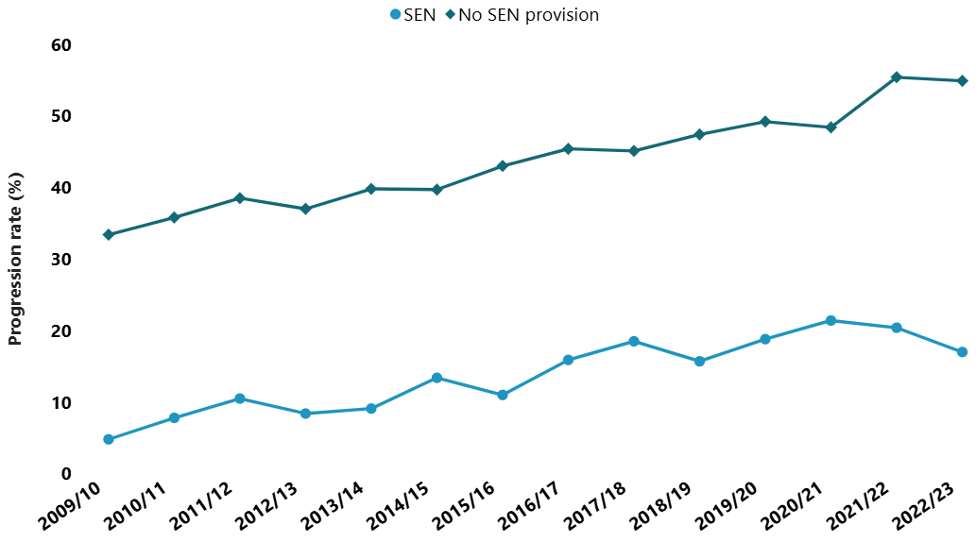
Source: Matched data from the Department of Education National Pupil Database, Widening participation in higher education, 2022/23
Progression to high tariff higher education
Across England, 1.6% of pupil with an EHC Plan and 5% of those with SEN support progressed to high tariff higher education in 2022/23 compared to 17% of pupils with no SEN provision. The progression rate for pupils with SEN support increased from 2% to 5%, 1% to 2% for pupils on EHC Plan, and from 12% to 17% for pupils with no SEN provision for the years 2009/10 and 2022/23, respectively. The absolutely inequality gap for England between SEN pupils and no SEN pupils widened slightly from 10 to 12 percentage points.
In Brighton & Hove, between 2009/10 and 2022/23, there has been a variable trend in the progression rates for pupils with any SEN – from 2% in 2009/10, to 3% in 2022/23 compared to an increase from 11% to 22% for pupils without SEN (Figure 36). The absolutely inequality gap between SEN pupils and no SEN pupils widened from 9 to 19 percentage points in the city.
Figure 36: Progression to high tariff higher education by age 19, by SEN provision, Brighton & Hove, 2009/10 to 2022/23
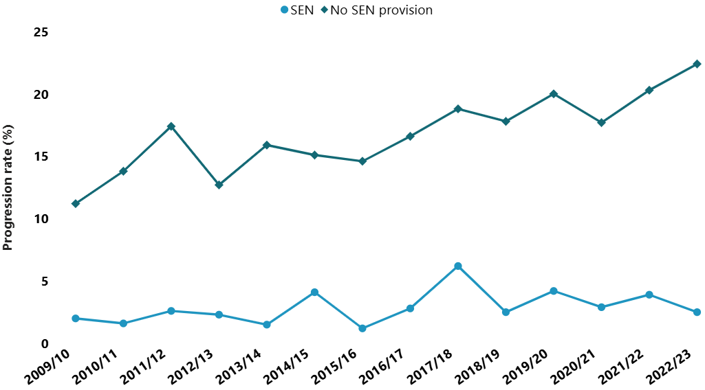
Source: Matched data from the Department of Education National Pupil Database, Widening participation in higher education, 2022/23

National evidence reviews on intersectionality

Methods
Intersectionality refers to the way in which multiple aspects of a person’s identity - such as ethnicity, socio-economic status, sexual orientation, and other characteristic - interact to shape their lived experiences. This approach is particularly important when considering access to services and the barriers individuals may face.
A literature review focusing on SEND children and young people who also belong to one or more protected or vulnerable groups was undertaken. The aim was to explore how intersecting factors - ethnicity, socio-economic disadvantage, experience of care, gender identity and sexual orientation - may influence their access to education, health services, and overall support. Evidence search reports, including search terms used, are available Evidence reviews. The literature review methods are provided in the Appendix 4.

Overview of findings
As shown in Table 14, the literature search that yielded the highest number of results focused on SEND and ethnicity. After screening, 26 papers were included and a summary of the synthesis is provided below. In contrast, for deprivation (4 papers), sexual orientation or gender identity (2 papers), and care-experienced (7 papers), the number of studies was too small, or the study types too varied, to allow meaningful synthesis across papers. Therefore, papers have been summarised. Sexual orientation and gender identity could not be considered separately, as was our intention, because the two papers covered both areas. A list of all papers screened (by topic), along with a summary of each paper and link to the publication: SEND and intersectionality in children and young people.pdf:

Table 14: Number of papers included and excluded across intersectional topics
SEND and intersection | Papers screened | Papers included | Papers excluded | Reason for exclusion
Ethnicity | 47 | 26 | 21 | - No ethnicity intersectional information with SEND  - No UK data  - Only on adults  - Advice or framework piece
Deprivation | 21 | 4 | 17 | - No deprivation intersection directly with SEND
Care experienced | 12 | 7 | 5 | - No social care experience intersection with SEND
Sexual orientation; Gender identity | 6 | 2 | 4 | - No intersectional information with SEND  - Opinion piece

Overall summary of findings
Children most affected by inequalities in SEND provision are often those who also belong to other groups that are treated unfairly. The literature highlighted that this is true for children from Black and racially minoritised or migrant backgrounds, those in care or care experienced and those living in families experiencing financial hardship. It also highlighted that boys are disproportionately represented in certain SEND categories - such as social, emotional and mental health disorders - and may face gendered assumptions about behaviour and learning.
Children experiencing compounding intersectional inequalities are less likely to have their needs identified early, less likely to receive appropriate support, and therefore may be more likely to experience exclusion, not do as well as expected, and experience long-term compounding disadvantage.
Challenges identified in the literature include lack of multilingual assessments, mislabelling / misdiagnosing due to language barriers; professionals having low expectations; and school accountability pressures such as meeting OFSTED standards leading to off-rolling practices of pupils. Off-rolling is the practice of removing a pupil from the school roll without a formal, permanent exclusion or by encouraging a parent to remove their child from the school roll, when the removal is primarily in the interests of the school rather than in the best interests of the pupil.

SEND and ethnicity
A total of 26 papers were included and synthesised by study type: 10 qualitative, 3 reviews, 2 mixed-methods, and 11 quantitative studies. Voices from children and young people, parent/carers, and teachers/ professionals were captured in the qualitative studies. Almost all were set in educational settings.

Overarching themes
The literature highlights several recurring themes that represent challenges faced by Black and racially minoritised SEND children and young people, as well as their parent/ carers, challenges that compound inequalities in assessment, diagnosis, access to support, education outcomes and transitions:
- Disparities in diagnosis and support
- Power imbalances and systemic bias
- Cultural attitudes towards SEND
- Barriers to access and inclusion
- Over- and under-representation in SEND categories.

Quantitative papers
Black Caribbean, Pakistani, and Roma children were more likely to be overrepresented in some SEND categories such as social, emotional, and mental health (SEMH), often due to cultural misinterpretations and systemic biases. Black Caribbean and Black Caribbean/Mixed White and Black Caribbean pupils were more likely than their White British peers to be identified with SEMH needs even after controlling for other factors such as socioeconomic status. Roma/Irish Traveller children were least likely to receive formal autism diagnoses or Education Health and Care Plans (EHC Plans) despite high need.
Being identified with extra needs may be useful in terms of additional support, however, there are negatives to some labels such as Moderate Learning Difficulties or SEMH, which may result in reduced opportunities because of lowered expectations or continue harmful stereotypes.

Qualitative papers
Figure 37 summarises the themes identified across the qualitative papers followed by an overview, with illustrative quotes from the reviewed papers.
Figure 37: Summary of themes across qualitative papers reviewed

Support
A recurring theme reported across the studies is the inadequacy of support systems, particularly for migrant pupils and those from Black and racially minoritised backgrounds. Pupils experience social isolation due to insufficient peer interactions and cultural stigmas within educational settings.,,,,, In addition, Black and racially minoritised families often reported a lack of local or community-based resources tailored to their needs,,,
“All my support network had zero understanding […] they have no clue about special needs […] I was so frustrated; I have nobody to talk [to] about my son.” (parent)
The absence of adequate multilingual learning resources and interpretation services adds barriers for non-native English speakers. Educators report that it also complicates assessing children’s needs adequately.,,,
"We’re very conscious of the issue that … what would be really wrong is if a child was in a special school because it was a language issue and not a learning issue…. we’ve had the odd child that has been wrongly placed that we’ve moved out very quickly because it became very quickly apparent that they haven’t had a special need." (headteacher of special school)

Power imbalance and professional relationships
Families from Black and racially minoritised backgrounds reported widespread experiences of discrimination, dismissal by school professionals, and lack of accessible information -especially those with limited English proficiency.
Lack of recognition of parent carer as an expert: The lack of culturally competent services, socioeconomic disadvantage and lack of flexibility left many parents feeling alienated and powerless in advocating for their child’s needs. Families often reported feeling unsupported by professionals who lack cultural understanding or fail to provide tailored guidance. The lack of accessible interpreted information meant families could not ask schools how to get their children assessed for educational help.,,,,
“Even if you can’t speak English, there’s no reason to marginalise the parent.” (parent)
Socioeconomic disadvantage and prejudice: Many of the studies reported the barrier created by lack of resources and prejudice, with families from lower socioeconomic backgrounds facing compounded barriers, limiting their access to services.,,,,
“…mum gets up at 4.30am to go out cleaning, then she walks to school and is a midday supervisor. Parents working long hours; we have no experience of this culture where people say….come here to live off benefits; that’s not our experience.” (headteacher)
There were cases where parents reported racist bullying, and the schools initiated a SEND assessment. ,
“…I got this telephone call out of the blue one Sunday afternoon, from his class teacher, suggesting that he have some test—I can’t remember exactly...because it was such a shock…—that there might be some reason for his under-performing: not the racism at the school that I told them about, but there might be some reason, that he might have some learning difficulties.” (parent)
Communication/language barrier and discrimination: Parents felt they were 'talked down to' due to their lack of fluency in English, or unfamiliar jargon used.,,,
“[the SENCO] had never heard me speak that way … something tells me that she didn’t even know that I was intelligent or educated … if I wasn’t half as articulate as I was, I would be buried under the avalanche of the no[s] and the rejections…” (parent)
When a child is also deaf or hard of hearing (DHH) effective communication is even more important as the child may not know/understand their home language, making communication and therefore correctly assessing their needs, very difficult.,

Attitude and perception
This theme explored the attitudes and perceptions toward SEND and ethnic diversity.
Cultural stigmas: Studies reported that Black and racially minoritised communities may harbour cultural stigmas around SEND diagnoses, creating barriers to seeking help or engaging with services.,,,,,
“Oh, my god, (deep breath) that was very difficult … Yes! … when I came to the UK, I thought my son will be going to Oxford University, not to a special school. That was very difficult to tell people”. (parent)
Teacher bias and assumptions: Educators may unconsciously or consciously hold biases that affect their interactions with Black and Racially Minoritised pupils, such as underestimating their abilities or misinterpreting behaviours.,,,, Boys, especially those from Black or mixed ethnic backgrounds, were consistently highlighted as worst affected by low expectations from teachers and professionals.,
“Alongside low expectations, I’ve heard young Black boys say ‘…Our teacher has no expectation for us to do well in our life.” (mentor)
Disciplinary actions and racial discrimination: Black and racially minoritised pupils and SEND pupils, especially boys, are disproportionately subjected to disciplinary measures, often stemming from misinterpreting behaviour as defiance or ‘disruptive behaviour’ rather than as an expression of their needs or considering pupils' experiences. This contributes to exclusion and alienation,,,,,, and being more likely to be labelled as having behavioural issues instead of assessed appropriately, leading to misdiagnosis. Parents reported that their children face racism without adequate support from schools.
“There are limited places to complain about racial discrimination or paths to follow it up seriously. Black & brown children are more likely to be categorised as SEMH, rather than ASD if they do receive a diagnosis, or ADHD, which then opens the door to medication as an option …. an autism diagnosis pushes more for a reasonable adjustment approach. This does not seem to be the more common approach for Black children in our experience.” (parent)
Professionals noted the physical presence or assertiveness of Black boys was often misread as threatening, contributing to punitive rather than supportive responses.
Parental perceptions: Parents often feel misunderstood or judged by schools, further alienating them from the system and creating mistrust. ,,,,,,
“If you’re black, then you’re seen as aggressive, but you’re someone else and you stand your ground, then you're assertive.” (parent)
Cultural difference: Some parents, particularly African parents, view education as an integral part of their child’s wellbeing, even when their child may have additional needs. The attitude of educators may differ. Parents may also reject the notion that their child is different and perceive schools of incorrectly labelling their child. ,,,
“… everything is SEN here (UK), lots of children learn to talk late … girls are shy and get upset easily, that is normal. She can walk, she can talk …’ (parent)

Delivering education
The role of institutional systems and environments in either enabling or obstructing equitable support for SEND pupils.
Rigid policies and lack of flexibility: School procedures may fail to adapt to the cultural and diverse needs of Black and racially minoritised pupils. For instance, standardised approaches to assessments or referrals for SEND services fail to consider unique cultural expressions of behaviour or learning needs.,,,
Where multilingual children are assessed for additional needs in English, they may either be incorrectly diagnosed as having SEND/LD/ND when language fluency was the issue, or they may be incorrectly identified as EAL (English as additional language) when in fact they have SEN needs.,,
Institutional barriers: Staff in educational settings experienced stifling environments, hindering their ability to apply student-centred practices, and challenge racism.
"You will see things internally within the school structure that are wrong and it shouldn’t even be allowed […] If you were to try and challenge that, the next thing you know your contract is not renewed." (contracted pastoral care)
“As a SEND professional, I’ve witnessed and heard of Black and Brown families disrespected by all levels of staff. I’ve seen White children's behaviour treated with far more understanding and trauma informed approaches than Black and Brown children. I’ve also heard disparaging and stereotypical comments made by staff of all levels, including racist language used and/or ignored.” (professional)
Participants described underperforming students often pushed out of schools. Parents feel the pressures put on schools to do well in assessments, for example Ofsted, which can be a detriment to children with disabilities.,,,,, Educational professionals also highlighted pressure to meet OFSTED targets. This hinders their ability to change the system to make it more inclusive, and such rigidity can lead to harmful practices like ‘off-rolling’.
Skilled teachers, stronger SEN outcomes: In mainstream lessons, teachers with SEND specific training made the most impact in pupil learning and professionals with SEN training were better equipped to navigate barriers in service provision, leading to improved support for children with special needs. Furthermore, trained staff played a crucial role in supporting migrant families, particularly those navigating both SEN and language barriers, as they were more aware of the diverse needs of children and their families.

SEND and other intersections

Deprivation
Deprivation is a significant and persistent factor shaping the experiences of children and young people with SEND, particularly in access to support and long-term outcomes. Literature searches on SEND and deprivation or socioeconomic disadvantage or poverty, found 4 papers (3 quantitative, 1 qualitative) meeting our criteria.
Quantitative studies: One study found that children in the most deprived areas of South West England were nearly twice as likely to have mental health problems by age four compared to their most affluent peers.
Another reported that children with autism (35%), autism and learning difficulties (38%), and pupils with other types of SEND (45%) all had higher proportions of socioeconomic disadvantage (eligible for free school meals) than pupils with no SEND (24%).
Families with lower caregiver education are significantly less likely to access intervention and early support services for children aged 0-6 years with suspected or diagnosed developmental disabilities. Higher levels of family economic deprivation predicted increased unmet need for early support service and were less likely to access early support. There are multiple ways economic deprivation can limit access to early support, this paper notes limitations due to direct costs (such as the need to pay for private services because free services are not accessible) and indirect costs (such as travel, childcare).
Socioeconomic backgrounds and inequality in school: Students from lower social class backgrounds reported inadequate exam provisions, isolation practices, and denied placements at suitable schools due to their “complex” needs. In contrast, more affluent families could switch to private education, home educate or bring external professionals into meetings when state provision failed. The withdrawal or absence of support—particularly in critical years like GCSEs—led to significant academic decline, as support was quietly removed.
"Year 7 and 8 I got the support I needed, and then Year 9 is when it started dropping off. As it went on, I got no support…in Maths I went from top set to third set, ’cos when the support stopped, they just put me down . . . I feel very let down since I was doing so well with my support and then when it all stopped, everything just collapsed. [Mum] was trying to get back all the support, but the school was just not listening." (Autistic student)

Care experienced
Literature searches on SEND and care experienced found 7 papers (5 quantitative, 1 qualitative) meeting our criteria.
Quantitative studies: Care experienced children are disproportionately identified with SEND,, and research shows that care experienced children with SEND encounter compounded negative educational outcomes, including, increased exclusion, suspension, non-enrolment/off rolling, and poorer educational achievement trajectories.
Exclusion in mainstream schooling is significantly higher among children receiving social care with no SEN, and even greater for those receiving social care who have a SEN need, compared to peers. For example, children with both SEND and looked-after status were excluded at rates of 42%, compared to 8% of students with no SEND or social care involvement. In special schools, 33% of children looked after were excluded compared to 12% of those with no social care involvement. Furthermore, children receiving social care services are more likely to be non-enrolled by Year 11 (a proxy for off-rolling) and those with a history of SEND are even more likely to be non-enrolled during these crucial GCSE years. Care experienced children with behavioural, emotional, and social difficulties are particularly vulnerable, being significantly more likely to face exclusion by Year 9 and were more likely to be male. When examining educational trajectories, SEN emerged as the strongest predictor of persistently low achievement or declining performance over time among children in care.

Education experiences of children adopted from care: The only qualitative paper explored narratives from adopters and adopted children, the majority of whom had social, emotional, and mental health (SEMH) needs and / or other SEN needs. It revealed several key themes, which included experiences of turbulent and unresolved emotions, challenges in forming trusting relationships, and difficulties within school systems that often fail to adequately understand and support adopted children.
"Having had experiences that an awful lot of kids will never have, thank God, it’s made her look at people in a more guarded way in general and she is much more picky about who she makes friends with ... and what she will tell people, particularly adults because it’s adults obviously that caused the problems in the first place." (adopter)
When describing school itself, children comments included: ‘not safe’ (Billy,13); ‘stressful’ (Frankie,13); ‘like hell’ (Corey,16); ‘like throwing me into a battle zone without any protection’ (Alex,14).
Positive experiences were also highlighted, such as valued and fulfilling relationships in school can provide opportunities for relational healing. However, there were concerns about limited understanding, inaccuracies, and discrimination related to adoption within schools, communities, and wider society.
"They don’t really know that children can be quite badly traumatised or affected by their earlier experience ... they’ll be like, ‘Oh, I’m sure they’re sad at first but they’ll get over it’...They see it as kind of like a phase, not a permanent thing." (Jesse, 16)

Gender identity and sexual orientation
Our intention was to report on intersectional literature on gender identity and sexual orientation for SEND young people separately, as they represent distinct dimensions of identity. However, only two papers were identified for SEND and gender identity and/or sexual orientation combined so we have summarised these here. Both papers touched on the urgent need for further research, targeted resources, and nuanced frameworks to better support gender-diverse children and young people within SEND systems, ensuring both psychological integrity and safeguarding are upheld.
LGBTQI+ students with SEND experience discrimination and victimisation and often face compounded marginalisation, with higher instances of bullying, a lack of tailored support, and environments that question the validity of their identities. There is a growing recognition of the complex intersection between SEND and gender identity / sexual orientation, particularly among children and young people experiencing gender dysphoria or identifying as transgender.
Evidence from educational psychologists working with autistic and gender-diverse youth showed how practitioners often engaged in active, collaborative sense-making due to the absence of clear theoretical or policy guidance. Central to their practice was the validation of young people’s identities, development of inclusive school cultures, and staff training to bridge knowledge gaps.

Parent and carer voice
The following section summarises a full report (Appendix 5) that syntheses existing parent and carers feedback captured between 2020 and November 2024 to highlight lived experiences of parents and carers with children and young people with Special Educational Needs and Disabilities (SEND), Learning Disabilities (LD), and Neurodivergence (ND) in Brighton & Hove.

Methods
A pragmatic approach was taken, with relevant organisations and services working in Brighton & Hove (identified by the Project Group) asked to provide reports that capture parent carer lived experience. Collating past reports that capture parents and carers views and experiences on services can reduce “ask fatigue” and synthesising experiences can help ensure this feedback is used to inform future services.
Most reports received were from the community and voluntary sector. A list of these organisations and the reports used can be found in the Appendix 5. They range in focus from feedback on specific services, strategies and issues, to general reports about parent carer experience. Common themes across these reports were collated by a single reviewer and validated by the Project Group.
Parent carer experiences vary widely across different characteristics and conditions, and the full range of diversity may not be reflected in existing feedback reports. Not all challenges or examples of good practice will be covered, and some feedback may have already been addressed by services.

Summary of themes
The full report is organised by theme and includes direct quotes from parent carers drawn from 24 reports. Below is a condensed summary under four headings: what is working well; barriers and challenges; what can be improved; and compounding factors and inequalities.

What is working well
Positive feedback for many providers: In almost all reports, parent carers talked positively about the impact of many individuals and services. Including proactivity, flexibility and caring, plus the impact of empathetic and helpful professionals. Health, social care, education, housing, and the community and voluntary sector were identified as providing good support, for both specialist and mainstream services.
Flexible provision & reasonable adjustments: Parent carers reported that provision flexible to the child and family needs has multiple positive benefits, like same day appointments; access to remote as well as face to face review; face to face or online support groups; provision for pupils unable to attend school; within schools, training for professionals and provision for sensory difficulties such as quiet rooms.
Communication & ongoing relationship with a key professional: Many reports talked about the value of an ongoing relationship with a key professional. For example, in health and social care supporting earlier referral, and in school facilitating tailored support and communication between school and home. Benefits mentioned included improving confidence, attendance, and identifying issues before they escalate.
Social & community groups: Parent carers talked about the importance of community groups, which allow their child to meet in supportive spaces, build social relationships and take part in activities that promote wellbeing and life skills. Many also talked about the value for parent carers themselves, to make connection with other families in similar positions, share knowledge and provide informal peer support.
Support & advocacy from community and voluntary services (CVS): That provide support and advocacy to families and create welcoming spaces. Parent carers talked about the value of family support courses and workshops that provide practical advice and guidance on things like applying for financial support and housing.
Accessible green spaces: A few reports mentioned accessible spaces, such as parks, with equipment or areas for children with special educational needs or disabilities to use as well as welcoming and inclusive environments across the city more widely.
Co-production in service design: Several reports mentioned the impact of effective co-production between organisations and communities, leading to improvements to the school transport system, new roles & resources such as the Social Communication Resource & Hidden Children Officer role, & creating avenues for parent carer feedback.

Barriers and challenges
Assessment & diagnosis pathway for neurodevelopmental conditions: Parent carers in many reports talked about the difficulty of accessing assessment for conditions such as autism and ADHD, with particular emphasis on long waiting times. There is often a feeling that getting an assessment depends significantly on advocacy by parent carers and individual professionals. The process is stressful for families, who feel that the challenges their child faces worsen while waiting.
Support for those without diagnosis: Several reports mentioned finding it difficult to obtain educational or workplace support without a diagnosis, despite guidelines stating that provision should be need-based rather than diagnosis-based.
Waiting times & capacity for therapies: Parent carers talked about high thresholds for getting onto therapy lists (including speech and language, occupational and physical therapy). Many parent carers emphasised how valuable therapy sessions are, but expressed frustration that only a limited number are provided. Some families who can afford it feel forced to seek private sessions.
Gaps in social care provision: A few parent carers describe a shortage of personal assistants which many families rely on, and a long wait for assessment for social care support. Many reports also described insufficient respite care and short breaks. Eligibility thresholds were felt to be prohibitively high and excluded autistic children and young people without a learning disability.
Navigating a complex system: A common experience across education, health and social care was the challenge of negotiating the system, such as the social care assessment and the EHC Plan process, which is perceived by many to be complex and disjointed. Differences in services, eligibility criteria and pathways across areas was felt to create confusion and inequity of access. Many parent carers described the strain of advocating for their child in a complex system and the impact on their mental health.
Lack of understanding & adaptations made by services: Most reports highlighted a lack of understanding among professionals, particularly in relation to autism (especially in girls) and ADHD. Healthcare environments can cause sensory overload and behavioural challenges, making it difficult to attend appointments. Education settings can lack recognition of behaviours, and accommodations for sensory needs or emotional dysregulation.
Perception of stigma & blame: Some parent carers reported that a feeling or fear of being judged for their parenting skills prevented them from accessing support. They also reported feeling a sense of shame and failure connected to their child’s poor attendance at school, and a fear of being fined for this.
Impact on health & wellbeing of wider family: Most reports talked about the strain on the whole family of caring responsibilities in the context of limitations in support. Caring responsibilities create a challenge for some parents to remain in paid employment. This, compounded by the cost-of-living crisis, was causing financial hardship.

What can be improved
Earlier identification & shorter wait for support: Parent carers talked about a need for early identification and intervention, suggesting training professionals in recognition of neurodivergence. Support offered straight away would avoid families reaching crisis point and smooth transitions between different schools, services, and into adulthood.
Interim support while on neurodevelopmental waiting list: Support needs for families who are on the pathway (without a diagnosis) came up in many reports. Many parent carers felt there was a lack of transparency about the process and would like clear information, including information on training and support on managing their child’s needs whilst awaiting diagnosis, support with education and sign posting; making home adaptations; family support work; mental health support; managing challenging or dangerous behaviour; supporting children to remain in school.
Mental health services: There was mixed experience accessing mental health services. Some parent carers reported good experiences when they can access services, for some there were difficulties accessing mental health review and services having high thresholds and limited number of sessions.
Adapt to specific needs: Parent carers described the need for services which consider mental health and neurodevelopmental conditions together, adapted to the particular needs of neurodivergent children and young people.
Intervene earlier: In several reports, parent carers highlight that support that is only available when in crisis, is difficult to access even then and emphasised that earlier intervention is needed to avoid reaching this point.
Access to activity programmes & respite care: Parent carers in many reports talked about the need for activity programmes and respite services that are accessible to a wider range of families, including having options throughout the week and in school holidays. Several reports also described a lack of provision for neurodivergent children and young people without a learning disability.
Support & community groups: Parent carers in many reports talked about a need for more funding and availability of community groups and courses.
Earlier transition planning: The need for better advance planning and support at key transition points is a key theme across services, with continuity of care between child and adult health and social care. There was a perceived gap in adult mental health services for young people with neurodevelopmental conditions. Plus inconsistency in annual health checks for young people with learning disabilities, long waiting times for assessment and handover gaps between child and adult social care.
More options for education, training & employment: Many reports highlighted that parent carers would like to see services encourage ambitions and aspirations for the next stage for young people with all degrees of needs, including access to earlier careers advice and a broader range of vocational training, work experience and supported internships.
Practical support into adult life: Some parent carers described a need for practical support into adult life, including skills training and support into independent living eg finance, paperwork, cooking. Several highlighted a need for more communication, transparency around consent, capacity and parental responsibility.
Specific gaps in local provision: Parent carers in several reports talked about a gap in understanding and provision for those with ADHD, Tics and Tourette’s, specific learning difficulties, Foetal Alcohol Spectrum Disorders, and Down Syndrome.
Communication & co-production: Parent carers want their expertise about their child valued and several reports specified that services should be designed in collaboration with families. Almost all the reports highlighted the importance of good communication between families and professionals, and a clear point of contact within services.
Training & neuro-affirmative culture: Many parent carers talked about the need for practitioner training across all settings; to improve understanding of how children and young people with differing conditions experience life; how to communicate effectively; and how to make tailored adaptations to support them. Parent carers emphasised the importance of a neuro-affirmative culture that is flexible, facilitates participation, recognises strengths and supports potential.

Compounding factors & inequalities
This section pulled out parent carer feedback on challenges that compound difficulties in getting support for their children, including for those who are LGBQ+, TNBI and/or Black and Racially Minoritised, where other family members have disabilities, are neurodivergent, or single parents. As we only used existing reports, this section does not capture the full range of experiences and may not represent some groups.

Barriers and inequalities
Cultural stigma, awareness and language barriers: Cultural stigma can be a barrier to engaging with support. In some communities there may be limited awareness or differing understandings of conditions like autism, and there may be language barriers for those with English as a second language. Parent carers described the importance of providers taking these differences into account when planning individual support.
Parent carer neurodivergence or disability: In two reports parent carers with disabilities talked about challenges accessing social care support for their children and themselves, and the compound effect on the mental health and wellbeing of the family.
Financial hardship, isolation and single parents: Financial and housing issues were highlighted in several reports. Low income and single parent families of children and young people with SEND face additional hardship. For single parents, affording and securing childcare is a particular challenge, and is associated with isolation and there is a lack of peer support groups for single parents.
Prejudice & discrimination: Families from Black and Racially Minoritised backgrounds described later diagnosis and intervention. Parent carers felt opportunities are fewer, and described a need for greater inclusion, particularly around transition. They talked about ensuring a clear transition plan, bespoke mentoring and advice. Black and Racially Minoritised children and young people have disproportionate experience of school exclusion, not in education, employment or training (NEET), and youth offending services, further impacting future education, training and employment opportunities. Parent carers felt there needs to be more focus on alternative strategies to exclusion, and more educational support for Black and Racially Minoritised young people in the youth offending service.

Supportive factors
Peer and group support: Some parent carers from Black and Racially Minoritised communities talked about the value of peer support groups and mentoring programmes specifically designed for children and young people within these communities.

What can be improved
Increased community provision: Parent carers described the need for targeted community groups sessions for families from Black and Racially Minoritised communities as well as other groups that are currently underserved such as LGBQ+ and TNBI young people with learning disabilities.
Cultural competency & trauma-informed support: Several reports emphasised the need for culturally competent services and a need for trauma-informed practice. One report mentioned the value of inclusion and diversity training programmes working particularly with schools and the police.
Inclusion & co-production: Feedback highlighted that across services there is a need to increase the diversity of staff and trainers, and consulting with people with lived experience to co-design services.

Summary of findings
Included in the Executive Summary

Recommendations
Included in the Executive Summary

Glossary
Amaze
Amaze is a charity that gives information, advice and support to families with children and young people with special educational needs and disabilities in Brighton & Hove and East Sussex
Brighton and Hove Inclusion Service (BHISS)
BHISS provides access to highly skilled and experienced professionals including educational psychologists, specialist teachers and practitioners
Common neurodivergent conditions
Neurodiversity is the variation in neurocognitive ability of all people. “Neurodivergent”, “neurominority” or “neurodistinct” may be used to refer to people with less typical neurotypes, such as attention deficit hyperactivity disorder (ADHD), autism, learning difficulties (dyslexia, dyscalculia, dysgraphia), dyspraxia/ developmental co-ordination disorder, foetal alcohol spectrum disorders, language disorders, attachment disorders and Tourette syndrome.
Children’s social care (CSC)
Children’s social care (CSC) exists to support children and families to keep children safe and intervene if there is a risk of harm and provide care for those who need it. There are three groups of children that fall under CSC:
- Children in need (CiN, including children formerly in need) – Children that require additional help from CSC services to support or maintain their health and well-being and/or who are disabled.
- Child protection plans (CPPs, those on or formerly on child protections plans) - A plan is as a result of local authority child protection investigations, where a child is known or suspected to be suffering or at risk of suffering significant harm.
- Children looked after (CLA, including children formerly looked after) – children who live away from their family.
Intersectionality
Intersectional thinking, or intersectionality, invites us to explore:
- how people experience the world
- how this impacts the way we interact with others
- the extent to which we feel able to share our lived realities
These experiences are shaped and influenced by aspects of our identity, such as our:
- ethnicity
- age
- gender
- sexual orientation
- class
- abilities
LGBQ+ (sexual orientation)
The acronym for Lesbian, Gay, Bi, Queer, Questioning and Ace (asexual). In this document various acronyms are used according to the specific sexual orientation (and sometimes combined with gender identities, for example LGBTQ+,) recorded in each piece of research or data. For this reason, the acronyms may vary.
TNBI (gender identity)
The acronym for Trans, non-binary and Intersex people. In this document various acronyms are used according to the specific gender identities (and sometimes combined with sexual orientation, for example LGBTQ+) recorded in each piece of research or data. For this reason, the acronyms may vary.

Off-rolling
Off-rolling is the practice of removing a pupil from the school register without a formal, permanent exclusion or by encouraging a parent to remove their child from the school roll, when the removal is primarily in the interests of the school rather than in the best interests of the pupil.
Phonological
Phonology is the study of the patterns of sounds in a language and across languages
Special educational needs and/or disabilities (SEND)
A child or young person has SEN if they have a learning difficulty or disability which calls for special educational provision to be made for him or her.
Autistic Spectrum Condition (ASC)
Children and young people with Autistic Spectrum Condition (ASC), including Asperger’s Syndrome and Autism, are likely to have particular difficulties with social interaction. They may also experience difficulties with language, communication and imagination, which can impact on how they relate to others.
Attention Deficit Hyperactivity Disorder (ADHD)
Attention deficit hyperactivity disorder (ADHD) is a group of behavioural symptoms that include inattentiveness, hyperactivity and impulsiveness. It is often seen alongside other neurodevelopmental conditions including autism, obsessive compulsive disorders (OCD), Tourette syndrome, dyslexia and dyspraxia. Often ADHD children and young people fall under the Social, Emotional and Mental Health (SEMH) within SEND. Speech, language and communication needs (SLCN)
Some children and young people with speech, language and communication needs (SLCN) have difficulty in communicating with others. This may be because they have difficulty saying what they want to, understanding what is being said to them or they do not understand or use social rules of communication.
Learning difficulties
Learning difficulties cover a wide range of needs, including:
- Moderate learning difficulties (MLD)
- Severe learning difficulties (SLD) where children are likely to need support in all areas of the curriculum and associated difficulties with mobility and communication
- Profound and multiple learning difficulties (PMLD) where children are likely to have severe and complex learning difficulties as well as a physical disability or sensory impairment
Specific learning difficulties (SpLD)
Specific learning difficulties (SpLD), affect one or more specific aspects of learning. This includes a range of conditions such as:
- Dyslexia – is a neurological condition that affects a person's ability to read, write and spell. It is not related to intelligence and often has a genetic component.
- Dyscalculia – is a specific learning disability that affects a person’s ability to understand and work with numbers and mathematical concepts. Individuals with dyscalculia may have difficulties with tasks such as counting, performing arithmetic operations, understanding mathematical symbols and grasping concepts like time and measurement.
- Dysgraphia – primarily affects a person's ability to write and express themselves in a written form. Individuals with dysgraphia may struggle with handwriting, spelling and organising their thoughts on paper.
Social, emotional and mental health (SEMH) difficulties:
Children and young people may experience a wide range of social and emotional difficulties which manifest themselves in many ways. These may include becoming withdrawn or isolated, as well as displaying challenging, disruptive or disturbing behaviour. These behaviours may reflect underlying mental health difficulties such as anxiety or depression, self-harming, substance use, eating disorders or physical symptoms that are medically unexplained. Other children and young people may have disorders such as attention deficit disorder, attention deficit hyperactive disorder or attachment disorder.
Sensory and/or physical needs:
Some children and young people require special educational provision because they have a disability which prevents or hinders them from making use of the educational facilities generally provided. These difficulties can be age related and may fluctuate over time. Many children and young people with vision impairment (VI), hearing impairment (HI) or a multi-sensory impairment (MSI) will require specialist support and/or equipment to access their learning, or habilitation support. Children and young people with an MSI have a combination of vision and hearing difficulties.
School’s Mental Health Service (SMHS):
Brighton & Hove City Council service working with schools to help them provide support for children and young people 0 to 25 years old who have mental health needs.
Sussex Community NHS Foundation Trust (SCFT)
SCFT is the largest provider of community health services in Sussex
Sussex Partnership Foundation Trust (SPFT)
Sussex Partnership NHS Foundation Trust provides mental health, learning disability, and neurodevelopmental services across South East England.
Synthesis
When considering a literature review, synthesis means bringing together information from different sources to create a clear and complete picture of what is known about a topic.
Instead of just listing what each study says, synthesis involves comparing findings, spotting patterns, highlighting differences, and identifying gaps. It helps you understand how different pieces of research connect, what they agree or disagree on, and what still needs to be explored.
Virtual School Heads
These are senior, local-authority education leaders in England responsible for overseeing and promoting the education of looked-after children and certain care-experienced children, rather than running a physical school.

References
Evidence search: Scoping review on special educational needs and disability (SEND). Frankie Marcelline. (16th August 2023). Brighton, UK: Sussex Health Knowledge and Libraries.

Coroners have a duty to issue a Prevention of Future Death (PFD) report to any person or organisation where, in the opinion of the coroner, action should be taken to prevent future deaths.
A dependent child is defined as an individual aged under 16. A person will also be defined as a child if they are 16 to 19 years old and they are: not married nor in a civil partnership nor living with a partner; and living with parents (or a responsible adult); and in full-time non-advanced education or in unwaged government training.
The Department for Education SEN categories are overdue a review, however they introduced a new category of Down Syndrome this year – only a few have been recorded in this new category in Brighton and Hove schools and the national SEN data for this year has not been published, so there is currently no benchmark for Down Syndrome.
This includes English Language; English Literature; Mathematics; 3 further qualifications that count in the English Baccalaureate (EBacc); and 3 further qualifications that can be GCSE qualifications (including EBacc subjects) or any other non-GCSE qualifications on the approved DfE list.
There are 4 designated primary SEND needs of children and young people recorded in the register. This includes communication and interaction, social emotional and mental health needs, cognition and learning, sensory and physical. Not all children identified as SEN on the register have a primary need recorded.
High tariff higher education are educational institutions that require the strongest A level grades and the most UCAS points for entry.
SEN breakdown figures (EHC Plan & SEN Support) are not available at Local Authority Level
Department of Health and Social Care, (2013). Statutory guidance on joint strategic needs assessments and joint health and wellbeing strategies
The British Psychology Society, (2017). Psychology at work: Improving wellbeing and productivity in the workplace
Department for Education, (2015). Special educational needs and disability code of practice: 0 to 25 years: Statutory guidance for organisations which work with and support children and young people who have special educational needs or disabilities
Department for Education and Department of Health and Social Care, (2022). SEND Review: Right support, right place, right time Government consultation on the SEND and alternative provision system in England
Department for Education, (2023). Special Educational Needs and Disabilities (SEND) and Alternative Provision (AP) Improvement Plan Right Support, Right Place, Right Time
Department for Education, (2015). Supporting pupils at school with medical conditions
Department of Health & Social Care and Department for Education, (2021). National strategy for autistic children, young people and adults: 2021 to 2026
Education & Skills Funding Agency and Department for Education, (2024). High needs funding: 2024 to 2025 operational guide
Care Quality Commission and Ofsted, (2025). Area SEND inspections: framework and handbook
Department for Education, (2015). Special educational needs and disability code of practice: 0 to 25 years: Statutory guidance for organisations which work with and support children and young people who have special educational needs or disabilities
Department for Education, (2021). The national strategy for autistic children, young people and adults: 2021 to 2026
Department for Education, (2025). Early years foundation stage (EYFS) statutory framework
Department for Education, (2014). Schools: guide to the 0 to 25 SEND code of practice Advice for school governing bodies/proprietors, senior leadership teams, SENCOs and classroom staff
Department for Education, (2014). Further education: guide to the 0 to 25 SEND code of practice Advice for further education colleges, sixth form colleges, 16 to 19 academies, and independent specialist colleges approved under section 41 of the Children and Families Act 2014
Department for Education, (2015). Special educational needs and disability code of practice: 0 to 25 years: Statutory guidance for organisations which work with and support children and young people who have special educational needs or disabilities
Gov.uk, no date. Children with special educational needs and disabilities (SEND): Special educational needs support (Accessed October 2024).
Department for Education, (2015). Special educational needs and disability code of practice: 0 to 25 years: Statutory guidance for organisations which work with and support children and young people who have special educational needs or disabilities
Department of Health & Social Care and Department for Education, (2021). National strategy for autistic children, young people and adults: 2021 to 2026
Department for Education, (2015). Special educational needs and disability code of practice: 0 to 25 years: Statutory guidance for organisations which work with and support children and young people who have special educational needs or disabilities
Council for Disabled Children, (2019). The Designated Clinical Officer for Special Educational Needs and Disabilities (SEND) Handbook. August 2025
Department for Education, (2015). Special educational needs and disability code of practice: 0 to 25 years: Statutory guidance for organisations which work with and support children and young people who have special educational needs or disabilities
Gov.uk, (2022). The independent review of children’s social care – Final report
Department of Health & Social Care, (2023). Suicide prevention in England: 5-year cross-sector strategy
Office for National Statistics, (2025). Prevention of Future Death reports for suicide in children in England and Wales: January 2015 to November 2023
Department of Health & Social Care, (2022). Building the Right Support Action Plan
Department of Health & Social Care and Department for Education, (2021). The national strategy for autistic children, young people and adults: 2021 to 2026
NHS England, (2019). The NHS Long Term Plan. 2019
Gov.uk, (2022). Health and Care Act 2022
Department of Health & Social Care, (2023). Oliver McGowan draft code of practice on statutory learning disability and autism training
Department for Education and Department of Health & Social Care, (2016). SEND resources for healthcare professionals
Ofsted and Care Quality Commission, (2023). Area SEND inspection of Brighton and Hove Local Area
Brighton & Hove City Council, (2023). Brighton & Hove Special Educational Needs and Disability (SEND) Strategy 2021 to 2026
Brighton & Hove City Council, (2024). Transition to Adulthood Strategy:(DRAFT) 2024-2027.
Amaze, (2024). SEND reforms Change Programme rollout
Brighton & Hove City Council, (2021). Brighton & Hove Adult Learning Disability Strategy: The Big Plan 2021-2026
Brighton & Hove City Council, (2023). Brighton & Hove adult autism strategy and action plan
NHS Sussex, (2021). All Age Learning Disability and Autism Strategy 2021-2024
NHS Sussex, (2024). Driving improvements in neurodevelopmental services across Sussex
Sussex Health & Care, (2023). Improving Lives Together Ambition to Reality: Our Shared Delivery Plan
Brighton & Hove City Council and Brighton and Hove CCG, (2019). Brighton & Hove Joint Health and Wellbeing Strategy 2019 to 2030
Sussex Health & Care, (2023). Integrated Community Teams
Sussex Health & Care, no date. Learning Disability and Autism. (Accessed October 2024).
Brighton & Hove City Council, (2021). Brighton & Hove Special Educational Needs and Disabilities Guide for Professionals: Executive Summary for Partners in Education
Brighton & Hove City Council, (2023). PowerPoint Presentation: Health and Adult Social Care Delivery Strategy 2023-2027
Brighton & Hove City Council, no date. Brighton & Hove’s Hidden Children Strategy
Brighton & Hove City Council, (2020). Brighton & Hove City Council: Our plan 2020 to 2023 - A fairer city, a sustainable future
Department for Work & Pensions, (2025). Family Resources Survey: financial year 2022 to 2023
Department for Education, (2025). Special educational needs in England: Academic year 2024/25
Department for Education, (2025). Outcomes for children in need, including children looked after by local authorities in England: Reporting year 2024
Department for Education, (2025). SEN provision for pupils in all schools in Brighton & Hove, South East and England, 2022/23 – 2023/24. Available at: 'Pupils in all schools, by type of SEN provision - including independent schools and general hospital schools - 2016 to 2024' from 'Special educational needs in England'
Department for Education, (2024). Schools, pupils and their characteristics: January 2024
Department for Education, (2025). Special educational needs in England: Academic year 2024/25
Department for Education, (2025). 'LA - Special education needs (SEN)' from 'Outcomes for children in need, including children looked after by local authorities in England'
Department for Education, (2025). Special education need for children looked after (CLA) at 31 March in Brighton & Hove, South-East, and England, 2022/23 – 2023/24. Available at: 'LA - Special education needs (SEN)' from 'Outcomes for children in need, including children looked after by local authorities in England'
Department for Education, (2025). Special education need for children on child protection plan (CPPO) at 31 March in Brighton & Hove, South-East, and England, 2022/23 – 2023/24. Available at: 'LA - Special education needs (SEN)' from 'Outcomes for children in need, including children looked after by local authorities in England'
Brighton & Hove City Council and University of Sussex, (2023). Safe and well at school
Brighton & Hove City Council. Health Counts Survey, (2024). Health Counts 2024
NHS England, (2025). Autism Waiting Time Statistics
Department for Education, (2025). Phonics screening check attainment Year 1, 2023/24. Available at: Phonics screening check attainment: Academic year 2024/25
Department for Education, (2025). Key stage 2 attainment: Academic year 2024/25 Revised
Department for Education, (2025). Key stage 4 performance: Academic year 2023/24
Department for Education, (2025). Pupil absence (Overall absence) in schools in England, 2023/24. Available at: Pupil absence in schools in England: Autumn and spring term 2024/25
Department for Education, (2025). Pupil absence (Persistent absence) in schools in England, 2023/24. Available at: Pupil absence in schools in England: Autumn and spring term 2024/25
Department for Education, (2024). Working together to improve school attendance
Brighton & Hove City Council, no date. How to educate your child at home (Data provided by Brighton & Hove City Council Children’s Services team for the needs assessment, September 2025).
Brighton & Hove City Council, no date. Tuition services for children unable to attend school due to a medical need (Data provided by Brighton & Hove City Council Children’s Services team for the needs assessment, September 2025.)
Department for Education, (2025). Suspensions and permanent exclusions in England: Autumn term 2024/25
Department for Education, (2025). Participation in education, training and NEET age 16 to 17 by local authority: Academic year 2024/25
Department for Education, (2025). 16-18 destination measures: Academic year 2023/24
Department of Education, (2025). Widening participation in higher education: Academic year 2023/24
Owen, D. (2019). What is off-rolling, and how does Ofsted look at it on inspection? Ofsted.
Strand, S., & Lindorff, A. (2021). Ethnic Disproportionality in the Identification of High-Incidence Special Educational Needs: A National Longitudinal Study Ages 5 to 11. Exceptional Children, 87(3), 344-368.
Roman-Urrestarazu, A., van Kessel, R., Allison, C., Matthews, F.E., Brayne, C., Baron-Cohen, S. (2021) Association of Race/Ethnicity and Social Disadvantage With Autism Prevalence in 7 Million School Children in England. JAMA Pediatrics.175(6):e210054.
Strand, S. & Lindorff, A. (2018). Ethnic disproportionality in the identification of Special Educational Needs (SEN) in England: Extent, causes and consequences Department of Education, University of Oxford.
The Alliance for Inclusive Education (ALLFIE), (2024). Lived Experience of Black/Global Majority Disabled Pupils and their Families in Mainstream Education
Nnalue, C., & Mahmud, A. (2025). The experiences of Black African parents on partnership: Working with education professionals in the English special education needs and disability system. Equity in Education & Society, 4(3), 383-399.
Nevers-Ashton, N. (2023). “You’re black, I’m black”: art therapy, race, autism, and domestic abuse. International Journal of Art Therapy, 28(1/2), 20–27.
Joseph, A. (2020). Navigating neoliberal school spaces: Parent and school staff perspectives on racially disproportional school exclusions in England. International Social Work, 63(4), 445-458.
Robinson, S.A. (2017). The voice of a gifted Black male with dyslexia represented through poetry: an auto-ethnographic account Journal of Poetry Therapy, 30(2), 113–119.
Ilochi, J.C. (2014) Reconceptualising inclusion: an intersectional approach to understanding the needs of black and minority ethnic children with special education needs [Master of philosophy thesis]. University of Birmingham Research Archive, E-theses Repository.
The Alliance for Inclusive Education (ALLFIE), (2024). Lived Experience of Black/Global Majority Disabled Pupils and their Families in Mainstream Education
Nnalue, C., & Mahmud, A. (2025). The experiences of Black African parents on partnership: Working with education professionals in the English special education needs and disability system. Equity in Education & Society, 4(3), 383-399.
Marku, B., Niolaki, G., Terzopoulos, A., & Wood, C. (2022). Eastern European parents’ experiences of parenting a child with SEN in England. Educational Psychology in Practice, 38(3), 297–316.
Oliver, C., & Singal, N. (2017). Migration, disability and education: reflections from a special school in the east of England. British Journal of Sociology of Education, 38(8), 1217–1229.
Nnalue, C., & Mahmud, A. (2025). The experiences of Black African parents on partnership: Working with education professionals in the English special education needs and disability system. Equity in Education & Society, 4(3), 383-399.
Marku, B., Niolaki, G., Terzopoulos, A., & Wood, C. (2022). Eastern European parents’ experiences of parenting a child with SEN in England. Educational Psychology in Practice, 38(3), 297–316.
Oliver, C., & Singal, N. (2017). Migration, disability and education: reflections from a special school in the east of England. British Journal of Sociology of Education, 38(8), 1217–1229.
Jørgensen, C. R., Dobson, G., & Perry, T. (2021). Migrant children with special educational needs in European schools – a review of current issues and approaches. European Journal of Special Needs Education, 36(3), 438–453.
Kashyap, K. (2018). Written evidence from Kathryn Kashyap, PhD candidate at the Institute of Education, University College London. SCN0276. UK Parliament.
Oliver, C., & Singal, N. (2017). Migration, disability and education: reflections from a special school in the east of England. British Journal of Sociology of Education, 38(8), 1217–1229.
The Alliance for Inclusive Education (ALLFIE), (2024). Lived Experience of Black/Global Majority Disabled Pupils and their Families in Mainstream Education
Nnalue, C., & Mahmud, A. (2025). The experiences of Black African parents on partnership: Working with education professionals in the English special education needs and disability system. Equity in Education & Society, 4(3), 383-399.
Joseph, A. (2020). Navigating neoliberal school spaces: Parent and school staff perspectives on racially disproportional school exclusions in England. International Social Work, 63(4), 445-458.
Marku, B., Niolaki, G., Terzopoulos, A., & Wood, C. (2022). Eastern European parents’ experiences of parenting a child with SEN in England. Educational Psychology in Practice, 38(3), 297–316.
Kashyap, K. (2018). Written evidence from Kathryn Kashyap, PhD candidate at the Institute of Education, University College London. SCN0276. UK Parliament.
Nnalue, C., & Mahmud, A. (2025). The experiences of Black African parents on partnership: Working with education professionals in the English special education needs and disability system. Equity in Education & Society, 4(3), 383-399.
Nnalue, C., & Mahmud, A. (2025). The experiences of Black African parents on partnership: Working with education professionals in the English special education needs and disability system. Equity in Education & Society, 4(3), 383-399.
Marku, B., Niolaki, G., Terzopoulos, A., & Wood, C. (2022). Eastern European parents’ experiences of parenting a child with SEN in England. Educational Psychology in Practice, 38(3), 297–316.
Oliver, C., & Singal, N. (2017). Migration, disability and education: reflections from a special school in the east of England. British Journal of Sociology of Education, 38(8), 1217–1229.
Kashyap, K. (2018). Written evidence from Kathryn Kashyap, PhD candidate at the Institute of Education, University College London. SCN0276. UK Parliament.
Special Needs Jungle, (2022). Intersectionality in SEND: Families experiences in schools
Oliver, C., & Singal, N. (2017). Migration, disability and education: reflections from a special school in the east of England. British Journal of Sociology of Education, 38(8), 1217–1229.
Special Needs Jungle, (2022). Intersectionality in SEND: Families experiences in schools
Gillborn, D. (2015). Intersectionality, Critical Race Theory, and the Primacy of Racism: Race, Class, Gender, and Disability in Education: Race, Class, Gender, and Disability in Education Qualitative Inquiry, 21(3), 277-287.
Gillborn, D. (2015). Intersectionality, Critical Race Theory, and the Primacy of Racism: Race, Class, Gender, and Disability in Education: Race, Class, Gender, and Disability in Education Qualitative Inquiry, 21(3), 277-287.
Nnalue, C., & Mahmud, A. (2025). The experiences of Black African parents on partnership: Working with education professionals in the English special education needs and disability system. Equity in Education & Society, 4(3), 383-399.
Marku, B., Niolaki, G., Terzopoulos, A., & Wood, C. (2022). Eastern European parents’ experiences of parenting a child with SEN in England. Educational Psychology in Practice, 38(3), 297–316.
Oliver, C., & Singal, N. (2017). Migration, disability and education: reflections from a special school in the east of England. British Journal of Sociology of Education, 38(8), 1217–1229.
Kashyap, K. (2018). Written evidence from Kathryn Kashyap, PhD candidate at the Institute of Education, University College London. SCN0276. UK Parliament.
Nnalue, C., & Mahmud, A. (2025). The experiences of Black African parents on partnership: Working with education professionals in the English special education needs and disability system. Equity in Education & Society, 4(3), 383-399.
Jørgensen, C.R., Dobson, G., & Perry, T. (2021). Migrant children with special educational needs in European schools – a review of current issues and approaches. European Journal of Special Needs Education, 36(3), 438–453.
Swanwick, R., Elmore, J., & Salter, J. (2021). Educational inclusion of children who are deaf or hard of hearing and from migrant Roma families: Implications for multi-professional working. Deafness & Education International, 23(1), 25–42.
The Alliance for Inclusive Education (ALLFIE), (2024). Lived Experience of Black/Global Majority Disabled Pupils and their Families in Mainstream Education
Nnalue, C., & Mahmud, A. (2025). The experiences of Black African parents on partnership: Working with education professionals in the English special education needs and disability system. Equity in Education & Society, 4(3), 383-399.
Marku, B., Niolaki, G., Terzopoulos, A., & Wood, C. (2022). Eastern European parents’ experiences of parenting a child with SEN in England. Educational Psychology in Practice, 38(3), 297–316.
Oliver, C., & Singal, N. (2017). Migration, disability and education: reflections from a special school in the east of England. British Journal of Sociology of Education, 38(8), 1217–1229.
Kashyap, K. (2018). Written evidence from Kathryn Kashyap, PhD candidate at the Institute of Education, University College London. SCN0276. UK Parliament.
Gillborn, D. (2015). Intersectionality, Critical Race Theory, and the Primacy of Racism: Race, Class, Gender, and Disability in Education: Race, Class, Gender, and Disability in Education Qualitative Inquiry, 21(3), 277-287.
Marku, B., Niolaki, G., Terzopoulos, A., & Wood, C. (2022). Eastern European parents’ experiences of parenting a child with SEN in England. Educational Psychology in Practice, 38(3), 297–316.
The Alliance for Inclusive Education (ALLFIE), (2024). Lived Experience of Black/Global Majority Disabled Pupils and their Families in Mainstream Education
Nnalue, C., & Mahmud, A. (2025). The experiences of Black African parents on partnership: Working with education professionals in the English special education needs and disability system. Equity in Education & Society, 4(3), 383-399.
Joseph, A. (2020). Navigating neoliberal school spaces: Parent and school staff perspectives on racially disproportional school exclusions in England. International Social Work, 63(4), 445-458.
Jørgensen, C.R., Dobson, G., & Perry, T. (2021). Migrant children with special educational needs in European schools – a review of current issues and approaches. European Journal of Special Needs Education, 36(3), 438–453.
Gillborn, D. (2015). Intersectionality, Critical Race Theory, and the Primacy of Racism: Race, Class, Gender, and Disability in Education: Race, Class, Gender, and Disability in Education Qualitative Inquiry, 21(3), 277-287.
Joseph, A. (2020). Navigating neoliberal school spaces: Parent and school staff perspectives on racially disproportional school exclusions in England. International Social Work, 63(4), 445-458.
Gillborn, D. (2015). Intersectionality, Critical Race Theory, and the Primacy of Racism: Race, Class, Gender, and Disability in Education: Race, Class, Gender, and Disability in Education Qualitative Inquiry, 21(3), 277-287.
Nevers-Ashton, N. (2023). “You’re black, I’m black”: art therapy, race, autism, and domestic abuse. International Journal of Art Therapy, 28(1/2), 20–27.
The Alliance for Inclusive Education (ALLFIE), (2024). Lived Experience of Black/Global Majority Disabled Pupils and their Families in Mainstream Education
Nnalue, C., & Mahmud, A. (2025). The experiences of Black African parents on partnership: Working with education professionals in the English special education needs and disability system. Equity in Education & Society, 4(3), 383-399.
Nevers-Ashton, N. (2023). “You’re black, I’m black”: art therapy, race, autism, and domestic abuse. International Journal of Art Therapy, 28(1/2), 20–27.
Kashyap, K. (2018). Written evidence from Kathryn Kashyap, PhD candidate at the Institute of Education, University College London. SCN0276. UK Parliament.
Special Needs Jungle, (2022). Intersectionality in SEND: Families experiences in schools
Gillborn, D. (2015). Intersectionality, Critical Race Theory, and the Primacy of Racism: Race, Class, Gender, and Disability in Education: Race, Class, Gender, and Disability in Education Qualitative Inquiry, 21(3), 277-287.
Gillborn, D. (2015). Intersectionality, Critical Race Theory, and the Primacy of Racism: Race, Class, Gender, and Disability in Education: Race, Class, Gender, and Disability in Education Qualitative Inquiry, 21(3), 277-287.
Special Needs Jungle, (2022). Intersectionality in SEND: Families experiences in schools
Joseph, A. (2020). Navigating neoliberal school spaces: Parent and school staff perspectives on racially disproportional school exclusions in England. International Social Work, 63(4), 445-458.
The Alliance for Inclusive Education (ALLFIE), (2024). Lived Experience of Black/Global Majority Disabled Pupils and their Families in Mainstream Education
Nnalue, C., & Mahmud, A. (2025). The experiences of Black African parents on partnership: Working with education professionals in the English special education needs and disability system. Equity in Education & Society, 4(3), 383-399.
Joseph, A. (2020). Navigating neoliberal school spaces: Parent and school staff perspectives on racially disproportional school exclusions in England. International Social Work, 63(4), 445-458.
Marku, B., Niolaki, G., Terzopoulos, A., & Wood, C. (2022). Eastern European parents’ experiences of parenting a child with SEN in England. Educational Psychology in Practice, 38(3), 297–316.
Kashyap, K. (2018). Written evidence from Kathryn Kashyap, PhD candidate at the Institute of Education, University College London. SCN0276. UK Parliament.
Special Needs Jungle, (2022). Intersectionality in SEND: Families experiences in schools
Gillborn, D. (2015). Intersectionality, Critical Race Theory, and the Primacy of Racism: Race, Class, Gender, and Disability in Education: Race, Class, Gender, and Disability in Education Qualitative Inquiry, 21(3), 277-287.
Nnalue, C., & Mahmud, A. (2025). The experiences of Black African parents on partnership: Working with education professionals in the English special education needs and disability system. Equity in Education & Society, 4(3), 383-399.
Nnalue, C., & Mahmud, A. (2025). The experiences of Black African parents on partnership: Working with education professionals in the English special education needs and disability system. Equity in Education & Society, 4(3), 383-399.
Marku, B., Niolaki, G., Terzopoulos, A., & Wood, C. (2022). Eastern European parents’ experiences of parenting a child with SEN in England. Educational Psychology in Practice, 38(3), 297–316.
Kashyap, K. (2018). Written evidence from Kathryn Kashyap, PhD candidate at the Institute of Education, University College London. SCN0276. UK Parliament.
Gillborn, D. (2015). Intersectionality, Critical Race Theory, and the Primacy of Racism: Race, Class, Gender, and Disability in Education: Race, Class, Gender, and Disability in Education Qualitative Inquiry, 21(3), 277-287.
Marku, B., Niolaki, G., Terzopoulos, A., & Wood, C. (2022). Eastern European parents’ experiences of parenting a child with SEN in England. Educational Psychology in Practice, 38(3), 297–316.
The Alliance for Inclusive Education (ALLFIE), (2024). Lived Experience of Black/Global Majority Disabled Pupils and their Families in Mainstream Education
Nnalue, C., & Mahmud, A. (2025). The experiences of Black African parents on partnership: Working with education professionals in the English special education needs and disability system. Equity in Education & Society, 4(3), 383-399.
Nevers-Ashton, N. (2023). “You’re black, I’m black”: art therapy, race, autism, and domestic abuse. International Journal of Art Therapy, 28(1/2), 20–27.
Swanwick, R., Elmore, J., & Salter, J. (2021). Educational inclusion of children who are deaf or hard of hearing and from migrant Roma families: Implications for multi-professional working. Deafness & Education International, 23(1), 25–42.
Ilochi, J.C. (2014) Reconceptualising inclusion: an intersectional approach to understanding the needs of black and minority ethnic children with special education needs [Master of philosophy thesis]. University of Birmingham Research Archive, E-theses Repository.
Marku, B., Niolaki, G., Terzopoulos, A., & Wood, C. (2022). Eastern European parents’ experiences of parenting a child with SEN in England. Educational Psychology in Practice, 38(3), 297–316.
Kashyap, K. (2018). Written evidence from Kathryn Kashyap, PhD candidate at the Institute of Education, University College London. SCN0276. UK Parliament.
Joseph, A. (2020). Navigating neoliberal school spaces: Parent and school staff perspectives on racially disproportional school exclusions in England. International Social Work, 63(4), 445-458.
Special Needs Jungle, (2022). Intersectionality in SEND: Families experiences in schools
Nnalue, C., & Mahmud, A. (2025). The experiences of Black African parents on partnership: Working with education professionals in the English special education needs and disability system. Equity in Education & Society, 4(3), 383-399.
Nevers-Ashton, N. (2023). “You’re black, I’m black”: art therapy, race, autism, and domestic abuse. International Journal of Art Therapy, 28(1/2), 20–27.
Joseph, A. (2020). Navigating neoliberal school spaces: Parent and school staff perspectives on racially disproportional school exclusions in England. International Social Work, 63(4), 445-458.
Ilochi, J.C. (2014) Reconceptualising inclusion: an intersectional approach to understanding the needs of black and minority ethnic children with special education needs [Master of philosophy thesis]. University of Birmingham Research Archive, E-theses Repository.
Kashyap, K. (2018). Written evidence from Kathryn Kashyap, PhD candidate at the Institute of Education, University College London. SCN0276. UK Parliament.
Gillborn, D. (2015). Intersectionality, Critical Race Theory, and the Primacy of Racism: Race, Class, Gender, and Disability in Education: Race, Class, Gender, and Disability in Education Qualitative Inquiry, 21(3), 277-287.
Kashyap, K. (2018). Written evidence from Kathryn Kashyap, PhD candidate at the Institute of Education, University College London. SCN0276. UK Parliament.
Marku, B., Niolaki, G., Terzopoulos, A., & Wood, C. (2022). Eastern European parents’ experiences of parenting a child with SEN in England. Educational Psychology in Practice, 38(3), 297–316.
Oliver, C., & Singal, N. (2017). Migration, disability and education: reflections from a special school in the east of England. British Journal of Sociology of Education, 38(8), 1217–1229.
Finning, K., Haeffner, A., Patel, S., Longdon, B., Hayes, R, Ukoumunne, O.C., Ford, T. (2024). Is neighbourhood deprivation in primary school-aged children associated with their mental health and does this association change over 30 months?. European Child & Adolescent Psychiatry 33, 3111–3121.
Roman-Urrestarazu, A., van Kessel, R., Allison, C., Matthews, F.E., Brayne, C., Baron-Cohen, S., (2021). Association of Race/Ethnicity and Social Disadvantage With Autism Prevalence in 7 Million School Children in England. JAMA Pediatrics.175(6):e210054.
Sapiets, S.J., Hastings, R.P. & Totsika, V. (2024). Predictors of Access to Early Support in Families of Children with Suspected or Diagnosed Developmental Disabilities in the United Kingdom. Journal of Autism and Developmental Disorders 54, 1628–1641.
Chatzitheochari, S., & Butler-Rees, A. (2023). Disability, Social Class and Stigma: An Intersectional Analysis of Disabled Young People’s School Experiences. Sociology, 57(5), 1156-1174.
Chatzitheochari, S., & Butler-Rees, A. (2023). Disability, Social Class and Stigma: An Intersectional Analysis of Disabled Young People’s School Experiences. Sociology, 57(5), 1156-1174.
Melkman E.P. (2020). Educational trajectories of children in care across the early education and primary school years: A national cohort study in England. The American journal of orthopsychiatry, 90(6), 720–732.
Fleming, M., McLay, J.S., Clark, D., King, A., Mackay, D.F., Minnis, H., et al. (2021). Educational and health outcomes of schoolchildren in local authority care in Scotland: A retrospective record linkage study. PLoS Med 18(11): e1003832.
Jay, M.A., Gilbert, R. (2021). Special educational needs, social care and health. Archives of Disease in Childhood, 106:83-85.
Jay, M.A., Grath-Lone, L., De Stavola, B., Gilbert, R. (2023). Risk of school exclusion among adolescents receiving social care or special educational needs services: A whole-population administrative data cohort study. Child Abuse & Neglect. 144:106325.
Jay, M.A., Grath-Lone, L., De Stavola, B., Gilbert, R. (2022). Evaluation of pushing out of children from all English state schools: Administrative data cohort study of children receiving social care and their peers. Child Abuse & Neglect.127:105582.
Melkman, E.P. (2022). Predicting out-of-school suspensions among youth in care in England: A national cohort study. Journal of School Psychology. 93:63-78.
Melkman E. P. (2020). Educational trajectories of children in care across the early education and primary school years: A national cohort study in England. The American journal of orthopsychiatry, 90(6), 720–732.
Best, R., Cameron, C., & Hill, V. (2021). Exploring the educational experiences of children and young people adopted from care: Using the voices of children and parents to inform practice. Adoption & Fostering, 45(4), 359-381.
Varsik, S. & Gorochovskij, J. (2023). Intersectionality in education: Rationale and practices to address the needs of students’ intersecting identities. OECD Education Working Papers, No. 302, OECD Publishing, Paris.
Allen-Biddell, D & Bond, C. (2022) What are the experiences and practices of educational psychologists when working with and supporting autistic, gender-diverse children and young people? Educational and Child Psychology. 39(1):76-91.

